What to do today
IMPORTANT! Parent or Carer – Read this page with your child and check that you are happy with what they have to do and with any weblinks or use of the Internet required.

1. Story time
Go to https://youtu.be/pTcflwvOYvc .
Listen to the first part of The Rainbow Bear, written by Michael Morpurgo and illustrated by Michael Foreman.
Pause at I went hunting rainbow.
- Which book is The Rainbow Bear more like, The Ice Bear or Tigress? Why do you think that?
- Is it at all like the other book? How?

2. Recognising alliteration
Look at How Michael Morpurgo describes the Rainbow Bear’s World.
Read the information about alliteration.
- Put a tick against each phrase that contains alliteration.

3. A polar bear’s diet
Read each of the names on The Rainbow Bear’s Menu.
- Write describing words that alliterate with the names in the boxes.
- Follow the instructions on Menu Sentences and write alliterative compound sentences about the Rainbow Bear’s food.

Now try this Fun-Time Extra
- You might have seen a lot of pictures of rainbows in people’s windows recently. Do you know the order of the colours of the rainbow? Look at Rainbows and read about the colours and a way to remember them.

How Michael Morpurgo describes the Rainbow Bear’s World
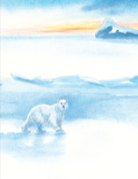
dug my den deep

Read these descriptive phrases from the story
My wild white wilderness

groaning and grinding ice

whooping and whistling and whales

a seal in the sea is slippery

Did you notice that in each one, Michael Morpurgo has had fun using several words that begin with the same sound?
This is called alliteration.
Here are five more descriptions of the polar Arctic. Put a tick next to the ones using alliteration.

a few rough ragged rocks

the cold dark sea

two glowing glistening glaciers

the soft smothering snow

a keen sharp wind

The Rainbow Bear’s Menu

Describe the food using words with the same initial sound, e.g. seal – slippery, silky, smooth etc.
Prey |  | Description words
Seal | 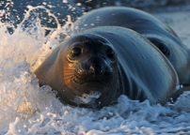
Beluga | 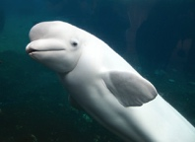
Walrus | 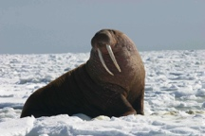
Narwhal | 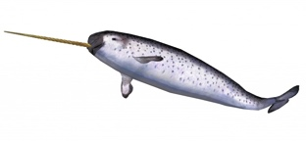
Fox (Arctic) | 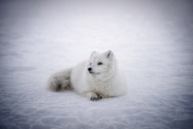
Fish | 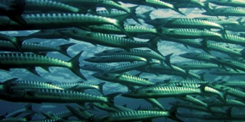
Crab | 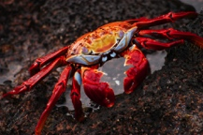

Menu Sentences

What to do:
Pick two of the Rainbow Bear’s foods
Write an alliterative, compound sentence about the two foods:
The Rainbow Bear eats slick slippery seals and fast frisky foxes.
Do the same thing for two more foods.

__________________________________________________________________________________________________

__________________________________________________________________________________________________

Rainbows

Rainbows always have the same colours in them in the same order

red, orange, yellow, green, blue, indigo and violet

If you want to remember the order of the colours of the rainbow you can use this mnemonic to help you:

R o y gets breakfast in Venice

Or this one

Richard Of York Gained Battle In Vain

At the end of a rainbow, it is said that a crock (like a big pot) of gold and other treasure is buried. What would you love to find buried there?

