What to do today
IMPORTANT! Parent or Carer – Read this page with your child and check that you are happy with what they have to do and with any weblinks or use of the Internet required.

1. Story time
Think back to Tigress by Nick Dowson and Julia Chapman (if you would like to watch it again go to https://youtu.be/gLJ4ruGyqj0 ).
Listen to the reading of Ice Bear, written by Nicola Davies and illustrated by Gary Blythe https://youtu.be/ToVq8VYStNw .

2. Similarities and differences
With a grown up, think about all the things that tigers and polar bears have in common and all the ways in which they are different from one another.
- Use Similarities and Differences to record everything you have thought about and discussed.
- Read the Suggestions page if you get stuck.

3. Tiger, polar bear or both?
Read each of the Animal Sentences.
- If the sentence applies to just tigers, write a capital T next to it.
- If the sentence applies to just polar bears, write a capital P next to it.
- If the sentence applies to both animals, write a capital B next to it.

Now try this Fun-Time Extra
- Which is your favourite – a tiger or a polar bear?
- On My Favourite, draw your choice.
- Write a sentence which says why you like that animal the best. Use because in your sentence to explain your choice.
- Don’t forget to use a capital letter and full stop in your sentence.
- Carry on and write more sentences about your animal.

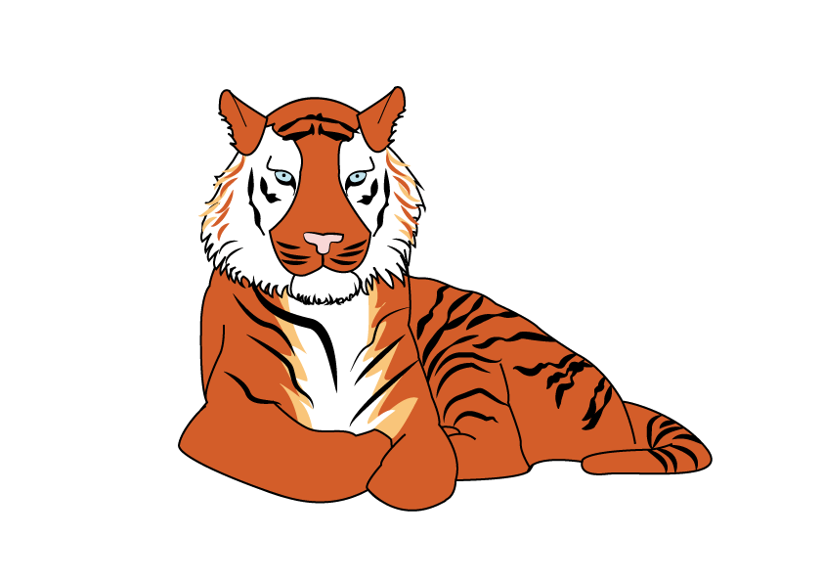
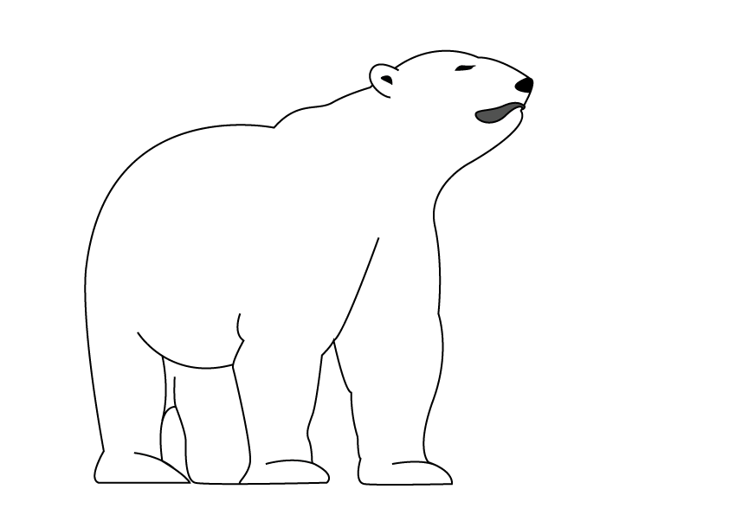
Similarities and Differences

Similarities – What do they have in common? | Differences – How are they different?

Similarities and Differences
Some Suggestions

Similarities – What do they have in common? | Differences – How are they different?
Fierce and a bit scary  Walk on four legs  Are carnivores (meat eaters)  Have thick fur  Give birth to live babies which need a lot of caring for  Feed babies with milk | Tiger is a big cat, polar bear is a bear  Tigers are orange and black, polar bears are white  Live in different places in the world  Eat different things – tigers don’t eat seals  Polar bears hibernate for the winter

Animal Sentences

- There are five species in the world: Bengal, South China, Indochinese, Sumatran and Siberian.
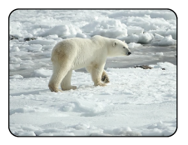
- They mainly eat deer, wild pigs, antelope and buffalo.

- They are strong swimmers.

- They are found in the Arctic, Canada, Alaska, Greenland, Russia and Norway.

- They measure over two and a half metres.

- They have black skin underneath their thick fur, which helps soak up the sun to keep them warm.

- They have an incredible sense of smell.
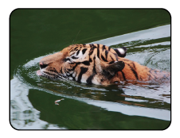
- They are classed as a very ‘vulnerable’ animal, as they are becoming more rare
in the wild.

Animal Sentences - Answers

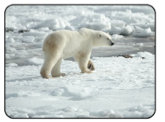

- There are five species in the world: Bengal, South China, Indochinese, Sumatran and Siberian. - Tiger

- They are strong swimmers. - Both

- They are found in the Arctic, in Canada, Alaska, Greenland, Russia and Norway. - Polar Bear

- They measure over two and a half metres. - Both

- They have black skin underneath their thick fur, which helps soak up the sun to keep them warm. - Polar Bear

- They have an incredible sense of smell. - Both

- They mainly eat deer, wild pigs, antelope and buffalo. - Tiger

- They are a very ‘vulnerable’ animal as they are becoming more rare in the wild. - Both

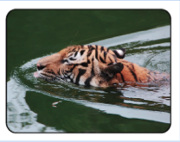

My Favourite

