What to do today
IMPORTANT! Parent or Carer – Read this page with your child and check that you are happy with what they have to do and with any weblinks or use of the Internet required.

1. Different types of writing
Read the page, Fiction and Non-Fiction and talk about each one with a grown up.

2. Story Time
Go to https://youtu.be/gLJ4ruGyqj0.
Listen to the reading of Tigress, written by Nick Dowson and illustrated by Jane Chapman.
- Do you think the book is fiction or non-fiction? Is it a bit of both?
- What was the most amazing fact about tigers that you learned?

3. Sorting sentences
Look at the Tiger Sentences. Some are fiction sentences, some are non-fiction, or ‘fact’ sentences.
- Read each sentence and highlight all the sentences that are non-fiction (facts). Check with the Tiger Sentences Answers page to see if you spotted them all.

4. Tiger captions and labels
Using Jane Chapman’s pictures to help you draw or paint a tiger.
- Write out the animal’s name and add some non-fiction labels to your picture: sharp claws, blue tongue, etc.

Now try this Fun-Time Extra
- Go to https://www.youtube.com/watch?v=ajkkbAGpj5Q and have fun finding out about other big cats.

Fiction and Non Fiction

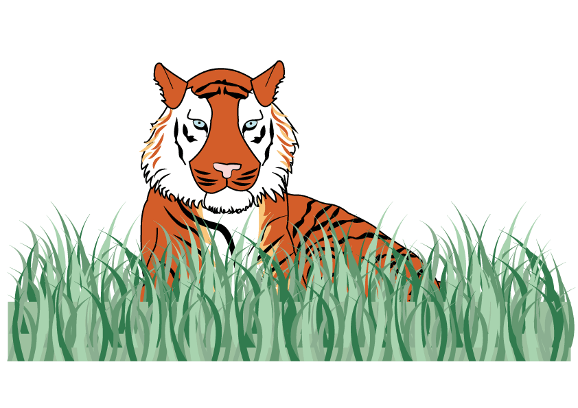

Fiction
The writing includes ideas which are not real; they are pretend or made-up.

Non-Fiction
The writing includes ideas which are real; they are facts and are true.

Tiger Sentences

The tiger’s bright stripes are perfect camouflage. | Tigers have amazing eyesight and hearing.
“You can’t see me!” said the tiger. | The tiger liked to have a bath before getting into its pyjamas.
Young tigers start to eat meat when they are about 8 weeks old. | “Please ride on my back!” roared the tiger to the Queen.
Tiger cubs have loose skin around their neck, which makes them easy to lift. | The tiger opened his purse to pay for the bag of tomatoes.
The tiger walked proudly on two legs, holding his walking stick, to see the king. | Mother tigers look after the cubs alone.

Tiger Sentences – Answers

The tiger’s bright stripes are perfect camouflage. | Tigers have amazing eyesight and hearing.
“You can’t see me!” said the tiger. | The tiger liked to have a bath before getting into its pyjamas.
Young tigers start to eat meat when they are about 8 weeks old. | “Please ride on my back!” roared the tiger to the Queen.
Tiger cubs have loose skin around their neck, which makes them easy to lift. | The tiger opened his purse to pay for the bag of tomatoes.
The tiger walked proudly on two legs, holding his walking stick, to see the king. | Mother tigers look after the cubs alone.

