What to do today
IMPORTANT! Parent or Carer – Read this page with your child and check that you are happy with what they have to do and with any weblinks or use of the Internet required.

1. Reading time
Read the information about goats on the Fact File.
- Why are these goats called Golden Guernseys?
- Name something you can make from goat’s milk.

2. Animal and their babies
Baby goats are called kids. What are other baby farm animals called?
- Read the names of the Farm Animals.
- Join the animal to the correct name for their babies with a line.
- Write a sentence about your favourite animal, saying why you like it.

3. Writing an animal fact file.
Choose one of the farm animals from the set.
- Use the Internet and books to find out all about your animal – try starting with https://www.bbc.co.uk/cbeebies/shows/down-on-the-farm.
- Create a fact file for your animal.

Now try this Fun-Time Extra
- Make copies of your fact file to send to friends and relatives.

Goat Fact File
Long curving horns

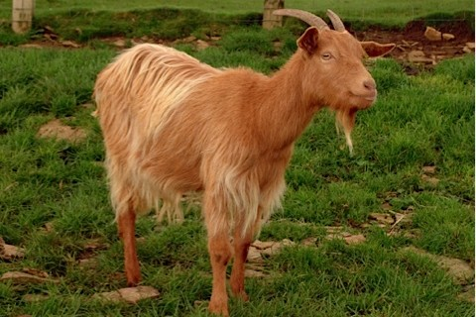
Distinctive chin tuft
Thick warm coat

What types are there?
There are many different types of goat in Britain. The one in the picture is called a Golden Guernsey. These come from an island in the Channel called Guernsey, and have lovely, orange-brown coloured coats.

Where do they live?
Goats like to be outdoors in fields and orchards but they don’t like getting wet so they have shelters or barns to go into when it is raining.

What do they eat?
Goats mainly eat grass and hay although they also love eating flowers and leaves from small bushes. If they get into your garden they will eat everything!

What do we get from them?
Goats give rich creamy milk that you can drink or put on your cereal. You can also turn the milk into yummy cheese and yoghurt. We also get meat and skins from goats.

What are their babies called?
Baby goats are known as kids and in the spring time female goats may have two or three kids that they feed with their milk.

What are they like?
Goats can be quite stubborn but they are very gentle and like to have people near them. Watch out though – the male goats (the Billys) are very smelly!

Farm Animals

Cows  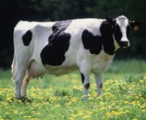 | kids
Pigs  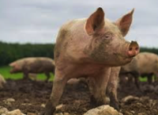 | lambs
Ducks  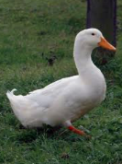 | chicks
Chickens  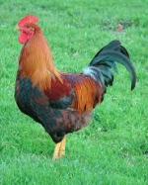 | piglets
Sheep  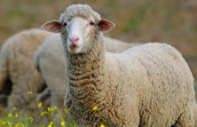 | foals
Horses  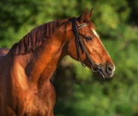 | calves
Goats  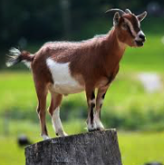 | ducklings

__________________________________

What types are there?

____________________________________________________________________________

Where do they live?

____________________________________________________________________________

What do they eat?

___________________________________________________________________________

What do we get from them?

____________________________________________________________________________

What are their babies called?

____________________________________________________________________________

What are they like?

____________________________________________________________________________

