What to do today
IMPORTANT! Parent or Carer – Read this page with your child and check that you are happy with what they have to do and with any weblinks or use of the Internet required.

1. Story time
Re-read The Billy Dogs Gruff.

2. Plurals
With a grown up, read the information on Spelling Plurals.
- Now read Croc’s Big Day. Look at the highlighted words.
- Write out each highlighted word in its plural form on More than One, placing each word in the correct column, -s or -es. The first one is done for you.
- Take Croc’s Snappy Challenge: add some extra words of your own to each column.

3. What’s under the bridge?
Read The Troll and the Crocodile.
What other, even scarier monster or animal could have been hiding by the river in the story?
- On Yikes!, draw your scary creature.
- Write punctuated sentences describing it in the same way as the Troll and Croc are described.

Now try this Fun-Time Extra
- The dogs want to put a notice up near the river, warning animals about the crocodile. What will they say on their notice?
- Write out their message on the Notice Board.
- Add some drawings to the picture.

Spelling Plurals
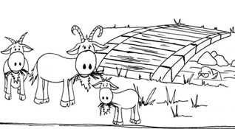

When we have just one of a noun (a thing or an object), we say that the noun is singular – a goat.

When we have more than one of a noun we say that the noun is plural – three goats.

With most nouns, when you write them in the plural you add either s or es to the word’s end – two pencils, some pens; lots of boxes, a few crosses.

But how do you know whether to add es or s?

Just follow this simple rule....

If your noun ends in ch, sh, x, s, ss or z you add es.
If your noun ends with any other letters, you just add s.

Croc’s Big Day

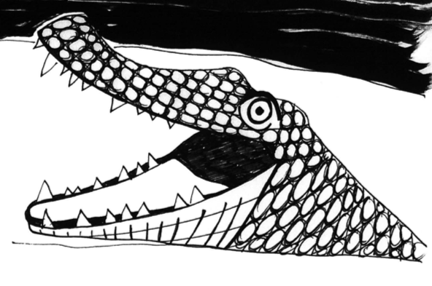

Croc was waiting silently in the river when a fox crept out of a bush and looked carefully around. In its mouth the fox was carrying a short branch, all covered in moss. The fox waited in a patch of sunshine and listened to the buzz of a solitary bee. Croc swam closer, ready to scare away the fox. With one swish of its tail the fox jumped forward and fixed the piece of wood in poor old Croc’s jaw, just like the dogs had told him to. It worked! Poor Croc was stuck once again with his mouth open and his teeth shining in the sun. Fox meanwhile padded along the branch across the stream and headed off into the wood, hoping to find a lunchbox so that he could pinch a little bit of food.

More than one...

Noun + s | Noun + es
 | foxes

The Troll...

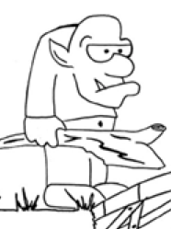

The Troll is short and ugly and bald, with blotchy purple skin and big bulging eyes. He has pointy ears and a sharp tooth like a fang that comes out of his mouth, even when it is closed. His nose is long and bulging and he always carries a big thick stick to frighten people – and goats!

... and the Crocodile!

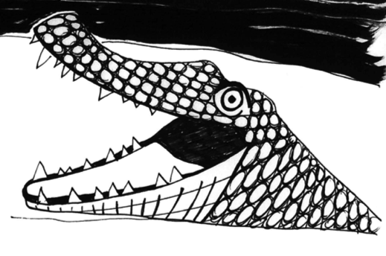

The Crocodile has green scaly skin and a long, scary looking mouth filled with sharp white teeth and a big pink tongue. His eyes never blink so he can always spot troublesome dogs trying to sneak across the river. His legs are short and squat but he can move like lightening when he needs to. He has a big thick tail to help him swim through the water.

Who is scariest, the Troll or the Crocodile?
And who is even more scary than either of them!?

Yikes!

________________________________________________________________________________________________________________________________________________________________________________________________________________________________________________________________________________________________________________________________________________________________________________________________________________________________________________________________________________________________________________
