What to do today
IMPORTANT! Parent or Carer – Read this page with your child and check that you are happy with what they have to do and with any weblinks or use of the Internet required.

1. Story time
Read and enjoy The Billy Dogs Gruff by Ruth Merttens and Jackie Abey.
- Ouch! Do you feel sorry for the crocodile having his mouth stuck open like that? Why/not?

2. Comparing stories
Think about The Billy Goats Gruff and The Billy Dogs Gruff.
- On Comparing Gruff Stories, write things that are the same in both.
- Write things that are different in the stories.
- Write a punctuated sentence saying which story of the two you prefer.
- Use the word because to explain why you like that story best.

3. Writing a letter
Read A Letter from the Goats to the Troll.
- On the blank letter page, write a letter from the dogs to the crocodile, beginning Dear Croc.
- Politely ask the crocodile to let you cross the river by the tree branch.
- Explain why you want to go to the other side of the river.
- Say what you’ll do for the Crocodile to make it up to him.
- Add a P.S. message after your signature.

Now try this Fun-Time Extra
- On The Other Side, draw what the dogs get up to after they have crossed the river.
Comparing Gruff Stories

Things that are the same in both stories | Things that are different in the stories

b e c a u s e

___________________________________________________________________________________________
_________________________________________________________________________________________________________________________________________________________________________________________________________________________________________________________________________________

A Letter from the Goats to the Troll
Dear Troll,  Please can we use your bridge?  We have no food to eat and | 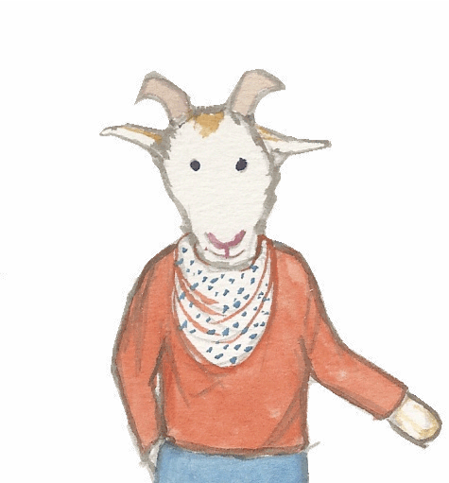
are very hungry. Did you hear our tummies rumbling last night?

We saw that there is tasty grass opposite our field but need to cross the stream to reach it. It looks delicious!

We will walk quietly over the bridge and make sure our hooves are very clean, so we don’t make a mess.

Love from,

The Three Billy Goats Gruff

P.S. We will make sure there is plenty of grass left for you!

______________________

__________________________________________________________________________________________________________________________________________________________________________________________
__________________________________________________________________________________________________________________________________________________________________________________________
__________________________________________________________________________________________________________________________________________________________________________________________
__________________________________________________________________________________________________________________________________________________________________________________________

____________________________

____________________________

__________________________________________________________________________________________________________________________________________________________________________________________
On the Other Side

______________________________________________________________________________________________________________________________________________________________________________________

