What to do today
IMPORTANT! Parent or Carer – Read this page with your child and check that you are happy with what they have to do and with any weblinks or use of the Internet required.

1. Story time
Go back to https://www.youtube.com/watch?v=aiy3a1v9Q2E
Re-listen to The Three Billy Goats Gruff.

2. Questions and question marks
Look at the set of Special Question Words.
- Read each word carefully.
- Practise spelling each one three times.
- Practise forming a question mark correctly.

3. Writing a speech bubble conversation
Look at the picture of Little Goat and the Troll.
- In his bubble, write a question that Little Goat could ask the Troll.
- Check the spelling of your question word.
- Use a properly formed question mark at the end of your sentence.
- Write the reply that the Troll gives.
- Take the Billy Goats Gruff Challenge: write questions and answers to go in the bubbles on What did you say?

Now try this Fun-Time Extra
- Read the words on Big Goat, Little Goat.
- Think about what each word means.
- Write out the words under the correct heading, Big or Little.

Special Question Words

What
Where
When
Why
Who
How
Can
Are
Do
Will

Question Marks

? | Practise forming question marks in this box. Start at the top left of the question mark and work down to the full stop ‘dot’.  Remember, the dot sits on the line.  ________________________________________________________________  ________________________________________________________  _______________________________________________________

Little Goat and the Troll

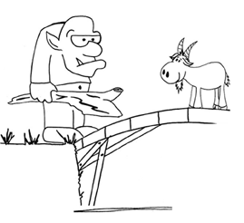
What did you say?

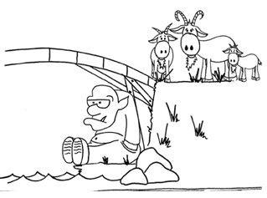

Big Goat, Little Goat

The medium sized Billy Goat Gruff is trying to describe his friends, Big Goat and Little Goat.

He uses these words to describe each one:

tiny massive huge small mini colossal

vast minute immense great microscopic teeny

Which words was he using for which goat?

Big goat | Little goat

