What to do today
IMPORTANT! Parent or Carer – Read this page with your child and check that you are happy with what they have to do and with any weblinks or use of the Internet required.

1. Story time
Go to https://www.youtube.com/watch?v=aiy3a1v9Q2E.
Listen to the story of The Three Billy Goats Gruff.

2. Retelling the story
Look carefully at the six Story Cards.
- Say what is happening in each of the pictures.
- Put the pictures in the correct story order. Watch The Billy Goats Gruff again to check what happens in the story.
- Use the sequenced pictures to help tell the story to someone in your family in your best storyteller voice.

3. Adding captions to pictures
Look at Once Upon a Time.
- Read the captions under the picture. Which caption is the right one for the picture?
- Write punctuated sentences to go with each of the Two Pictures from The Billy Goats Gruff.
- Make sure your sentences start with capital letters and have full stops and good finger spaces between words.

Now try this Fun-Time Extra
- In the story the goats trip, trap and tramp across the bridge. What other ‘walking’ verbs do you know? (Walk, run, dash, sprint, etc.)
- List these on Trip, Trap, Tramp.

The Three Billy Goats Gruff Story Cards

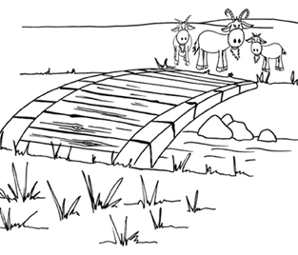 | 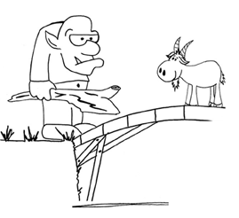 | 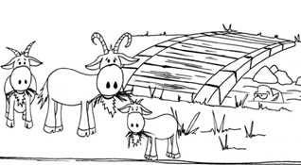
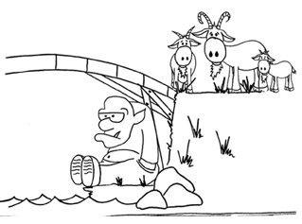 | 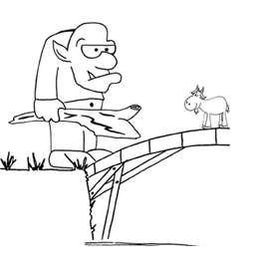 | 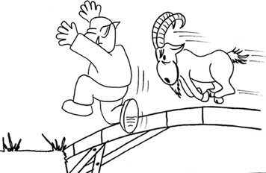

Once Upon a Time...

The three goats munched on the tender juicy grass until they were full and happy.

The smallest of the Billy Goats Gruff timidly asked the Troll if he could cross over the bridge.

The three Billy Goats Gruff looked across the river at the tasty green grass that grew on the other side.

The Troll ran away screaming for his mummy!

Two Pictures from The Billy Goats Gruff

__________________________________________  __________________________________________  __________________________________________  __________________________________________  __________________________________________  __________________________________________ | __________________________________________  __________________________________________  __________________________________________  __________________________________________  __________________________________________  __________________________________________

Trip, Trap, Tramp

