What to do today
IMPORTANT! Parent or Carer – Read this page with your child and check that you are happy with what they have to do and with any weblinks or use of the Internet required.

1. Reading time
Open https://www.activewild.com/common-british-birds/
- Scroll down and read the paragraph on Blue Tits – the kind of bird in the pictures from Sleeping Beauty!
- How is a great tit’s head different to a blue tit’s head?

2. Bird spotting
You are going to be a bird spotter.
- Read the instructions on Bird Spotting. Prepare a spotter’s chart.
- Keep a written record of the birds you see over one whole week.

3. Describing a favourite bird
Choose your favourite of the birds you're hoping to spot.
- On My favourite bird this week, draw or paint your bird.
- Write sentences explaining what it looks like.
- Use and to join together ideas in your sentences: It is very small and it has amazing blue wings.
- Write sentences explaining what you like about it.
- Use because in your sentences to explain your thoughts: I like it because it moves really fast and makes no almost no sound.

Now try this Fun-Time Extra
- Send copies of your bird spotter’s chart to a relative or friend. Ask them to look out for the birds too. Did you see the same sort and numbers of birds? Which were their favourites?

Bird Spotting

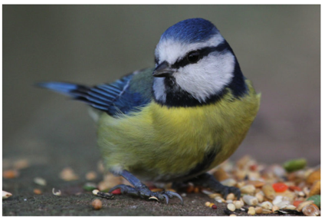

You are going to be a bird spotter!

1. Print off a blank My Bird Spotting Chart.

Keep a record of the birds you see over a whole week.
Fill in the date you start spotting and the date you finish spotting.

- If you have a garden, watch to see which birds visit it.
- If you go out for a walk, look around and see which birds are about.
- If you are just at home, look through the window and try to spot any birds nearby. – remember to look up in the sky!

2. Look again at the birds on https://www.activewild.com/common-british-birds/
or those on the Poster of Common British Birds.

3. Either fill in the names on your spotter’s chart of common birds you think you might see
Or wait until you see a bird and then, with a grown up’s help, work out what sort of bird it is and write their name on the chart.
You might want to use https://www.rspb.org.uk/birds-and-wildlife/wildlife-guides/identify-a-bird/ to help you.

4. Put a tally mark or tick next to that sort of bird every time you see one during the week.

- How many different birds did you see?
- Which bird did you see most often?
- Was there a sort of bird that you really wished you had seen?

My Bird Spotting Chart

Start date: _____________________ End date: _______________________

Type of bird | Tally

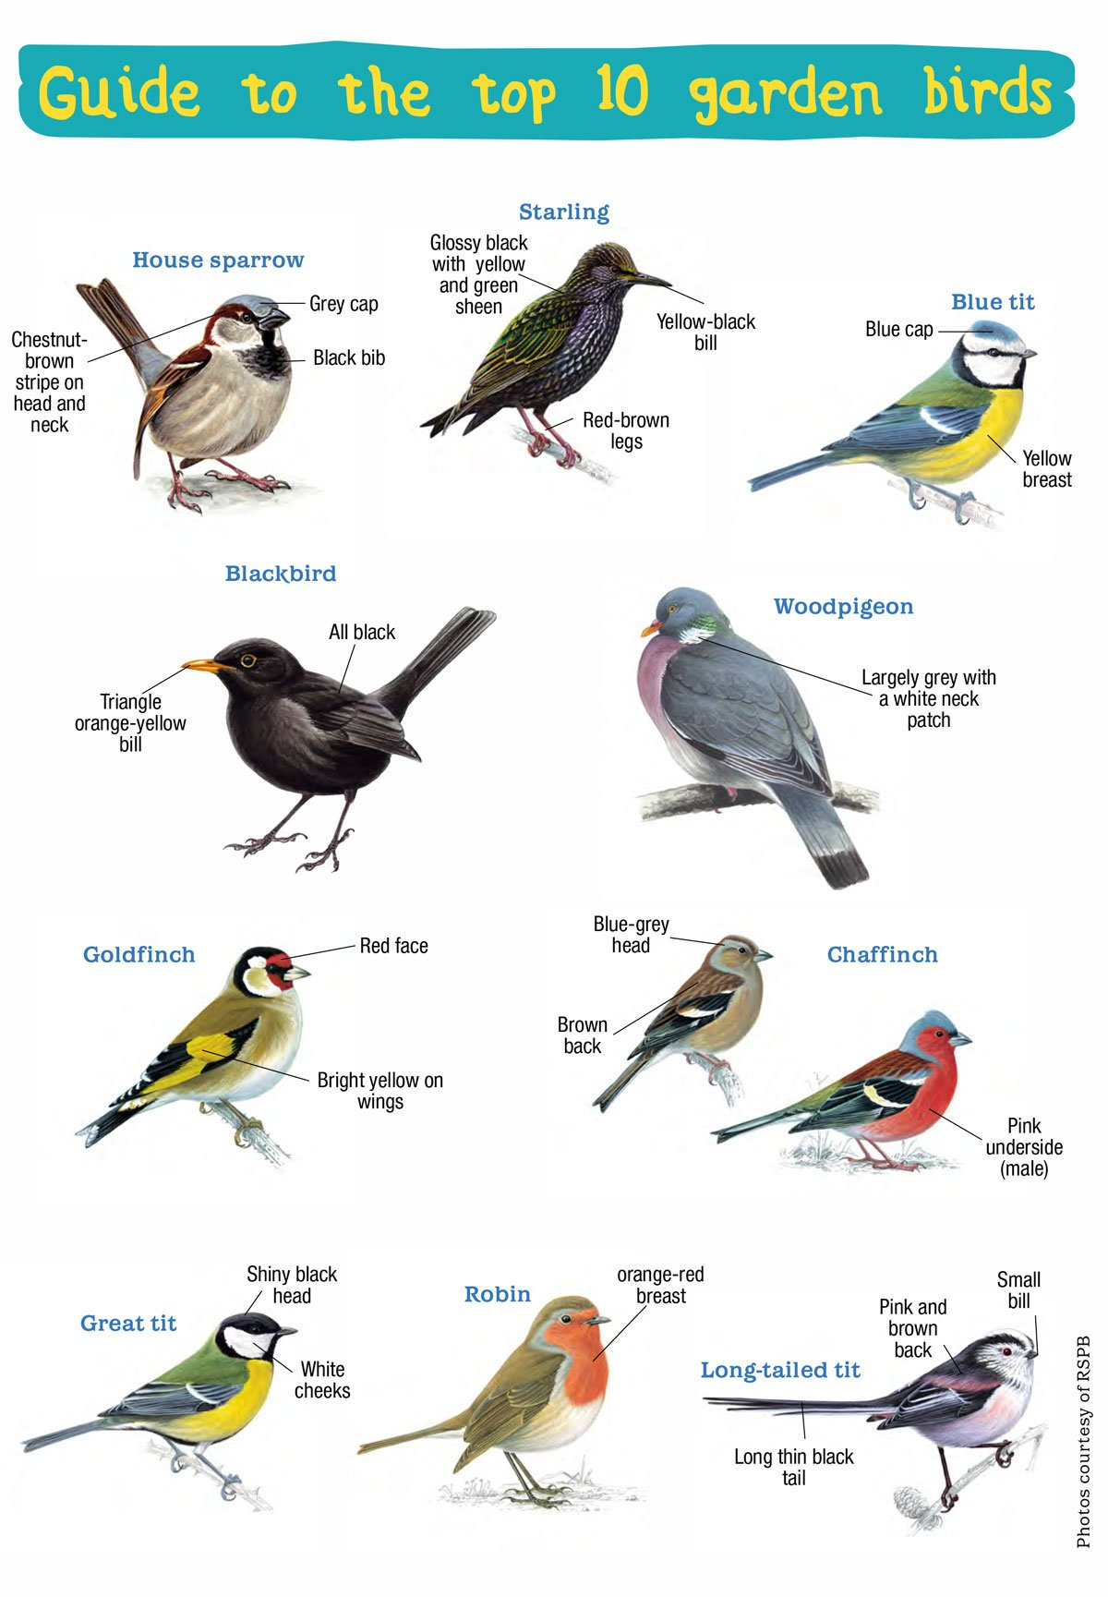

From: Eco Kids Planet https://www.ecokidsplanet.co.uk/blogs/news/handy-little-guide-to-the-uk-s-top-10-garden-birds
My favourite bird

_______________________________________________________________________________________________________________________________________________________________________________________________________________________________________________________________________________________________________________________________________________________________________________________________________________________________________________________________________

