What to do today
IMPORTANT! Parent or Carer – Read this page with your child and check that you are happy with what they have to do and with any weblinks or use of the Internet required.

1. Story time
Listen to the second part of Sleeping Beauty (from 11.00 mins onwards)
http://player.hamilton-trust.org.uk/story_telling_display.php?cid=896
- Look again at the story book to remind yourself.
- Read the instructions on My Two Sleeping Beauties.
- Fill out the boxes and write your sentences.

2. Getting past the hedge
How would you have tried to get past the hedge to rescue the Princess? Dig a tunnel underneath, climb up a ladder, get dropped over by a helicopter, use a flame-thrower to burn a hole through, etc.
- Draw on Getting Past the Prickly Hedge a picture of you trying a new way.
- Write punctuated sentences explaining what you would do.

3. Waking Sleeping Beauty
In the story, the Prince wakes Sleeping Beauty with a kiss.
- Who or what else might have woken her up, and how would they have done it? Complete the boxes on Waking up Sleeping Beauty.
- Say who might have woken the Princess: a dog, a bird, a thunderstorm, the post-lady, etc.
- Say how they would have woken her: Given her a lick; sung loudly; boomed with thunder; knocked on the door, etc.

Now try this Fun-Time Extra
- Do a drawing of one of the people or things you wrote about waking Sleeping Beauty up.

My Two Sleeping Beauties

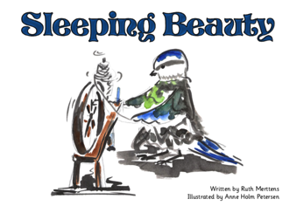 and 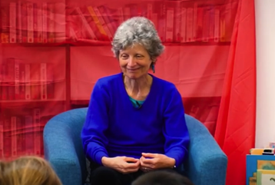

Things that are the same | Things that are different

Which version did you prefer?

____________________________________________________________________________________________________________________________

Why did you prefer that version?

____________________________________________________________________________________________________________________________
____________________________________________________________________________________________________________________________

b e c a u s e

Getting Past the Prickly Hedge

_______________________________________________________________________________________________________________________________________________________________________________________________________________________________________________________________________________________________________________________________________________________________________________________________________________________________________________________________________________________________________________
Waking up Sleeping Beauty

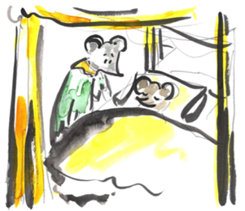

Who or what might have woken Sleeping Beauty? | How would they/ that have woken her?

Take your favourite of these ideas and write punctuated sentences explaining who or what woke Sleeping Beauty up and how they did it.

__________________________________________________________________________________________________________________________________________________________________________________________________________________________________________________________________________________________________________________________________________________________________________________________________________________________________________________

