What to do today
IMPORTANT! Parent or Carer – Read this page with your child and check that you are happy with what they have to do and with any weblinks or use of the Internet required.

1. Story time
Open http://player.hamilton-trust.org.uk/story_telling_display.php?cid=896
- Listen to Adele Moss tell the story of Sleeping Beauty.
- Stop at the point when Aurora pricks her finger and falls fast asleep (11 mins).

2. The wishes in the story
Listen again to the part of the story where the good fairies make wishes for Aurora (4 mins in).
- On Wishes, list the four wishes you hear being made for Aurora.
- Write a punctuated sentence in your best handwriting explaining which of these you think is the best wish.
- Use the word because in your sentence to explain your choice: I think being kind to everyone is the best wish because...

3. Writing about wishes and gifts
What wish would you make for a godchild or new baby?
- Read the suggestions at the top of My Wish.
- Draw a picture of yourself.
- Add a speech bubble above your head containing a punctuated sentence saying what your special wish would be: May you always...

Now try this Fun-Time Extra
- On My Birthday is..., write out the full date of your birthday.
- Do you get excited about your birthday like Aurora did about her 16th in the story? What exciting things have happened on your birthdays?

Wishes

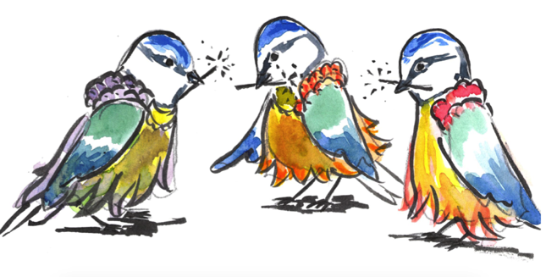

The four wishes we hear are...

1. ____________________________________________________________

2. ____________________________________________________________

3. ____________________________________________________________

4. ____________________________________________________________

Of these four wishes, which do you think would be the best?

________________________________________________________________________________________________________________________________________________________________________________________________________________________________________________________
b e c a u s e
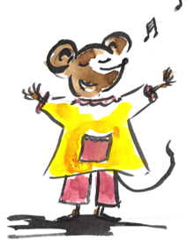

My Wish

Instead of things like toys or games, think of skills or good situations and feelings that you would wish for a godchild or baby to have.
Here are some suggestions: being amazing at football or dancing, being really good at riding a bike or a skateboard, being cheerful, having loads of friends, being able to swim quickly!

My Birthday is...

_____________________________________________________

