What to do today
IMPORTANT! Parent or Carer – Read this page with your child and check that you are happy with what they have to do and with any weblinks or use of the Internet required.

1. Story time
Read the story, Sleeping Beauty by Ruth Merttens and Anne Holm Petersen.

2. Sequencing the story
Look at the twelve Sleeping Beauty Story Cards.
- Cut out the cards.
- Put the events from the story in the right order.
- Use the cards to help you orally retell the story of Sleeping Beauty to someone in your family or via Skype to a relative you can’t visit at the moment.

3. Sleeping Beauty’s Party
When she woke up after her sleep, Sleeping Beauty wanted to have a really good party.
- Read the instructions for Sleeping Beauty’s Grand Wake-Up Party.
- Give your suggestions for her party.
- Do a drawing of the party.

Now try this Fun-Time Extra
- Use your teddies, dolls and other small world figures and props to put on Sleeping Beauty’s party in your home.
Sleeping Beauty Story Cards

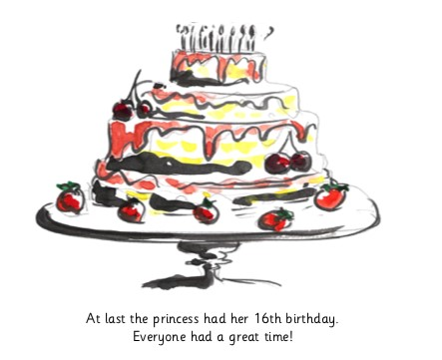 | 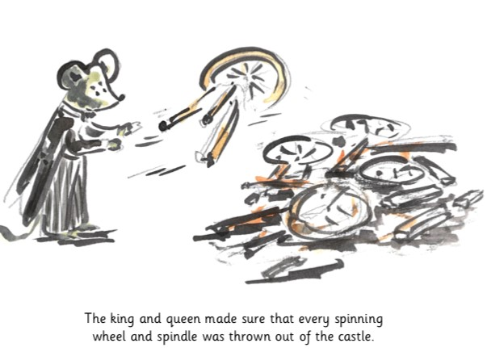
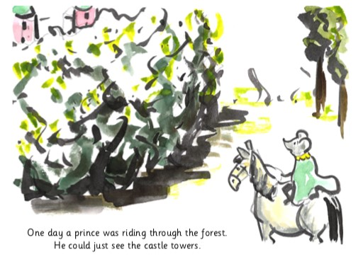 | 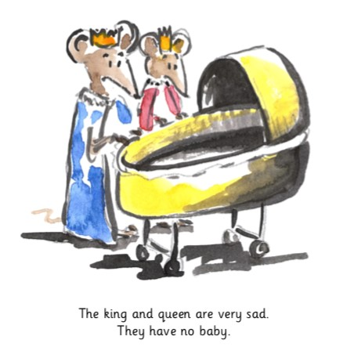
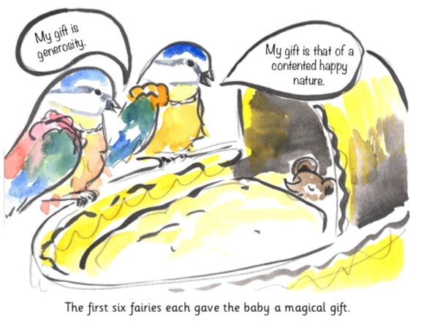 | 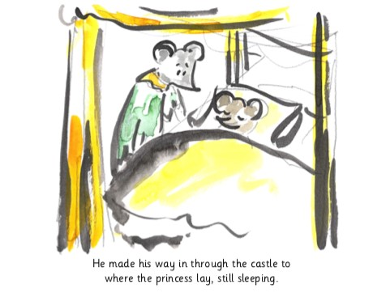

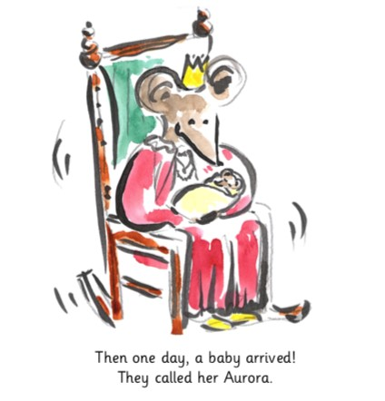 | 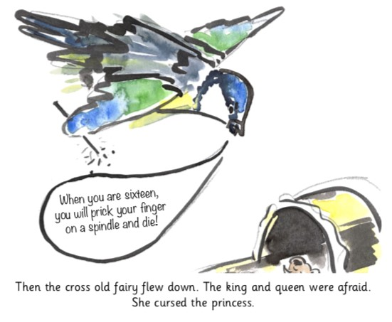
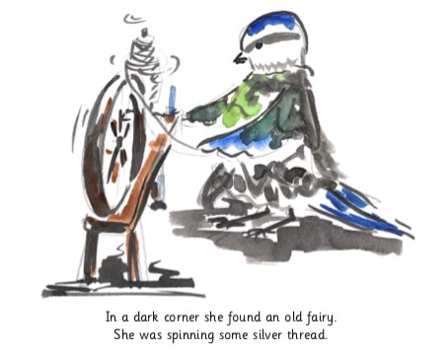 | 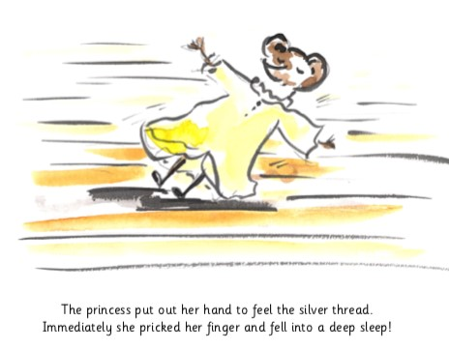
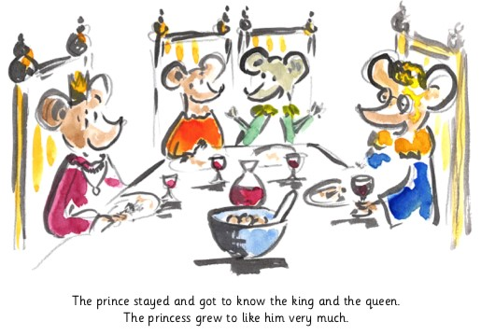 | 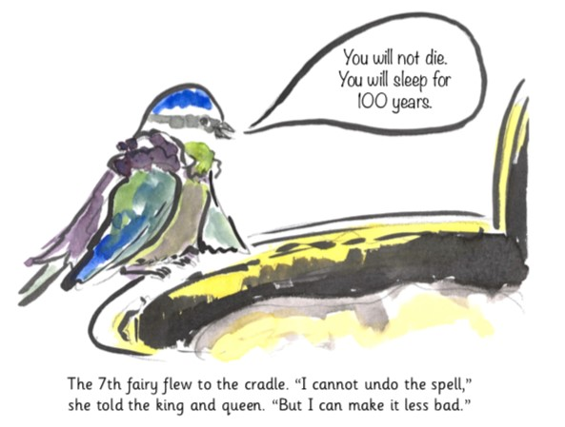

Sleeping Beauty’s Grand Wake-Up Party

Sleeping Beauty has asked you to help her plan her grand wake-up party!
First, she wants you to list six tasty things she and her friends could eat or drink at the party.

Use really exciting describing words for each of the foods or drinks you recommend (huge chocolate cakes, wobbly red jellies).

______________________________________________

______________________________________________

______________________________________________

______________________________________________

______________________________________________

______________________________________________

Now she wants you to suggest what games she and her friends should play at the party.
Think of all the good games they could play.
Write a sentence about two of these games,
Use either the word and or the word or to join your ideas together.
Example: You can play blind man’s buff and a game of pass the parcel.

____________________________________________________________________________________________________________________________________________________

Now write another sentence about two more games ideas.

____________________________________________________________________________________________________________________________________________________

Sleeping Beauty’s Party

