What to do today
IMPORTANT! Parent or Carer – Read this page with your child and check that you are happy with what they have to do and with any weblinks or use of the Internet required.

1. Story time
Re-read the Hamilton story, Chicken’s Bad Dream by Ruth Merttens and Jackie Abey.

2. Thinking up ideas for a new story
You are going to write a story based on Chicken’s Bad Dream, called Cat’s Bad Dream.
- Carefully read the instructions on Writing the story of Cat’s Bad Dream
- Use the Story Planner to capture all your brilliant ideas.

3. Writing a new story
Now use pieces of story paper to write out your story.
- Use your best handwriting for your sentences.
- Put neat regular spaces between your words.
- Use an initial capital letter and a full stop for all your sentences.

Now try this Fun-Time Extra
- What would you love to dream about? Living in a castle? Playing football for Manchester United? Swimming in the sea with dolphins?
- On My Perfect Dream, write sentences describing your perfect dream. Add a picture to go with your writing.

Writing the story of Cat’s Bad Dream

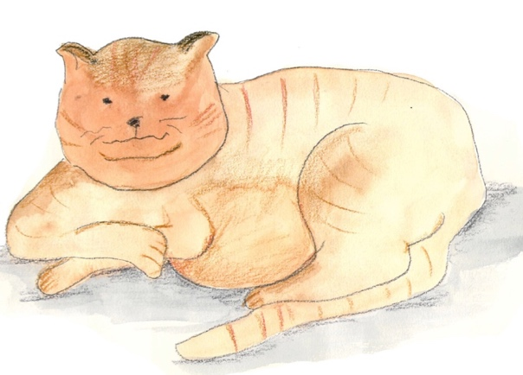
Planning your story:

- Imagine that, just like Chicken, Cat was sleeping.
She too was having a bad dream.
- Which scary animals might be in her bad dream?
Come up with scary animals of your own or use some of these creatures:

wasp wolf crow eagle killer whale lizard shark spider rat bat scorpion tarantula

- Look carefully at the Story Planner.
- Write the name of the first scary animal you think might be in Cat’s dream and add a describing word, e.g. Grey Wolf was in her dream. Is wolf a he or a she?
- What two things do you think Wolf might be doing in the dream to frighten poor old Cat?
Use and to join your two ideas together: He was howling and snarling at her.
- Do the same thing for two more animals: e.g. sneaky Rat and furry Tarantula.
- Then Cat woke up. Say what Cat then does to be safe: Cat hissed and dashed through the cat flap into the house.

Writing out your story
- When your Story Planner is full, carefully copy out the whole story in your very best handwriting onto a page of story paper.
- If you want to, you can have more than three animals in your story. Write about more animals you want to include. Use more than one piece of story paper.
- Add drawings of all the animals from your story around the edges of the paper.

My Story Planner

Cat was sleeping. She was having a bad dream.

______________________ was in her dream.

S/he was ____________________________________________________
_________________________________________________________________________________________________________

______________________ was in her dream.

S/he was _________________________________________________________________
__________________________________________________________________________________________________________

______________________ was in her dream.

S/he was ________________________________________________________________
__________________________________________________________________________________________________________

Then Cat woke up. She ____________________________________________________
_______________________________________________________________________________________________________________________________________________________________

__________________________________

My Perfect Dream

