What to do today
IMPORTANT! Parent or Carer – Read this page with your child and check that you are happy with what they have to do and with any weblinks or use of the Internet required.

1. It’s story time
Read and enjoy the Hamilton story, Chicken’s Bad Dream by Ruth Merttens and Jackie Abey. Use the suggested Reading Strategies to deal with any new and tricky words you meet.

2. Answering questions about a story
Look at the questions in the clouds on Tell Me About It.
- Read each question. Think about your answer.
- Tell someone in your family what you think.
- If you can, take Chicken’s Big Challenge and write your answers down in your neatest handwriting on the Answers page.

3. Describing scary animals
Think about all the slightly scary animals that Chicken sees in her dreams.
- Pick one animal that you thought was a bit scary too.
- On Scary Animals, draw the animal and write a sentence saying what it looks like. Use really good words to describe your creature.
- Write another sentence saying why it is quite a scary animal. Use the word because in your sentence to explain why you think the animal is quite scary: I think a snake is scary because it...

Now try this Fun-Time Extra
- What good ideas do you have for someone who is a bit worried about going to bed? On My Bedtime Advice, draw pictures and write captions for each piece of advice you have. (Leave the light on, don’t shut the door, cuddle up with a teddy, etc.)

Reading Strategies

When you come across a word you don’t know, use these strategies to help you read it!

Sound out the word
First strategy to use!
Break words into syllables  e.g. go-ing | Look for smaller words within words  be-fore
Skip the word and read the rest of the sentence to work out what it says | Did the sentence you read make sense?
Use the pictures | Remember the text
Remember Key Words
is the to and with I am

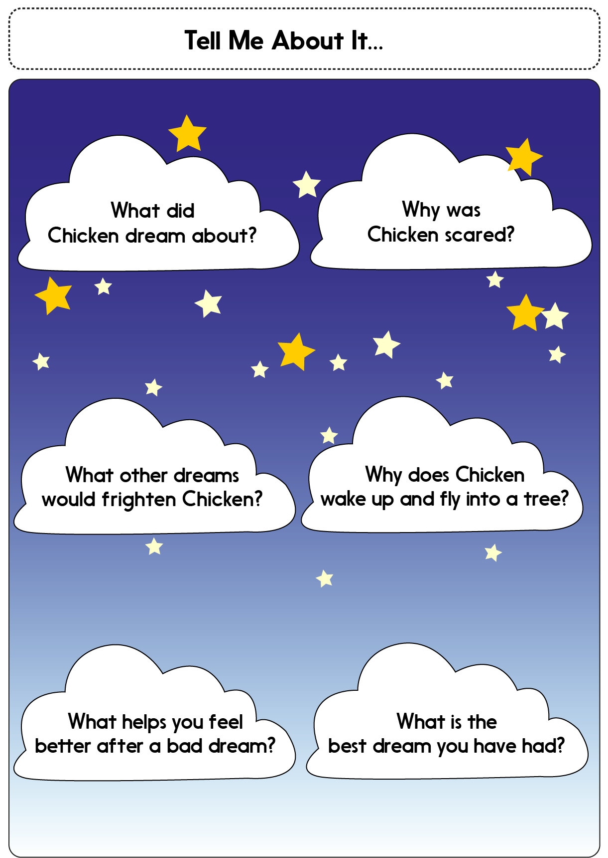

Answers Page

Scary Animals

________________________________________________________________________________________________________________________________________________________________________________________________________________________________________________________________________________________________________________________________________________________________________________________________________________________________________________________________________________________________________________
My advice if you are a bit scared at bedtime

