What to do today
IMPORTANT! Parent or Carer – Read this page with your child and check that you are happy with what they have to do and with any weblinks or use of the Internet required.

1. It’s story time!
Go to https://vimeo.com/170148486 and listen to the reading of Bedtime for Monsters, written and drawn by Ed Vere.

2. Answering questions about a story
Look at the page of Bedtime Monster Questions.
- Read each question carefully. Think of your answer.
- Tell someone at home what you think.
- Earn yourself a Monster Medal by also writing your answers down on the Answers page in your neatest handwriting.

3. Sequencing a story
Look at the Bedtime Monster Picture Cards.
- Cut up the cards and shuffle them.
- Lay them down in the right order for the story.
- Re-listen to the story if you get muddled.
- When you have got all the cards in the right order, tell someone in your family the whole story.
- If you are telling someone who is younger or more scared than you, reassure them that it is not scary in the end!

Now try these Fun-Time Extras
- On Bedtime!, explain your bedtime routine in pictures and words.
- What is your favourite story to snuggle down to? On My Favourite Bedtime Story write down its name, draw a scene from it and then write a sentence explaining what happens in the story.

Bedtime Monster Questions
- Read each question.
- Think of an answer.
- Share what you think with someone at home.

What does the monster ride on?
What is the monster thinking as they are travelling?
How do you think the child feels when they hear that a monster is on its way?
How might you feel if a monster were climbing the stairs to your bedroom?
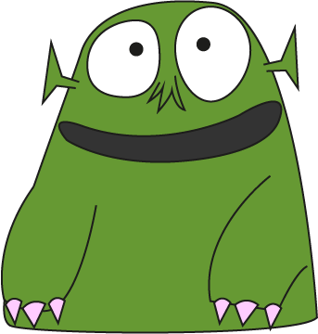
What happens at the end of the story?
What does the monster actually want?
What does the child leave out for the monster?

Answers

Monster Picture Cards

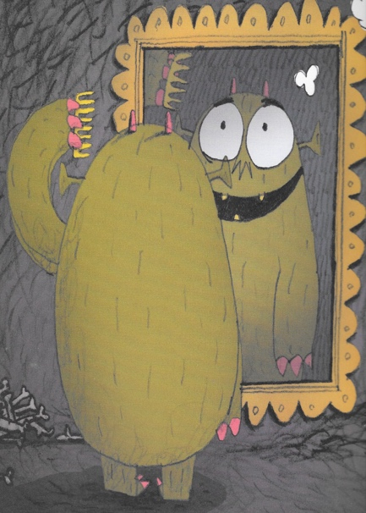 | 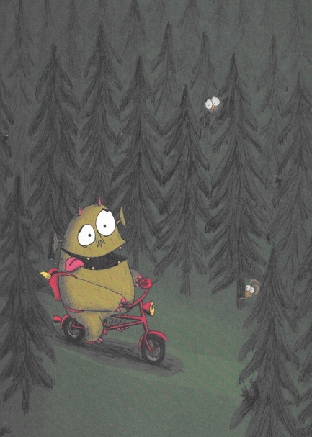 | 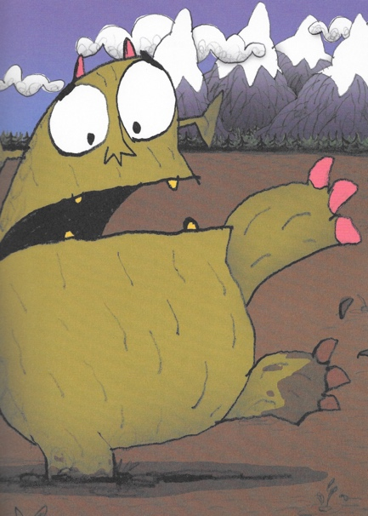
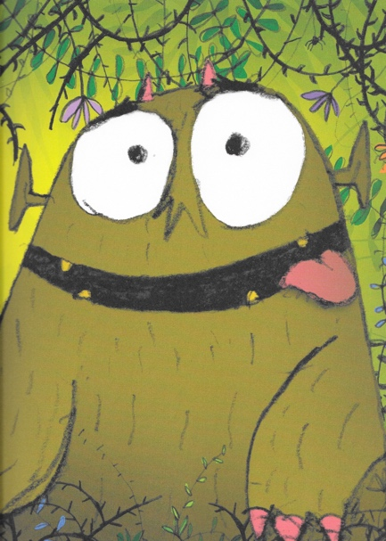 | 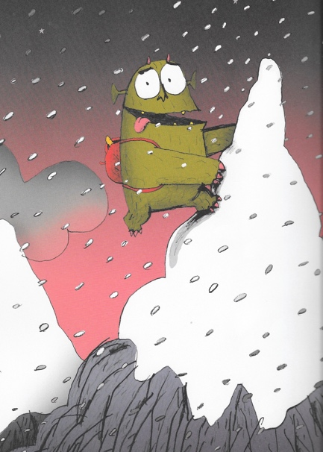 | 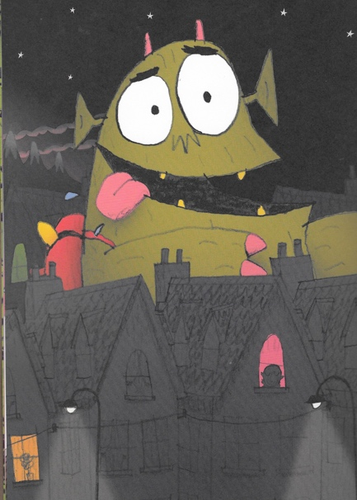
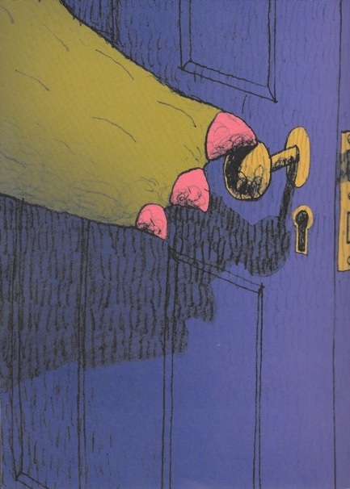 | 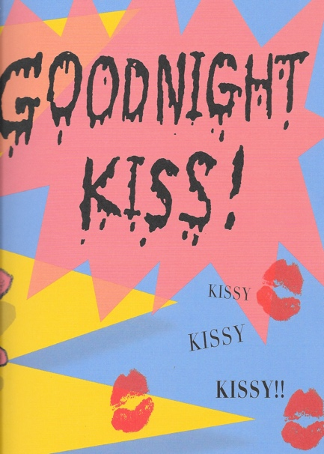 | 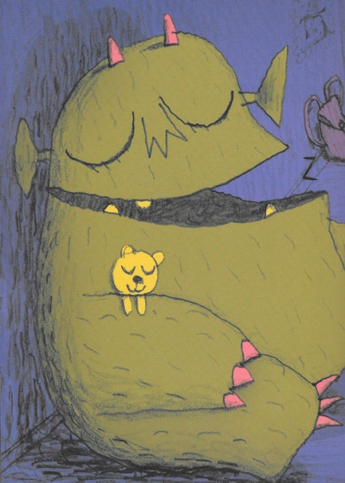

Bedtime!

My Favourite Bedtime Story

_____________________________________________________

