What to do today
IMPORTANT! Parent or Carer – Read this page with your child and check that you are happy with what they have to do and with any weblinks or use of the Internet required.

1. Reading poems
Read the poem The Secret Song by Margaret Wise Brown.
The poem is made up of a series of questions and answers.
- Highlight each question sentence in the poem in one colour and each answer sentence in another.
- How many questions are there? How many replies?

2. Question words and question marks
Look at the page of Question Words and Question Marks
- Read, then write out each question word three times in your neatest handwriting. Start each word with a capital letter.
- Practise forming question marks.

3. Writing questions for animals to answer
Name the animals that were mentioned in The Secret Song.
- Think of five new animals you like or know.
- Draw these animals in the boxes on Questions for Animals.
- Write a question that you would ask each animal. E.g., Where do you go at night, Badger? What do you eat, Ladybird?
- Spell your question words accurately. Start sentences with a capital letter. Finish your sentences with question marks.
- Can you use a different question word each time?

Now try this Fun-Time Extra
- On scraps of paper, use the Question Words to help you write questions for the people in your house. Leave space for them to answer. Read people’s answers!

The Secret Song

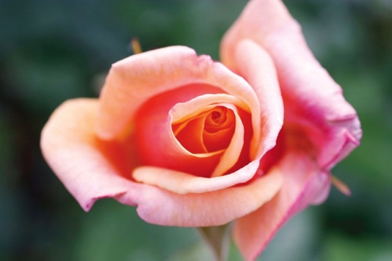

Who saw the petals  drop from the rose?  I, said the spider,  but nobody knows.  Who saw the sunset  flash on a bird?  I, said the fish,  but nobody heard.  Who saw the fog  come over the sea?  I, said the sea pigeon,  only me. | Who saw the first  green light of the sun?  I, said the night owl,  the only one.  Who saw the moss  creep over the stone?  I, said the grey fox,  all alone.

by Margaret Wise Brown
from Read Me First: Poems for Younger Readers for Every Day of the Year

Question Words

What | __________________________________________________
When | __________________________________________________
Where | __________________________________________________
Who | __________________________________________________
Why | __________________________________________________
Which | __________________________________________________
How | __________________________________________________
Can | __________________________________________________

Start at the top end of the curve and work rightwards and down, finishing by putting the ‘full stop’ under your question mark.

?

Animal Questions

My animals | My questions

______________________________________________
______________________________________________
______________________________________________
______________________________________________
______________________________________________
______________________________________________
______________________________________________
______________________________________________
______________________________________________
______________________________________________
______________________________________________
______________________________________________
______________________________________________
______________________________________________
______________________________________________
_______________________________________________
______________________________________________
______________________________________________
______________________________________________
______________________________________________

