What to do today
IMPORTANT! Parent or Carer – Read this page with your child and check that you are happy with what they have to do and with any weblinks or use of the Internet required.

1. Poem reading
Read and enjoy the poem Nut Tree by Julia Donaldson.

2. Recognising rhymes
Look at Rhymes in Nut Tree. The rhyming words in the first verse of the poem have been highlighted.
- Highlight the rhyming words in all the other verses.
- Read the further suggested rhyming words for each set.
- Watch out – there is a word in each box that doesn’t rhyme! Can you spot it? Highlight the non-rhyming word.
- Now work together to check with the Answers page.

3. The life cycle of a tree
Nut Tree tells the story of a tree from a tiny nut to a full-grown tree making more nuts of its own. We call this story a tree’s ‘life cycle’.
- Look at Life Cycle of a Nut Tree.
- Pick any box you like. In it, draw a picture of the nut underground.
- Follow the arrows round, drawing a picture for each stage in order, using the details in each verse to tell you what to draw.
- Add a descriptive label to each box: Nut underground; Tiny shoot; Small tree, etc.

Now try this Fun-Time Extra
- Try to learn Nut Tree off by heart. Start with just the first verse.
- Add actions or hand movements to each verse as you say them out loud, e.g. bunching your hand up like a small nut for the first verse, showing one little finger pointing upwards, wriggling, for the tiny shoot in verse two…
Nut Tree

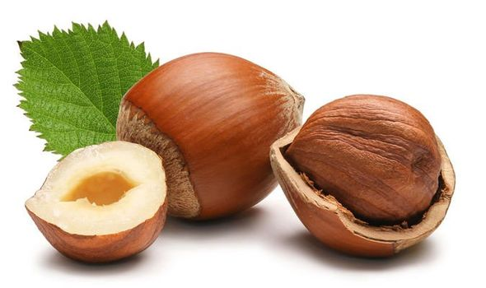

Small, brown, hard, round,
The nut is lying underground.
Now a shoot begins to show.
Now the shoot begins to grow.
Tall, taller, tall as can be,
The shoot is growing into a tree.
And branches grow, and stretch and spread
With twigs and leaves above your head.
And on a windy autumn day
The nut tree bends, the branches sway,
The leaves fly off and whirl around,
And nuts go tumbling to the ground:
Small, brown, hard, round.

by Julia Donaldson

From Wriggle and Roar, by Julia Donaldson and Nick Sharratt

Rhymes in Nut Tree

Verses | Suggested rhyming words

Small, brown, hard, round,  The nut is lying underground. | sound loud hound  frowned found
Now a shoot begins to show.  Now the shoot begins to grow. | so low oh  how sew
Tall, taller, tall as can be,  The shoot is growing into a tree. | see sea he  key toe
And branches grow, and stretch and spread  With twigs and leaves above your head. | bed said fed  sad ted bread
And on a windy autumn day  The nut tree bends, the branches sway, | hay say by  spray clay
The leaves fly off and whirl around,  And nuts go tumbling to the ground:  Small, brown, hard, round. | bound crowned  mound show  drowned

Rhymes in Nut Tree Answers

Small, brown, hard, round,  The nut is lying underground. | sound loud hound  frowned found
Now a shoot begins to show.  Now the shoot begins to grow. | so low oh  how sew
Tall, taller, tall as can be,  The shoot is growing into a tree. | see sea he  key toe
And branches grow, and stretch and spread  With twigs and leaves above your head. | bed said fed  sad ted bread
And on a windy autumn day  The nut tree bends, the branches sway, | hay say by  spray clay
The leaves fly off and whirl around,  And nuts go tumbling to the ground:  Small, brown, hard, round. | bound crowned  mound fond  drowned

The Life Cycle of a Nut Tree

