What to do today
IMPORTANT! Parent or Carer – Read this page with your child and check that you are happy with what they have to do and with any weblinks or use of the Internet required.

1. Story time
Go back to https://www.youtube.com/watch?v=0Bfh37iJRpU and hear Dear Greenpeace for the last time.
- Where do you think Arthur, the whale, goes at the end of the story?
- How do you think Arthur feels at the end of the story – sad or happy? Why do you think that?

2. Recalling story details
In the story, what things did Emily do for Arthur that were kind or loving?
- On Kind things Emily does for Arthur, list all the things you remember.
- If you get stuck, listen to the story again or read the ideas on the Suggestions page.

3. Writing a thank you letter
You are going to write a letter from Arthur to Emily, saying thank you for being so kind.
- Print off and fold up the Thank You Card template to write your letter.
- Use a proper letter layout for your message on the inside of the card.
- Choose a sign-off from Arthur. Will he use a formal one like Greenpeace (yours sincerely) or a friendly, informal one like Emily (love, Emily)?

Now try these Fun-Time Extras
- Add a picture to the front cover of your Thank You Card from Arthur.
- Use another copy of the template to write a thank you letter to someone else who deserves a nice big thank you!
Kind things Emily does for Arthur in the story

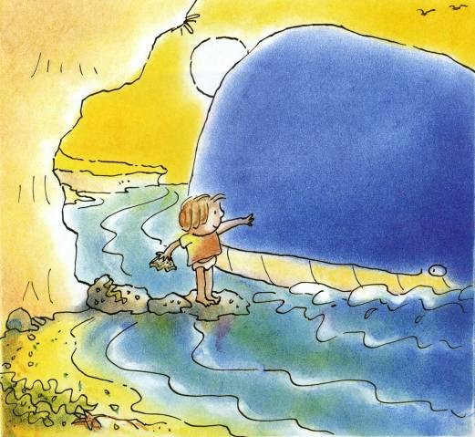

Suggestions

- Gives Arthur salt in the water so it’s more like the sea
- Feeds Arthur crunched up corn-flakes and bread-crumbs
- Calls and smiles to Arthur at the beach
- Gives Arthur some of her sandwich
- Strokes Arthur’s head
- Tells Arthur that she loves him
- Asks Greenpeace how she can help Arthur

Thank You!

