What to do today
IMPORTANT! Parent or Carer – Read this page with your child and check that you are happy with what they have to do and with any weblinks or use of the Internet required.

1. Story time
Go back to https://www.youtube.com/watch?v=0Bfh37iJRpU and listen again to Dear Greenpeace.
- Have you ever seen a whale? How would you feel if you saw one?

2. What is in Emily’s pond?
What else might Emily have seen in her pond if it was not a whale?
- On What could have been in Emily’s pond, draw pictures of things she might have seen – a giant frog, a massive fish, a funny monster... even a shape-shifting alien!
- Label each one with a descriptive caption: a really big frog; a huge monster with blue skin.

3. Writing a letter
Write a letter to a relative or friend telling them what you think was in Emily’s pond. Use your best handwriting.
- Lay your letter out properly. Look again at Emily’s first letter to make sure you have got everything in the right place.
- Include a good description of the creature.
- Don’t forget to use a friendly, cheerful sign-off: lots of love; love from; a big hug from, etc.
- If you are not feeling very confident, use the letter template.

Now try this Fun-Time Extra
- Post your letter and see if you get a reply!

What could have been in Emily’s pond

Emily’s First letter

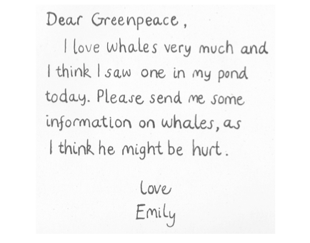

Letter template

Dear __________________

In Dear Greenpeace, Emily says she has seen a _________
_________________________________________________

I think she saw ____________________________________
____________________________________________________________________________________________________________________________________________________________________________________________________

Please write back and let me know what you think.

________________________

________________

____________________________

____________________________________________________________________________________________________________________________________________________________________________________________________________________________________________________________________________________________________________________________________________________________________________________________________________________________________________________________________________________________________________________________________________________________________________________________________________

_________________________
_________________________

