What to do today
IMPORTANT! Parent or Carer – Read this page with your child and check that you are happy with what they have to do and with any weblinks or use of the Internet required.

1. Communicating with relatives who are far away
How can you communicate with relatives that you can’t meet up with?
- On Getting in Touch, list as many different ways as you can think of to communicate with family and friends: letters, emails, postcards, phone calls, FaceTime, text messages, Skype calls, Zoom, etc.

2. Story time
Go to https://www.youtube.com/watch?v=0Bfh37iJRpU and listen to the reading of the story Dear Greenpeace, written by Simon James.
- Which form of communication is the story all about? Letters!
- Read the information on Emily’s First Letter and highlight the letter features you are asked to find.

3. Reading letters
You are going to re-read some of the letters from Dear Greenpeace and then say why you think they were sent.
- Read the information on Why were the letters written?
- Follow the instructions to match the letters to their descriptions.

Now try this Fun-Time Extra
- Look at all the ways to communicate with people that you listed on Getting in Touch.
- See how many of these forms of communication you can use in one week. Which was the one you used most often?

Getting in Touch

How many different ways are there to get in touch with relatives who you can’t meet up with?

Draw pictures of each way you can think of and write down their names.

Emily’s First Letter

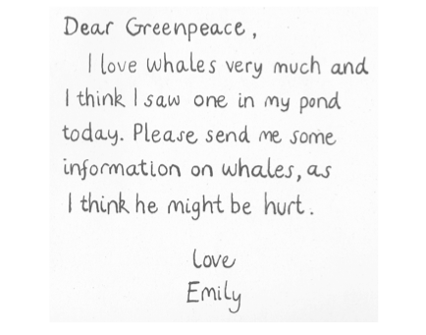

Four things to highlight in Emily’s letter

1. Highlight Dear.
Most letters begin with Dear. It always has a capital letter and is written on the top, left hand side of the paper.
2. Highlight the comma ( , ) after Greenpeace.
You always put a comma after the person’s name at the beginning of a letter.

3. Highlight the little space before I love (below Dear). This is an indentation. Often in letters the first line of a paragraph starts after a little gap like this.

4. Highlight Love and Emily.
These are the ‘sign off’ lines in the letter. Often in letters the sign off lines are in the middle of the paper, underneath the last line of the letter.
Why was the letter written?

- Carefully re-read each of The First Six Letters.
- Think about why each letter was sent.
- Cut out the jumbled-up description boxes on this page.
- Match the descriptions to the correct letters.
- One letter doesn't have a description. Write a description in the empty box saying why that letter was written
To ask whether the whale is lost | To ask if the whale could be a blue whale and what they eat
To explain where whales live | To give information about whales | To ask for information about whales

The First Six Letters
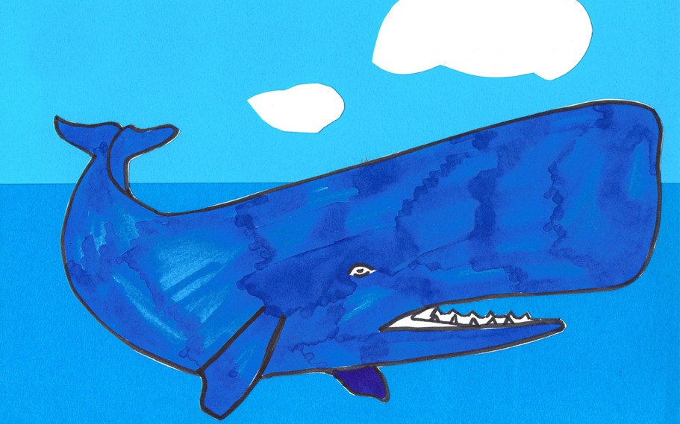

Dear Greenpeace,
I love whales very much and I think I saw one in my pond today. Please send me some information on whales, as I think he might be hurt.
Love
Emily

Dear Emily,
Here is some information about whales. I don’t think you’ll find it was a whale you saw, because whales don’t live in ponds, but in salt water.
Yours sincerely,
Greenpeace

Dear Greenpeace,
I am now putting salt in the pond every day before school and last night I saw my whale smile. I think he is feeling better. Do you think he might be lost?
Love
Emily

Dear Emily,
Please don’t put any more salt in the pond, I’m sure your parents won’t be pleased.
I’m afraid there can't be a whale in your pond, because whales don’t get lost, they always know where they are in the oceans.
Yours sincerely,
Greenpeace

Dear Greenpeace,
Tonight I am very happy because I saw my whale jump up and spurt lots of water. He looked blue.
Does this mean he might be a blue whale?
Love
Emily

P.S. What can I feed him?

Dear Emily,
Blue whales are blue and they eat tiny shrimp-like creatures that live in the sea. However, I must tell you that a blue whale is much too big to live in your pond.
Yours sincerely,
Greenpeace

P.S. Perhaps it is a blue goldfish?

