What to do
IMPORTANT Parent or Carer –
Please check that you are happy with any weblinks or use of the internet.

1. Counting practice

- Ask your child to start counting up to twenty slowly and clearly.
- Stop them by clapping once.
- They must whisper the number they would be saying next. Are they correct?
- Repeat this several times, stopping them at different points.
Extension
- Do as above but counting backwards from 20
- Or start at 40 and count forwards. Or start at 56… etc.

2. Working together

- Print the set of 12 numbered tiles or create these yourself by cutting up an old cereal packet and writing the numbers on.
- Make sure you can see the shape pictures.
- Follow the instructions to play Count the Sides.

Try this Fun-Time Extra
- Try to draw a circle. Here’s how…
Tie a piece of string to a pencil.
Pin one end of the string.
(You need a fat drawing pad.)
Use this to draw a circle.

Count the Sides Instructions

You need the numbered tiles and a pile of coloured counters each.

- Muddle up the tiles and spread them out face down.
- Take turns to turn over a tile.
6

- Read the number and then look at the shapes.
- You are looking for a shape with that number of sides.

- If you picked number 4, you have a choice of two shapes.
4
square or rectangle

- If you picked number 1, you must choose the circle.
1
circle

- Read the number and then look at the shapes.
- Put a counter of your colour beside that shape on the SHAPE PICTURES.

Your aim is to get at least one counter beside each shape on SHAPE PICTURES and three counters beside one of the shapes.

SHAPE PICTURES
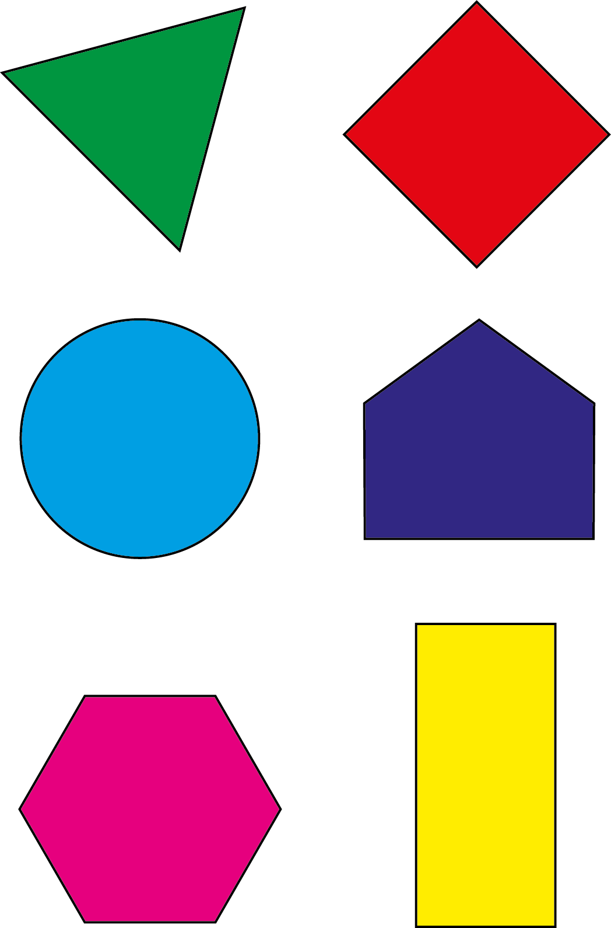

Number Tiles
