What to do
IMPORTANT Parent or Carer –
Please check that you are happy with any weblinks or use of the internet.

1. Counting practice

  - Write numbers 1 to 10 on large scraps of paper. Place them around the floor.
  - Your child chooses a number to stand on.
- They must do actions to match that number.  - For example, if they stood on 6, they may do six wing flaps!  - If they stood on 8, they might do eight bunny hops.  - Now they choose a different number to stand on.  - Then you have a turn. | 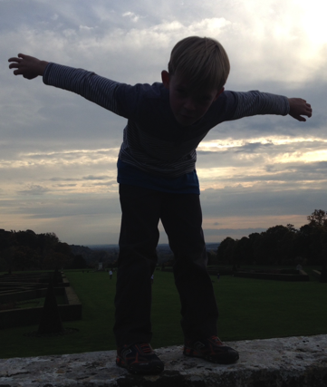

  - Keep taking turns and matching actions to numbers. Here are some good actions!
Hand claps
Head-over-heels
Bunny hops
Wing flaps
Legs apart, legs together jumps
Tongue outs

Extension
- They have to do one less action than the number they choose!

2. Working together

- Follow the instructions on Make a Shape as outlined below
  - You need thin card or two pieces of paper stuck together
  - You also need the templates printed out.

Try these Fun-Time Extras
- Choose an empty packet from the cupboard. Cut it carefully open and spread it out. Look at the flat shape that was folded to make this packet.
- Use a flat sheet of paper to make a cylinder.
Make a Shape

You need:
- thin card or fat paper
- template (print next page)
- crayons or felt-tips
- PVA glue

In advance
- If you haven’t got any thin card, you can stick two pieces of paper together in advance with a little flour and water paste. Just mix a couple of tablespoons of flour with very little water, and stir hard to make a thick glue. Paint this thinly over a piece of paper and place another piece on top. Allow to dry.
- Print the templates. Cut these out really carefully.

What to do
- Lay the template on the card.
- Carefully draw round it.
- Lift the template from the page.
- Cut round your drawing carefully
(A child may want an adult to do some of the cutting!)
- Before you fold the shape, decorate each face.
- Fold the shape to make a box.
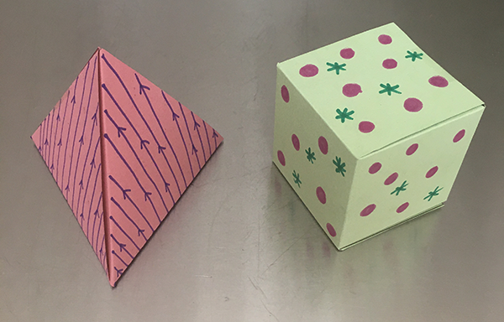

TEMPLATES
