What to do
IMPORTANT Parent or Carer –
Please check that you are happy with any weblinks or use of the internet.

1. Counting practice

- Show your child a 20p coin. Don’t name it.
- They have to count the number of pennies that coin is worth.
E.g. you show 20p, and they count: one, two, three, four… up to twenty. Then they stop.
- Do they count correctly? Do they stop at the right amount?
- Repeat this using a 5p, a 10p and, maybe, a 50p.
Extension
- Do as above but use a £1 coin.

2. Play it together

- You are going to make different amounts between 10p and 20p, and – if appropriate, between 20p and 30p.
  - Use the board ‘Five’s a Winner.
  - EITHER use 10ps and 1p, 2p, and 5p real coins, OR print the coin tiles provided and cut these out. OR you can make coin rubbings of your own and use these.
  - Print or make the amount cards.

Try these Fun-Time Extras

- Choose three coins. Lay them in order, smallest to largest. Say their names. Use mugs or plastic tumblers. Turn three tumblers over the coins so that each tumbler hides a coin.
- Move the tumblers around and then line them up again. Can your partner say which coin is under which tumbler?

Five’s a Winner Instructions

You need 10ps, 2ps, 5ps, 1ps – two of each of the first three and four 1ps.
You also need the Amounts Cards and some paper and pencils.

NB If your child is not yet ready for numbers above 20, only use the Amounts Cards between 10p and 20p

How to play
- Cut out the Amounts Cards and spread these out, face down.
- Set out your coins so you can both see them clearly.
- Take turns to play.
- Choose a card. Turn it over.
- Read the amount.
- Take one or two 10p coins according to whether the amount begins with ‘1’ or ‘2’.
- Take the correct number of 1p or other coins to complete the amount.
- Ask your partner to check. Have you made the matching amount correctly?
- If yes, draw a £1 coin on your paper.
- Now your partner has a turn.
- Choose another card and repeat. Can you make all the amounts?

The winner is the person who has drawn the most £1 coins on their page!

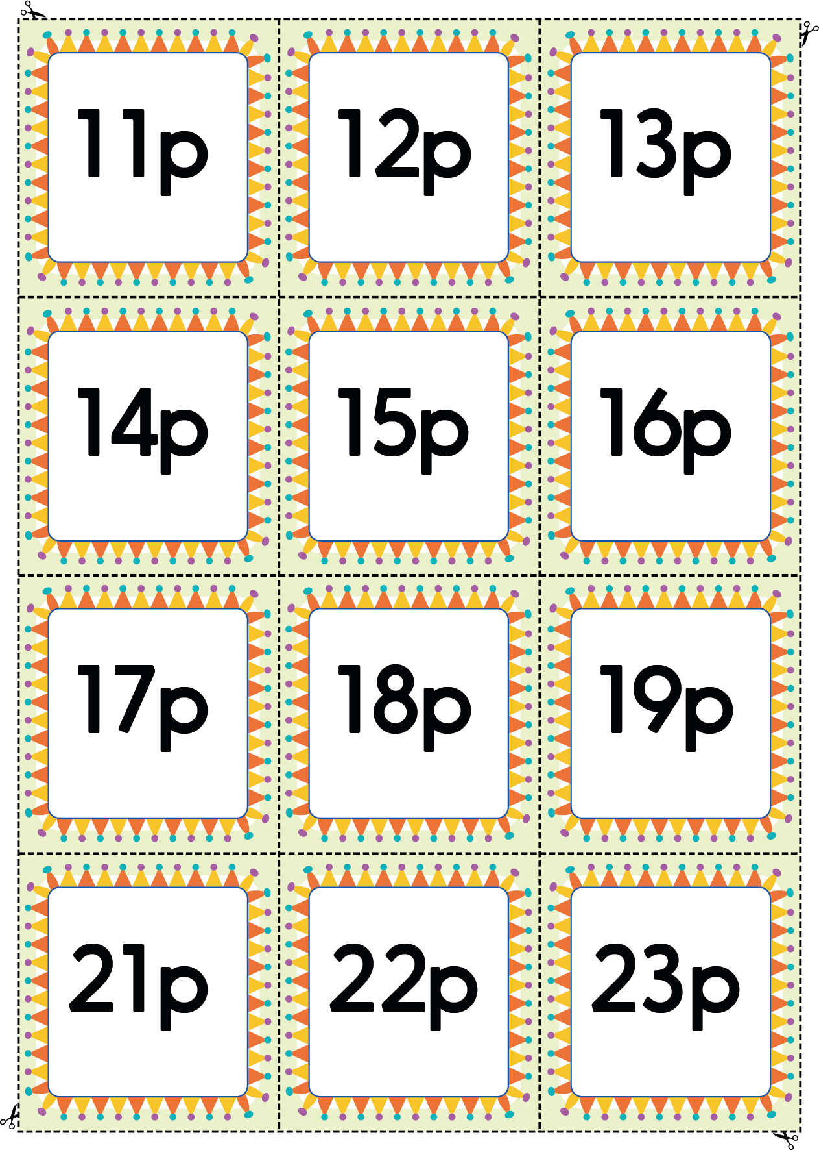
Amounts Cards
