What to do
IMPORTANT Parent or Carer –
Please check that you are happy with any weblinks or use of the internet.

1. Counting practice

- Ask your child to start counting up to twenty slowly and clearly.
- Stop them by clapping once.
- They must whisper the number they would be saying next. Are they correct?
- Repeat this several times, stopping them at different points.
Extension
- Do as above but counting backwards from 20
- Or start at 40 and count forwards. Or start at 56… etc.

2. Working together

- Read the instructions for Track the Coin below and then use the board to enable you to enjoy playing the game together.
  - You will need coins: 1p, 2p, 5p, 10p, 20p, 50p and £1 – one of each. You also need counters, which can be Lego™ pieces, dried beans, wooden beads or even something edible like raisins!
- Line the coins up in the middle of the track.
- Take turns to play the Track the Coin.

Try these Fun-Time Extras
- Choose two coins and hold them in your closed fists. Ask a child to choose a fist. Describe the coin to them. E.g. it is not round, it is quite big and heavy and it is silver.
- If they guess correctly, they eat a raisin!
- Now they do the same for you.

Track the Coin Instructions

You will need
Coins, one each of: 1p, 2p, 5p, 10p, 20p, 50p and £1
A coin for spinning (to have it land heads or tails)
Counters, which can be Lego™ pieces, dried beans, wooden beads or even something edible like raisins!

How to play
- Line up the coins in the middle of the track.
- Take a counter each and place it on the start.
- Take turns to play.
- Use a different coin and spin it.
- If it lands heads, move 2 spaces.
- If it lands tails, move one space.
- If you land on an amount, read it aloud. Then point at the coin that matches it.
- If you are correct, you may stay on that space and take a counter.
- If you are incorrect, you must move back to where you started your turn.
- Take turns to play like this.
- If you land on a robber, he steals one of your counters!
- When you both reach the start again, count your counters.
- The winner has the most counters.

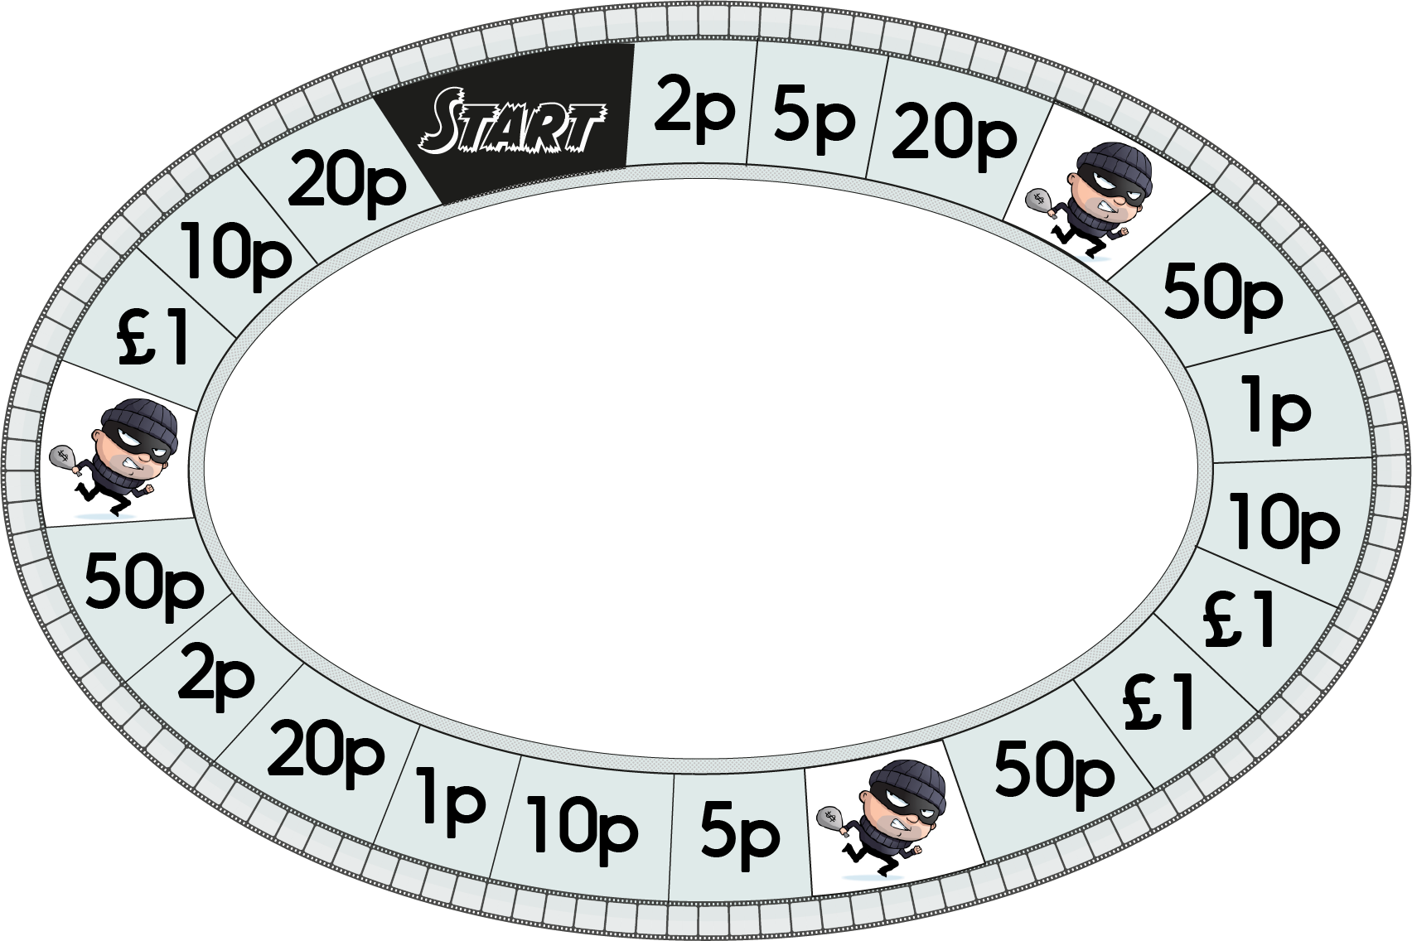
Track the Coin

