What to do
IMPORTANT Parent or Carer –
Please check that you are happy with any weblinks or use of the internet.

1. Counting practice
  - You need two pairs of gloves.
  - Count the fingers on the glove hand. There are five fingers.
  - Roll each glove into a ball.
  - We shall throw the gloves onto a chair, counting in 5s as we do this.
  - Five, ten, fifteen, twenty.
  - Now unroll the gloves and count all the fingers. Are there twenty?
  - Repeat several times.

Extension
- Throw one glove back and forth between you, counting in fives each time you throw it. Five, ten, fifteen, twenty, twenty-five, thirty, thirty-five, etc.
- How far can you continue the count?

2. Working together

Use a 3 x 3 grid to create a pattern of counters: Red, yellow, blue.
- You need nine small counters, bricks, painted shells, beads, or other small coloured objects - three each of three colours. (They do not have to be red, yellow and blue. Any three colours will do!
- Follow the instructions in Red, Yellow, Blue below.

Try these Fun-Time Extras

- Play noughts and crosses on a grid.
- Play against a machine! Here … https://www.google.com/search?client=safari&rls=en&q=noughts+and+crosses+game&ie=UTF-8&oe=UTF-8

Red, Yellow, Blue

You will need: nine small objects, three each of three colours. These can be Lego™ bricks, counters, beads, painted shells, or any other small coloured objects. The colours do not have to be red, yellow and blue. They can be any three different colours!

What to do

- You have to place all nine counters on the grid.
- You must follow the rules!
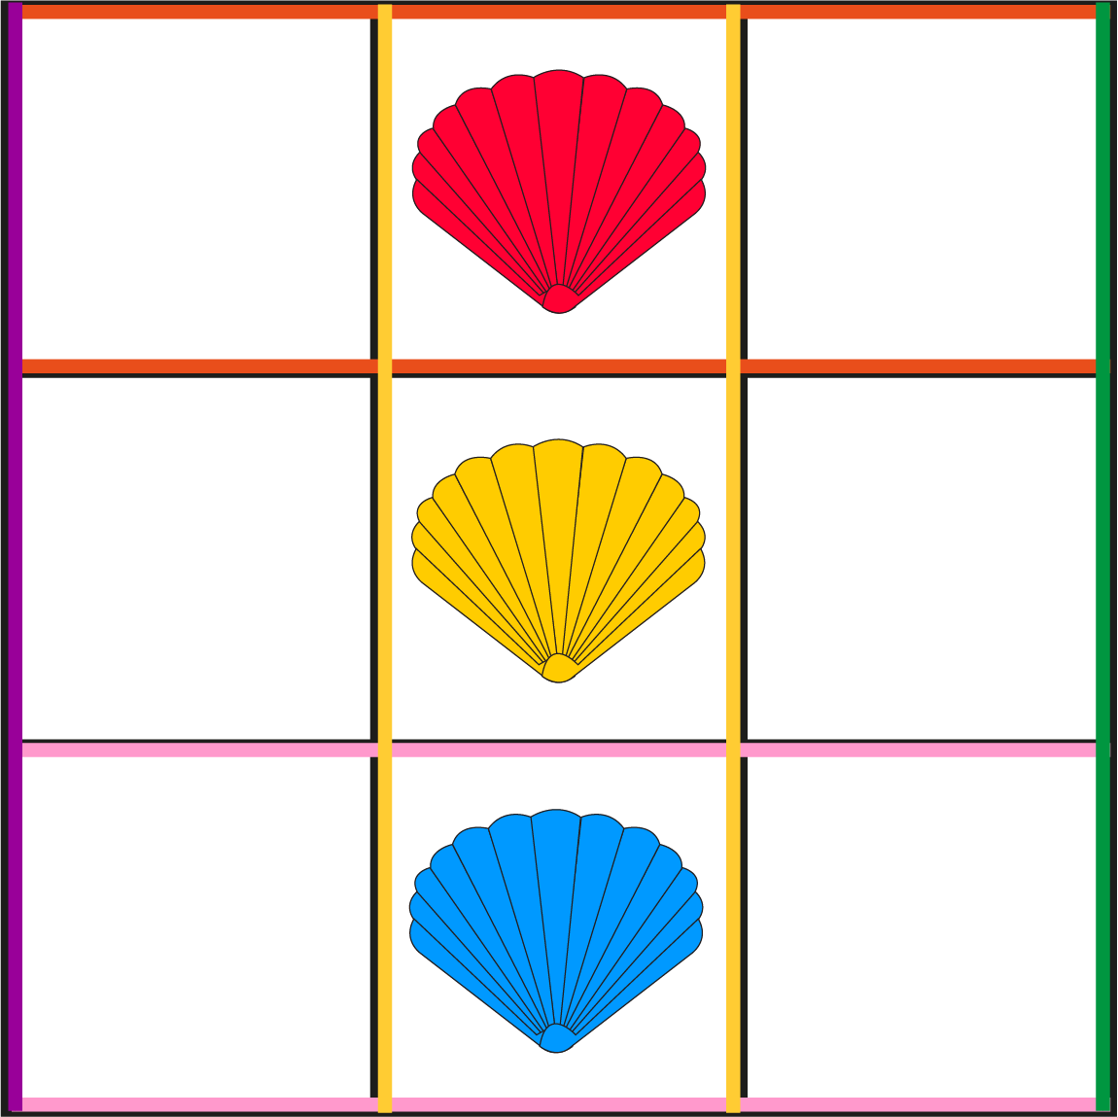 | RULES  - There must be exactly one yellow counter in every row and every column.  - There must be exactly one blue counter in every row and every column.  - There must be exactly one red counter in every row and every column.
HINT
Try to get the middle column in place first.
Then get the middle row in place.

- When you think you have done this, find someone else to check!
- Is there another, different way, of doing this?

