What to do
IMPORTANT Parent or Carer –
Please check that you are happy with any weblinks or use of the internet.

1. Counting practice
  - Count to 100 in unison together.
  - Match the count with fingers, standing
up one digit for every number spoken.
  - Every time you reach a multiple of 10,
i.e. 10, 20, 30, 40, etc. clap your hands
and say, “Cuppa tea!”
- Continue like this all the way to 100 – cuppa tea!

2. Working together

- We call the multiples of ten the ‘cuppa-tea’ numbers because, from 10 onwards, they end ---ty. (twenty, thirty… etc.)
- Complete the working activity on Cuppa Tea
  - You need good colouring pens or crayons.
  - Follow the instructions on below.

Try these Fun-Time Extras

- Count in tens with others on YouTube
https://www.youtube.com/watch?v=Ftati8iGQcs
- Draw a rocket and write the multiples of ten in a line up to the moon!

Cuppa Tea

Instructions

You need: Good colouring pens or crayons.

- The multiples of 10, numbers ending in a zero, are special.
- We need to recognise them and distinguish them from the teen numbers (thirteen, fourteen, fifteen… etc.). These numbers end ---teen.
- The multiples of 10 from 20 to 90 all end ---ty, so we call them the ‘cuppa tea’ numbers to stress the last syllable ----ty.

What to do
- Count along the grid. Get to the end of the first row and start on the second row.

- Every time you come to a ‘cuppa tea’ number, colour it.
- Also colour the cup of tea in the row at the bottom.
- Write the multiple of ten below the cup. The first one is done for you.
- Continue until you reach the end of the grid.
- Count along the cups, saying the name of each number clearly.

Scroll down for grid and cups.

Cuppa Tea Numbers

1 | 2 | 3 | 4 | 6 | 7 | 8 | 9 | 10 | 11 | 12
13 | 14 | 15 | 16 | 18 | 19 | 20 | 21 | 22 | 23 | 24
25 | 26 | 27 | 28 | 30 | 31 | 32 | 33 | 34 | 35 | 36
37 | 38 | 39 | 40 | 42 | 43 | 44 | 45 | 46 | 47 | 48
49 | 50 | 51 | 52 | 54 | 55 | 56 | 57 | 58 | 59 | 60
61 | 62 | 63 | 64 | 66 | 67 | 68 | 69 | 70 | 71 | 72
73 | 74 | 75 | 76 | 78 | 79 | 80 | 81 | 82 | 83 | 84
85 | 86 | 87 | 88 | 90 | 91 | 92 | 93 | 94 | 95 | 96
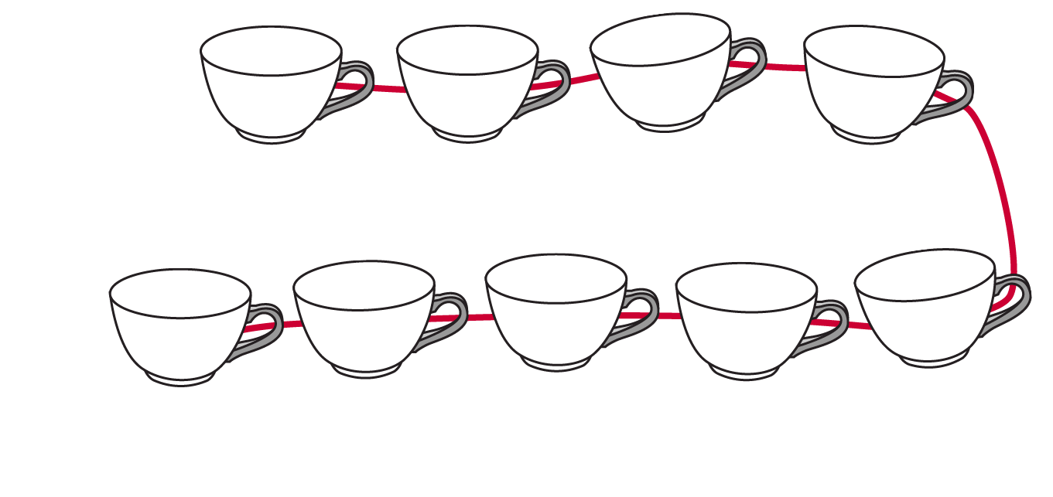

10

