What to do
Writing
IMPORTANT Parent or Carer –
Please check that you are happy with any weblinks or use of the internet.

Our focus today is writing.

1. Discuss a book.

Read Superheroes – All sorts up to the ‘BUT’. Can your child predict/remember how the book ends? Then read the final page together.

2. Write about an everyday superpower.

  - Remind your child that the superheroes in the book are not the type that have the super strength to lift up a building or who can put out a forest fire with icy blasts from their fingertips. They are everyday superheroes. What sort of superhero might your child be? Talk about their ideas, encouraging them to think about everyday powers (being kind/helpful, thinking up good games, etc.) and how these are helpful.
  - Build sentences verbally about the superpowers, e.g. I am gentle when I play with my baby brother. or I brush my dog so she does not get matted.
  - When you have built a sentence verbally, write each word, sounding out the letters, together on My Superpower! below.
  - For more confident writers, try making the sentence a bit longer using ‘when’ ‘because’ or ‘so’.

NB. Getting young children to write is not easy! See Guidance and handwriting groups below.

Try these Fun-Time Extras

- Have fun, creating a superhero photo (see below). You can write a story together about the picture you make.
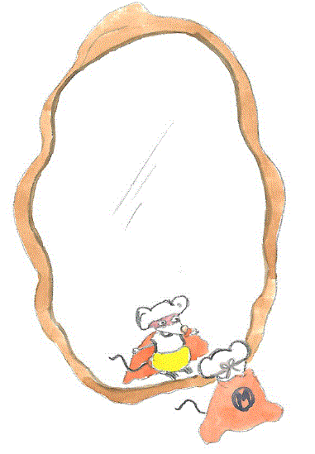
My Superpower!
Writing Frame, B

when because so

Superhero Photos

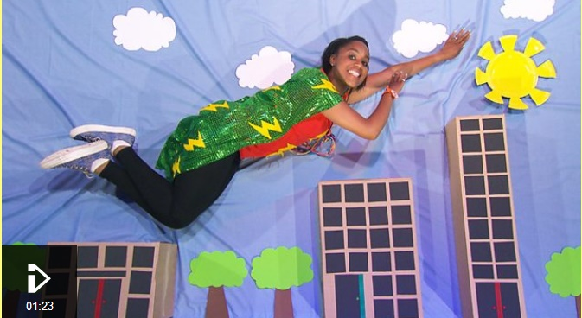

Resources:

- Blue sheet, carpet or fabric
- White paper, card or recycling materials to make clouds, buildings, trees, and the sun
- Any superhero costumes, bought or made
- Camera or camera phone

Instructions:

- Play the clip below to give you ideas.

- Set up a superhero scene together and, when it is ready, your child lies on the blue fabric, as if they are flying.

- Take a photo from above to create the illusion of them flying over the city.

https://www.bbc.co.uk/cbeebies/makes/the-lets-go-club-superhero-quick-trick

Guidance for writing – some dos and don’ts

- DO focus on letter formation. See sheet below. It’s really important that children get into the habit of writing letters correctly – this is not about how the finished letter looks, it’s all about how they write it – what direction they move the pencil or pen. Bad habits are almost impossible to break – if they form letters wrongly, the finished letter may look good BUT in the long run, they are much less likely to be able to write fluently.

- DON’T write a word or a line for them to copy. If they can’t remember how to write a letter, demonstrate, forming it correctly, so that they can imitate you.

- DO give loads of praise. Writing is so hard, and children get discouraged easily. It may be that they have just written one or two words, but if you praise them, it may be four words next time!

- DON’T do ‘dotty’ letters for them to trace. It is much better for children to form their own letters. We are teaching them to write not trace!

- DO write for them sometimes. It is important that young children can express their ideas in written form, and sometimes it is really good to write down what they say so that their ideas are expressed in writing on the page. Sometimes you can take turns to scribe. You write a bit, then they write a bit.

