**What to do today**

*IMPORTANT Parent or Carer – Read this page with your child and check that you are happy with what they have to do and any weblinks or use of internet.*

**1. Read a poem**

* Read *Dancing Disk in the Sky*.Read the poem twice – once in your head and once out loud.
* What do you like about this poem? Is there anything that you dislike? What would you ask the poet about this poem?

**2. Remind yourself about metaphors**

* Use the *Revision Card* to remind yourself about metaphors.
* Complete *Metaphor Ideas*.Try to think of more than one metaphor for each of the objects. Try to make the object do something unusual too, like Hibaq Osman does.
* Choose your three favourite metaphors. Why are you pleased with these?

Well done. Share your three favourite metaphors with somebody else. Can they come up with any themselves?

**3. Write your own poem**

* Read *Writing Ideas*.
* Try writing your own poem about a comforting object, with metaphors and with a similar start to Dancing Disk in the Sky.

**Try these Fun-Time Extras**

* Practise reading your poem and Dancing Disk in the Sky out loud. Read *Top Tips for Reading a Poem Aloud* to help you.
* Record and share your readings with somebody else.

**Dancing Disk in the Sky**

**by Hibaq Osman**

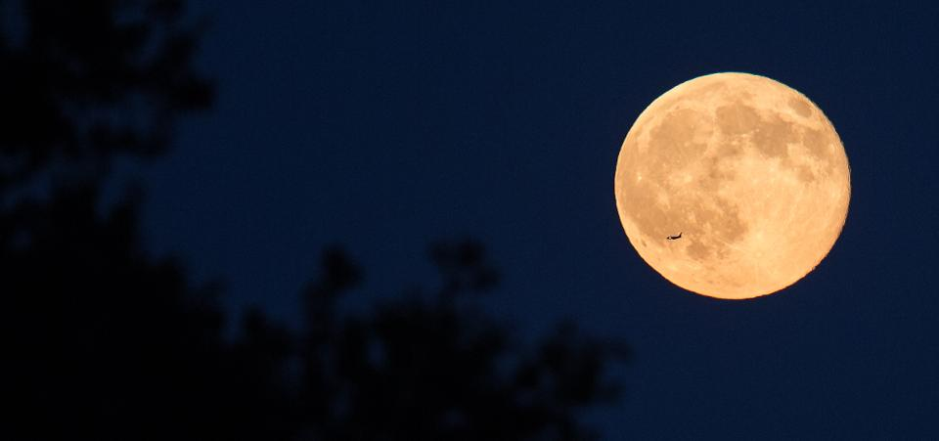

If you asked what The Moon is

people would tell you

in their proudest voices:

The Moon is a circle in the sky

waiting for your greeting

you should say hello

in any of the languages you know

or maybe say them all

just in case!

The Moon is a reflection in the water

that jiggles with the wind

It is a silver plate dancing with you

by the river bank

It has many friends

who speak to it at night

and you, with your small voice,

no need to worry

The Moon is a very good listener!

Look up and see

If you peek behind your curtains

The Moon will dance for us

so nobody feels lonely.

**Revision Card - Metaphors**

A metaphor is a comparison in which a place, person or thing is described as if it was another entirely different but similar thing.

*Ben is a greedy pig*.

Ben is not actually a pig - he’s a boy - but the comparison to a greedy pig is very effective in telling us that Ben obviously tucks into his food like a farm animal at meal times!

Metaphors very often contain the verbs is or are, was or were.

*The stars were jewels in the night sky*.

*Life is a journey*.

*The children in my class are a dream*.

*He was a big baby, moaning about the weather like that*.

Metaphors are different to similes

Similes describe people, places, situations or things by comparing them to something that they are like.

Similes either contain the word like or the phrase as…as…

*Ben ate like a snuffling pig.*

*Ben was as greedy as a pig.*

*In* ***Dancing Disk in the Sky****, Hibaq Osman uses two metaphors to describe the moon.*

a circle in the sky waiting for your greeting

a silver plate dancing with you by the river bank

Hibaq Osman chooses quite ordinary metaphors – (The moon is a circular shape and it does look like a silver plate) BUT she then makes the moon do unusual things. It waits for your greeting and it dances with you by the river bank!

**Metaphor Ideas**

*Choose metaphors for each of these objects. You could make the object do something unusual too – just like Hibaq Osman does. (Think ‘What is it like? What could it be doing?’)*

|  |  |
| --- | --- |
| **The Moon** | * **A circle in the sky waiting for your greeting** * **A silver plate dancing with you by the river bank** |
| **The Sun** |  |
| **The Stars** |  |
| **The Sea** |  |
| **The Sky** |  |
| **The Wind** |  |
| **The Rain** |  |
|  |  |
|  |  |

**Writing Ideas**

Hibaq Osman wrote **Dancing Disk in the Sky**, thinking about the many children and adults around the globe who need a friend and thinking about what a calming presence the moon can be in those times.

The poem has a very particular start:

*If you asked what The Moon is*

*people would tell you*

*in their proudest voices.*

*Can you change this start and write a new poem?*

Think of another natural object that could comfort people. It could be the sun, the rain, the wind, the sea, a tree or plant or animal.

Change the start of the poem (think what sort of voices people would use) and then write two or three descriptions of your object.

* What is it like?
* What could you imagine it doing for people?
* What should they do in response?

**Write your poem**

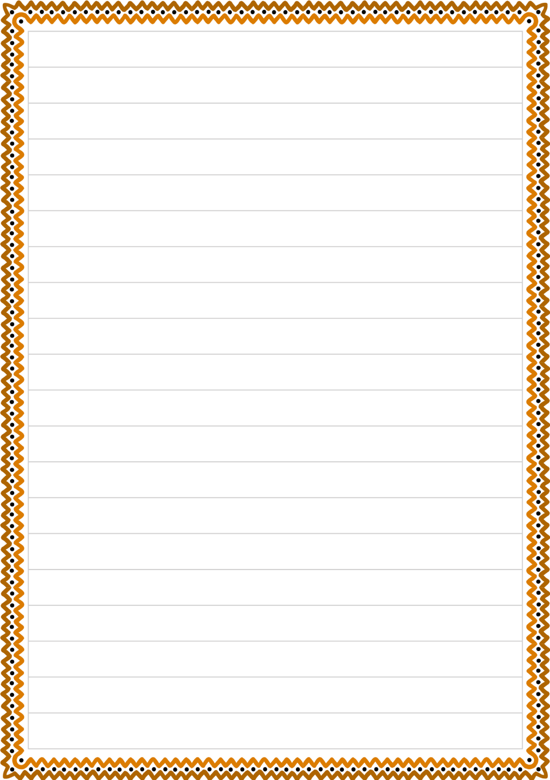

**Top tips for reading a poem aloud**

* Work on the **tricky words.** Find out what they mean and how they are said. Practise saying them.
* Look for the **full stops.** Make sentences flow to the full stop, even when there’s a new line.
* **Slow down.** Speak slowly when you’re reading a poem, so that others can hear the words.
* **Project your voice**. Imagine someone on the other side of the room and speak to them.
* **Practise**. Read and read and read your poem, so that you get better each time.

