What to do today
IMPORTANT Parent or Carer – Read this page with your child and check that you are happy with what they have to do and any weblinks or use of internet.

1. Read a poem
- Read How to cut a pomegranate. Read the poem twice – once in your head and once out loud.
- Underline any vocabulary that you’re not sure about. Find out meanings. The Visual Dictionary might help you.
- Listen to the poem being read. Does it sound as you expected?
https://www.youtube.com/watch?v=zQhF_5yssUU&t=22s
- What do you like about the poem? Is there anything you dislike? Why do you think the poet wrote this poem?

2. Highlight descriptions
- Read through the poem and highlight descriptions of the pomegranate. You might find more than 10 descriptions.
- Check the descriptions at the end of this pack. Which are your favourite three? Why?

3. Write your own descriptions.
- Read Cut-Fruit – Writing Ideas. Write your own descriptions about cut fruit. Try to arrange your ideas to make a poem.

Try these Fun-Time Extras
- Share your poem with somebody else. You could record it and send it to them.
- Ask someone who is older than you to teach you a skill that is important to them. It doesn’t have to be about cutting fruit! Listen carefully to them, take notes and practise the skill.

How to Cut a Pomegranate
by Imtiaz Dharker

‘Never,’ said my father,  ‘Never cut a pomegranate  through the heart. It will weep blood.  Treat it delicately, with respect.  Just slit the upper skin across four quarters.  This is a magic fruit,  so when you split it open, be prepared  for the jewels of the world to tumble out,  more precious than garnets,  more lustrous than rubies,  lit as if from inside. | 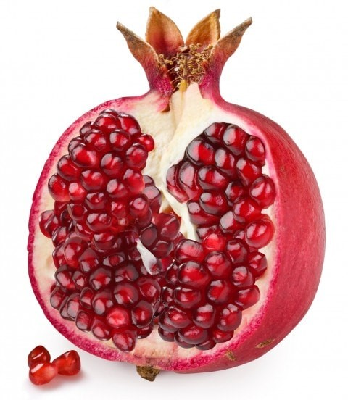
Each jewel contains a living seed.
Separate one crystal.
Hold it up to catch the light.
Inside is a whole universe.
No common jewel can give you this.’
Afterwards, I tried to make necklaces
of pomegranate seeds.
The juice spurted out, bright crimson,
and stained my fingers, then my mouth.
I didn’t mind. The juice tasted of gardens
I had never seen, voluptuous
with myrtle, lemon, jasmine,
and alive with parrots’ wings.
The pomegranate reminded me
that somewhere I had another home.

Visual Dictionary

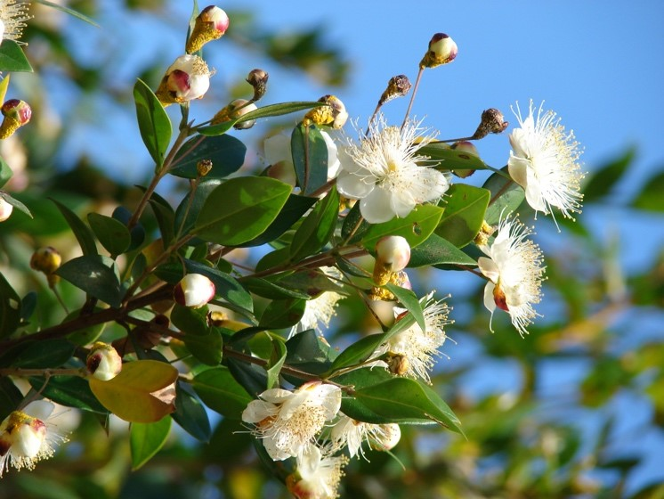 | 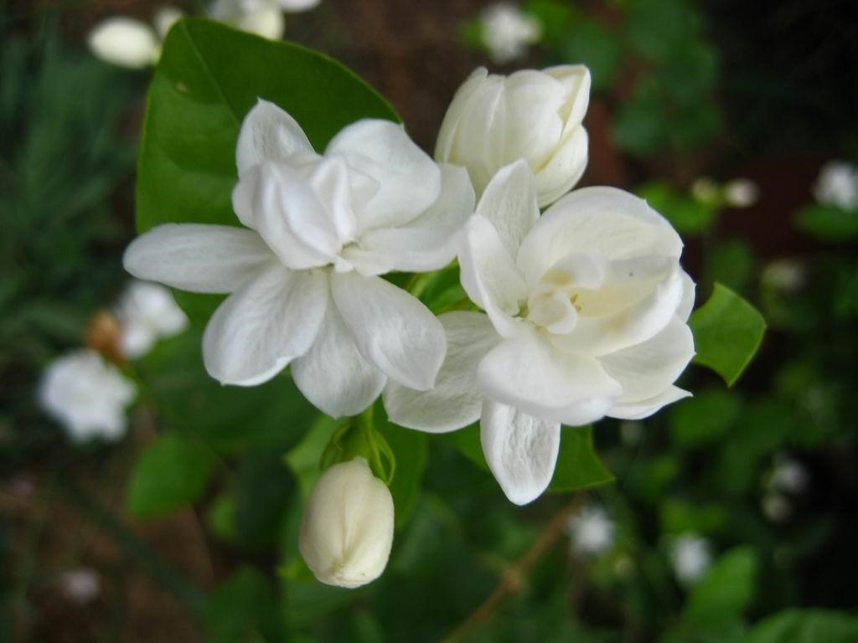
myrtle | jasmine
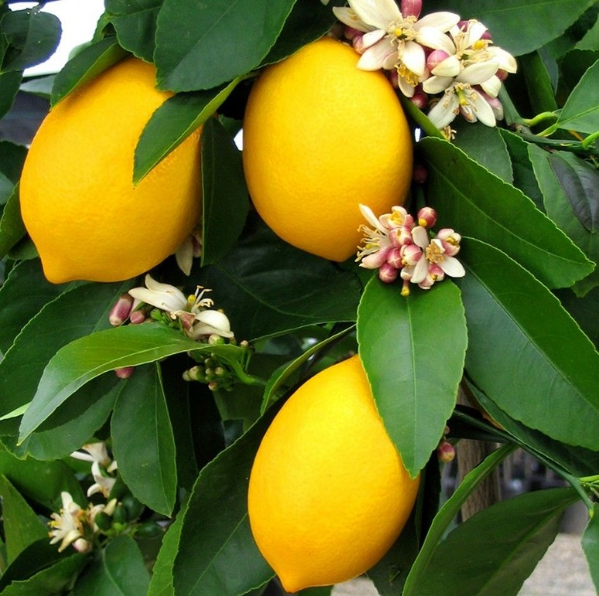 | 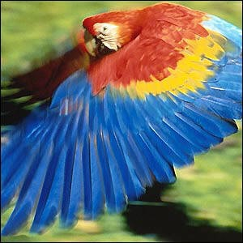
lemon | parrot’s wings

Cut fruit – Writing ideas

How to Cut a Pomegranate is a poem full of descriptions about the fruit. These are some of the phrases it uses:

- it will weep blood
- magic fruit
- jewels of the world tumble out
- more precious than garnets
- more lustrous than rubies
- lit as if from inside
- juice spurted out
- bright crimson
- tasted of gardens I had never seen
- voluptuous with myrtle, lemon and jasmine
- alive with parrot’s wings

Can you write new phrases about other fruit?

Look closely at actual fruit or Fruit Pictures.

Write words and phrases that describe and compare.

Can you organise your lines so that they make a poem?

Fruit Pictures
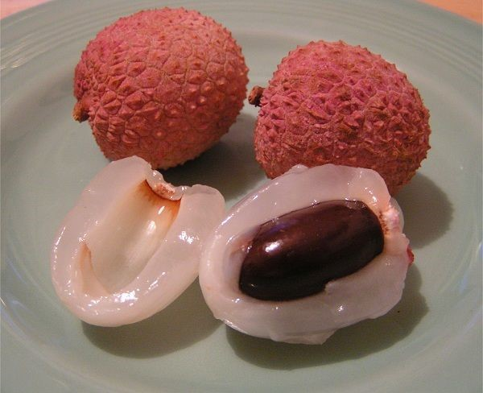  Lychee | 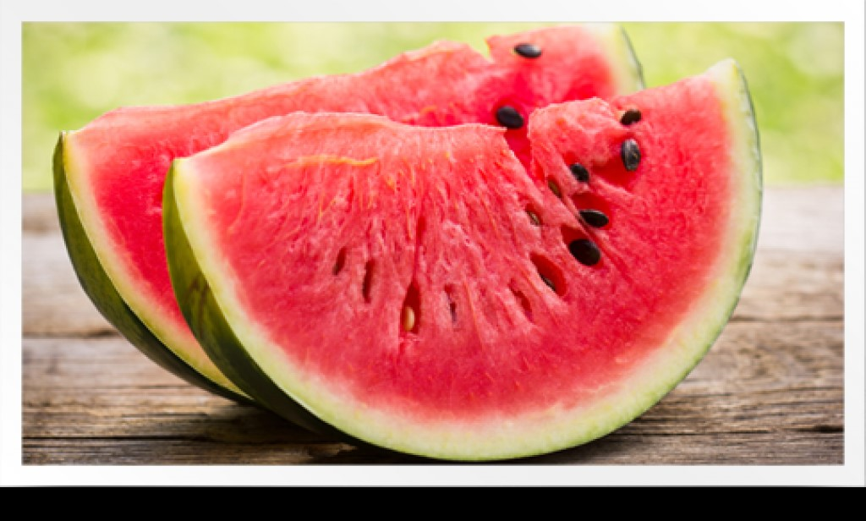  Watermelon
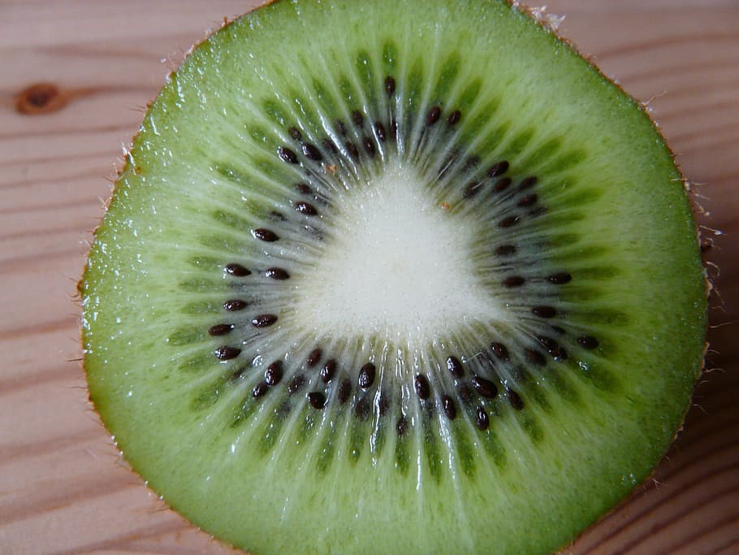  Kiwi | 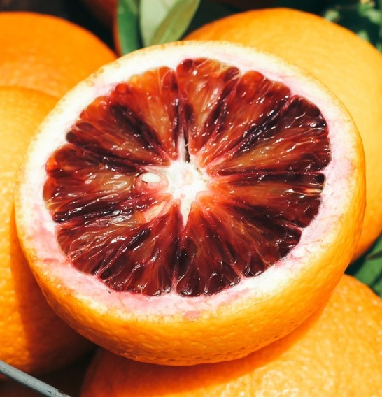  Blood Orange

Fruit Poem

Pomegranate Descriptions

- it will weep blood
- magic fruit
- jewels of the world tumble out
- more precious than garnets
- more lustrous than rubies
- lit as if from inside
- juice spurted out
- bright crimson
- tasted of gardens I had never seen
- voluptuous with myrtle, lemon and jasmine
- alive with parrot’s wings

