What to do today
IMPORTANT Parent or Carer – Read this page with your child and check that you are happy with what they have to do and any weblinks or use of internet.

1. Watch and narrate the film
- Watch The Piano. This time, watch with the sound down and try reading your version of the story (from Day 2) as the film plays. Can you make your story fit the action of the film? https://vimeo.com/200936986
2. Remind yourself about writing in sentences
- Use the Revision Card to remind yourself about writing in sentences.
- Imagine what else could have happened in the man’s life. Write 5-10 clear sentences about your ideas. Include some sentences with subordinate clauses.

3. Write about your own life
- You’re not an old man! But you will have memories. Which five or six memories would you choose as most important?
- Use words and pictures to record these on the Story Board.
- Choose one or two and write about them. Describe the memories and why they are important.

Try the Fun-Time Extras
- Tell someone you trust about your important memories. Are they surprised about what you have chosen?
- Interview someone in your family about their life. What 5 or 6 memories would they choose as most important in their life?
- Make an illustration to match The Seven Ages of Man by William Shakespeare. Can you show each of the seven ages?

Revision Card - Sentences

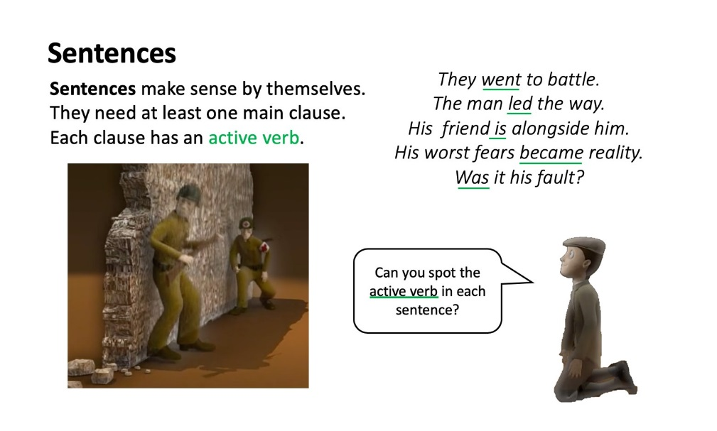
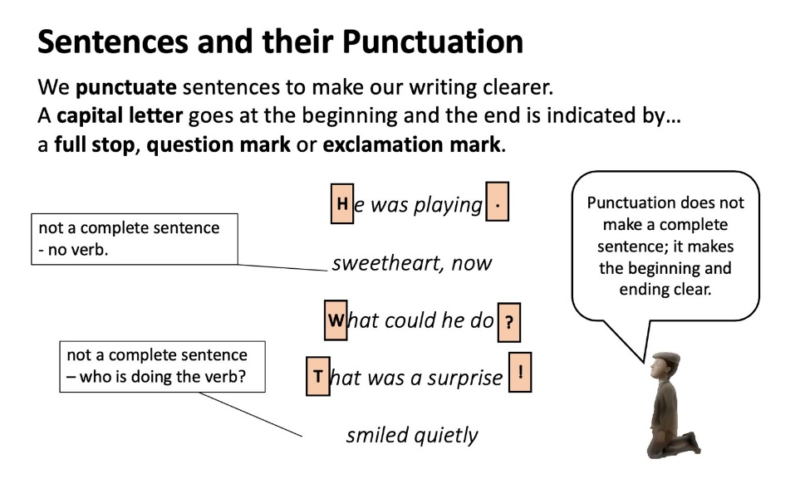
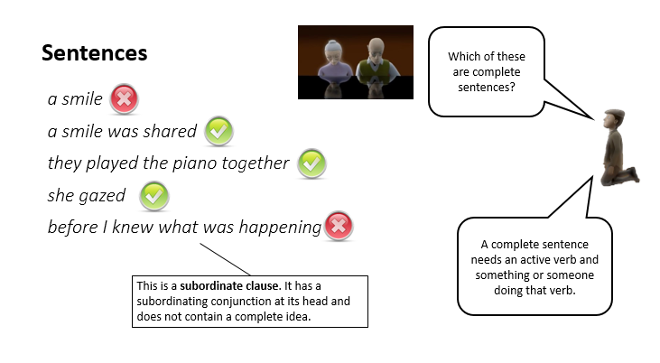

Other Events

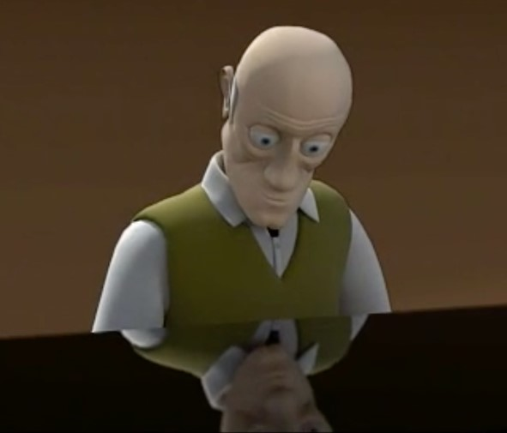

What else might have happened in the man’s life. Write your ideas as full sentences. Include some sentences with subordinate clauses.
Story Board

1. | 2. | 3.
4. | 5. | 6.

Your important memories

The Seven Ages of Man by William Shakespeare

https://www.youtube.com/watch?v=61z2fPAOr8g

All the world's a stage,
And all the men and women merely players,
They have their exits and entrances,
And one man in his time plays many parts,
His acts being seven ages. At first the infant,
Mewling and puking in the nurse's arms.
Then, the whining schoolboy with his satchel
And shining morning face, creeping like snail
Unwillingly to school. And then the lover,
Sighing like furnace, with a woeful ballad
Made to his mistress' eyebrow.
Then a soldier, Full of strange oaths, and bearded like the pard,
Jealous in honour, sudden, and quick in quarrel,
Seeking the bubble reputation
Even in the cannon's mouth. And then the justice
In fair round belly, with good capon lin'd,
With eyes severe, and beard of formal cut,
Full of wise saws, and modern instances,
And so he plays his part. The sixth age shifts
Into the lean and slipper'd pantaloon,
With spectacles on nose, and pouch on side,
His youthful hose well sav'd, a world too wide,
For his shrunk shank, and his big manly voice,
Turning again towards childish treble, pipes
And whistles in his sound. Last scene of all,
That ends this strange eventful history,
Is second childishness and mere oblivion,
Sans teeth, sans eyes, sans taste, sans everything.

