What to do today
IMPORTANT Parent or Carer – Read this page with your child and check that you are happy with what they have to do and any weblinks or use of internet.

1. Watch the film again
- Watch The Piano for a second time. What do you notice when you watch it this time? https://vimeo.com/200936986
- Make a list of the Scene Order. Use short notes to describe each scene.

2. Remind yourself about sentence punctuation.
- Use the PowerPoint on Sentence Punctuation or, if this is not possible, use the Revision Card to remind yourself.
- Read Sentence Punctuation Missing. Can you add capital letters and end-of-sentence punctuation to this piece of writing?

3. Now for some writing
- Write your own telling of the story of The Piano. Use your Scene Order list to help you. You could use the Story Board to plan with words and pictures before you begin.

Well done. Read your writing to a grown-up. You can check your answers to Sentence Punctuation Missing at the end of this pack.

Try the Fun-Time Extra
- Record your version of the story and share it with somebody else. Explain to them about the original film.
- Watch the performance of The Seven Ages of Man again. Now pick part of the poem to learn by heart or recite to impress a grown-up! https://www.youtube.com/watch?v=61z2fPAOr8g

Scene Order

1.

2.

3.

4.

5.

Revision Card - Sentences

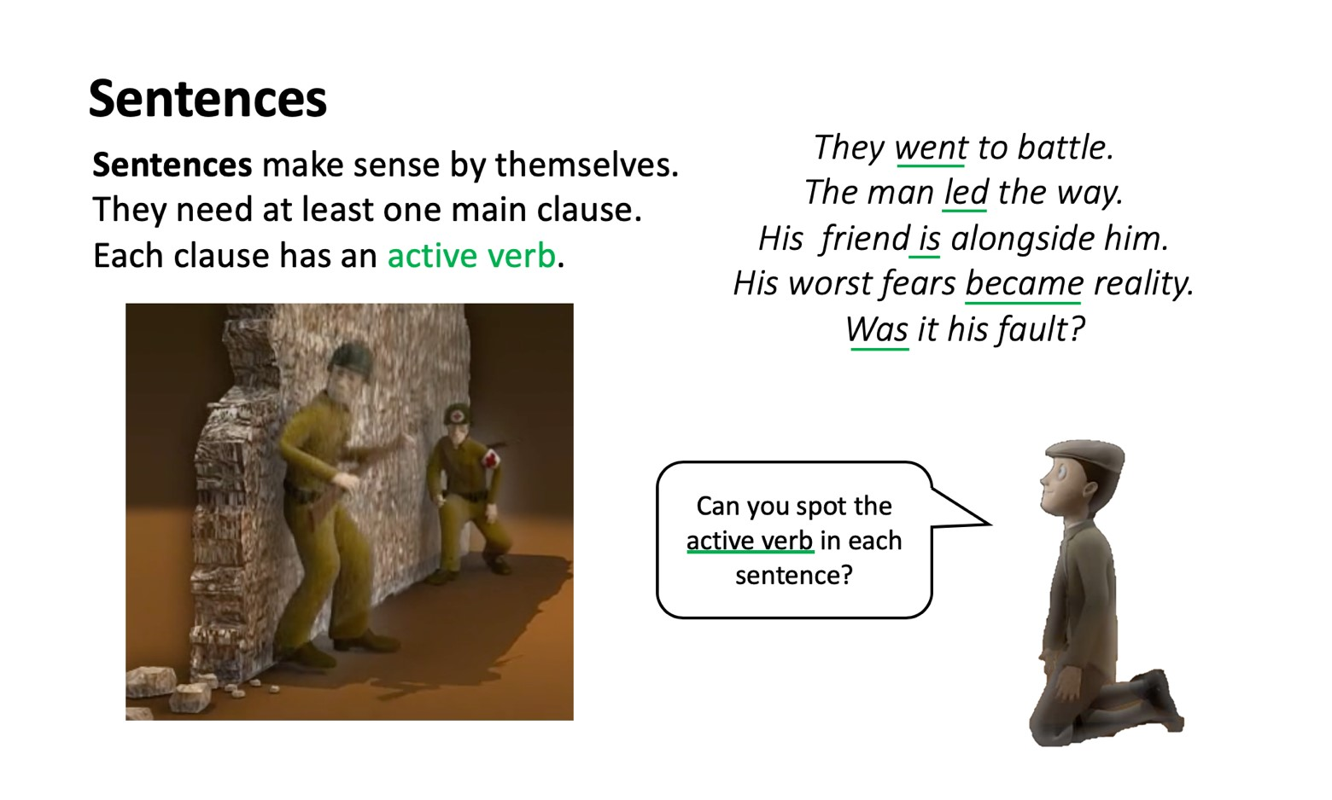
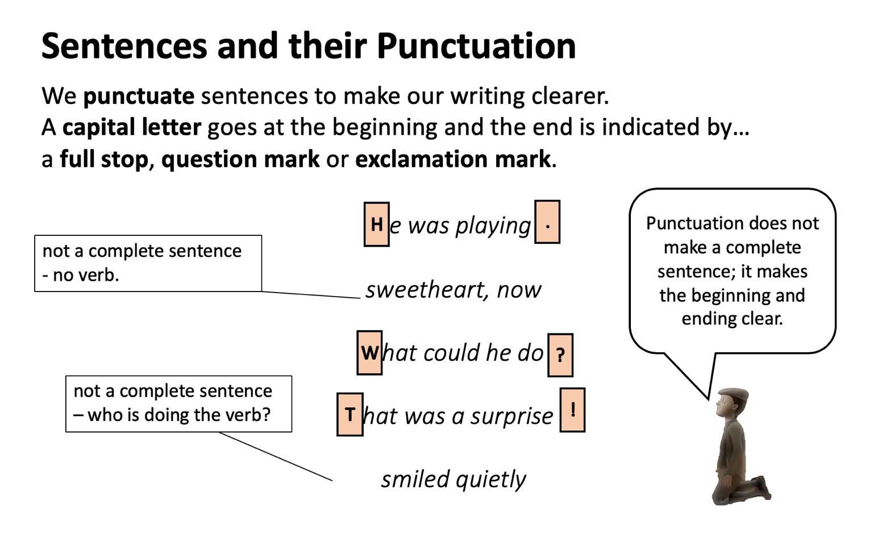

Sentence Punctuation Missing

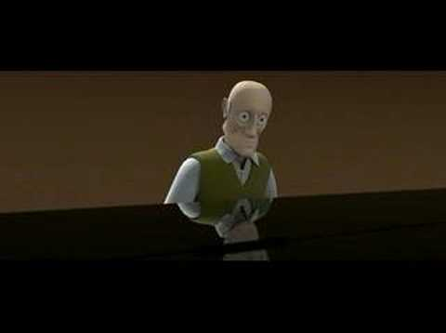

with tear filled eyes, the old man began to glide his gnarled fingers across the piano, which held many memories every time he touched a single ivory key, the memory grew stronger

as the melody continued to grow, a ghostly hand came into view his wife had presented herself with a heart-warming duet the bond was like no other.

however, after one kiss, she disappeared as the spirit of his wife faded, and the melody too, the smell of smoke filled his lungs all of a sudden, his comrade made a move almost instantly, he was hit continuing to cradle him in his arms, he knew he wasn't going to wake again although guilty, he still felt honoured to be a part of the war

the delight of his birthday now was shining in his youthful eyes he was overwhelmed with excitement crouching low, he opened the baby blue box and began to trot around on the wooden hobby horse

as the dull colours of grey faded to blue, his grandson, joined the beautifully played tune the young boy contributed to the melody and played the final note they smiled at each other happily, with peace and tranquillity surrounding them

By Layla
From https://www.cjsdorset.org/the-piano/
Story Board

1. | 2. | 3.
4. | 5. | 6.

The Piano

Write your version of the story here.

The Seven Ages of Man by William Shakespeare.

https://www.youtube.com/watch?v=61z2fPAOr8g

All the world's a stage,
And all the men and women merely players,
They have their exits and entrances,
And one man in his time plays many parts,
His acts being seven ages. At first the infant,
Mewling and puking in the nurse's arms.
Then, the whining schoolboy with his satchel
And shining morning face, creeping like snail
Unwillingly to school. And then the lover,
Sighing like furnace, with a woeful ballad
Made to his mistress' eyebrow.
Then a soldier, Full of strange oaths, and bearded like the pard,
Jealous in honour, sudden, and quick in quarrel,
Seeking the bubble reputation
Even in the cannon's mouth. And then the justice
In fair round belly, with good capon lin'd,
With eyes severe, and beard of formal cut,
Full of wise saws, and modern instances,
And so he plays his part. The sixth age shifts
Into the lean and slipper'd pantaloon,
With spectacles on nose, and pouch on side,
His youthful hose well sav'd, a world too wide,
For his shrunk shank, and his big manly voice,
Turning again towards childish treble, pipes
And whistles in his sound. Last scene of all,
That ends this strange eventful history,
Is second childishness and mere oblivion,
Sans teeth, sans eyes, sans taste, sans everything.

The Piano by Layla R - with sentence punctuation

With tear filled eyes, the old man began to glide his gnarled fingers across the piano, which held many memories. Every time he touched a single ivory key, the memory grew stronger.

As the melody continued to grow, a ghostly hand came into view. His wife had presented herself with a heart-warming duet. The bond was like no other.

However, after one kiss, she disappeared. As the spirit of his wife faded, and the melody too, the smell of smoke filled his lungs. All of a sudden, his comrade made a move. Almost instantly, he was hit. Continuing to cradle him in his arms, he knew he wasn't going to wake again. Although guilty, he still felt honoured to be a part of the war.

The delight of his birthday now was shining in his youthful eyes. He was overwhelmed with excitement. Crouching low, he opened the baby blue box and began to trot around on the wooden hobby horse.

As the dull colours of grey faded to blue, his grandson, joined the beautifully played tune. The young boy contributed to the melody and played the final note. They smiled at each other happily, with peace and tranquillity surrounding them.

From https://www.cjsdorset.org/the-piano/

