What to do today
IMPORTANT Parent or Carer – Read this page with your child and check that you are happy with what they have to do and any weblinks or use of internet.

1. Watch a short film
- First listen to this music – it’s only 2 minutes long. As you listen, imagine for what sort of film you think it would be a good sound track. What images come into your mind?
https://www.youtube.com/watch?v=NvryolGa19A
- Now watch a film made to match the music. If possible, watch it with a grown-up. https://vimeo.com/200936986
- Did the film match your expectations? How was it different?

2. Think about the film
- Read the Film Questions. Talk to the grown-up and think about your answers to each question.
- Write some thoughts in clear sentences.

3. Write captions
- Look closely at the Film Stills.
- Write captions for each one – 2/3 sentences that will explain what is happening and why.

Well done. Show your captions to a grown-up. Explain to them about the story of the film.

Try these Fun-Time Extras
- Watch a performance of a poem on a similar theme. It’s a Shakespeare poem and the language isn’t modern. Watch closely and follow the words. Can you work out what it’s about?
https://www.youtube.com/watch?v=61z2fPAOr8g

Film Questions

What did you like about the film? Was there anything that you disliked? Why? | What did the film remind you about?  Did it remind you of anything you have ever seen or anything you have ever read? Did it remind you of anything that has happened to you?
What patterns did you spot in the film? | What puzzles and questions did the film leave you with?

Film Stills

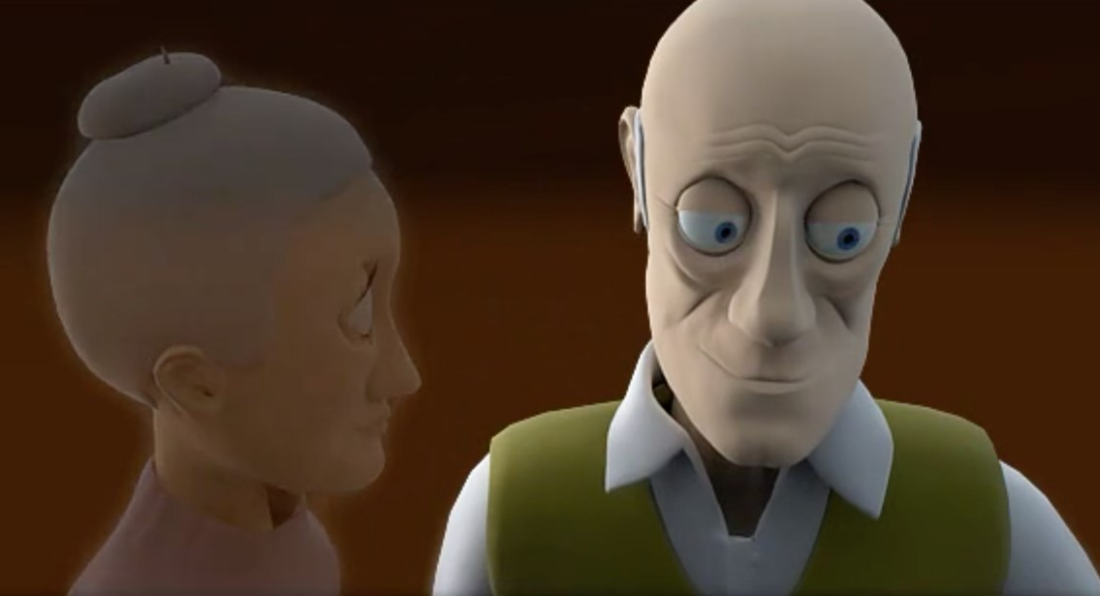 | 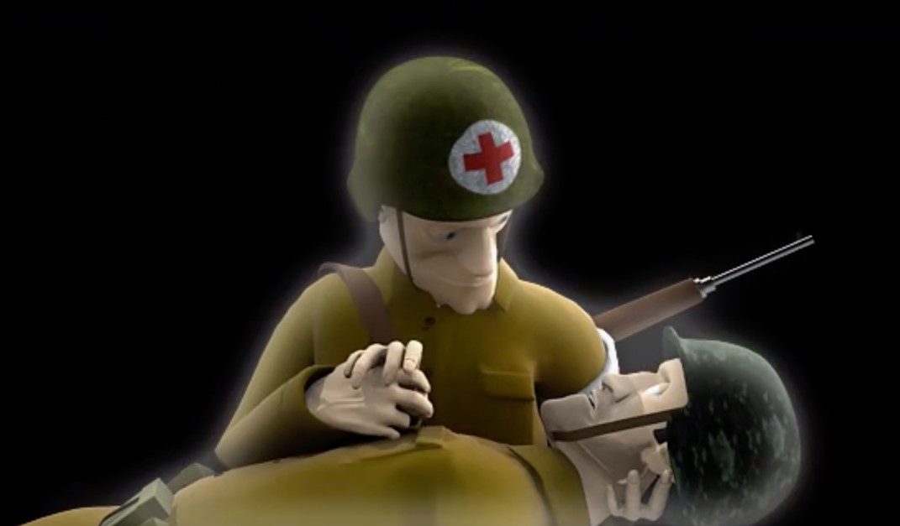
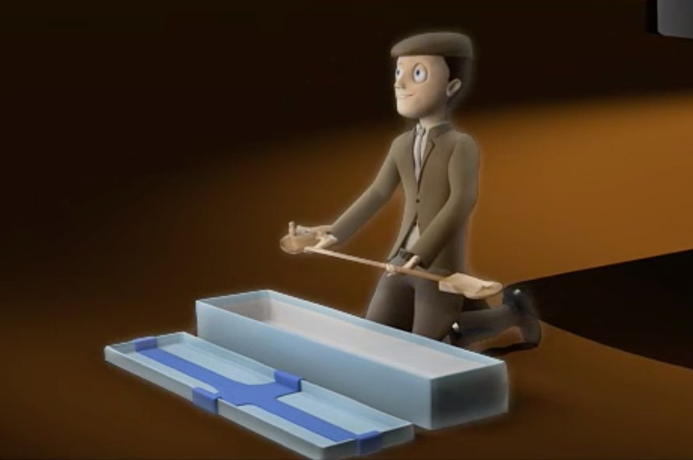 | 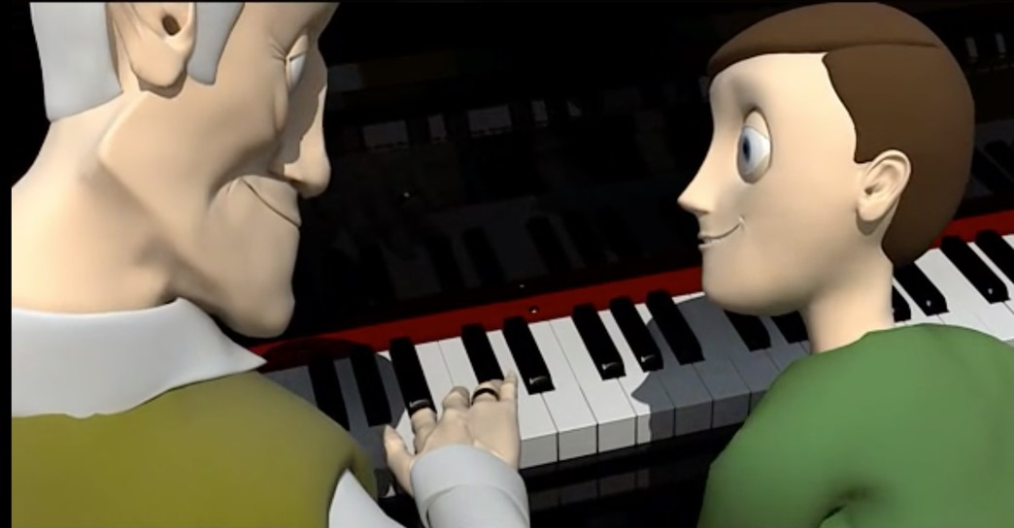

Captions

1.
2.
3.
4.

The Seven Ages of Man by William Shakespeare

https://www.youtube.com/watch?v=61z2fPAOr8g

All the world's a stage, And all the men and women merely players,
They have their exits and entrances,
And one man in his time plays many parts,
His acts being seven ages. At first the infant,
Mewling and puking in the nurse's arms.
Then, the whining schoolboy with his satchel
And shining morning face, creeping like snail
Unwillingly to school. And then the lover,
Sighing like furnace, with a woeful ballad
Made to his mistress' eyebrow.
Then a soldier, Full of strange oaths, and bearded like the pard,
Jealous in honour, sudden, and quick in quarrel,
Seeking the bubble reputation
Even in the cannon's mouth. And then the justice
In fair round belly, with good capon lin'd,
With eyes severe, and beard of formal cut,
Full of wise saws, and modern instances,
And so he plays his part. The sixth age shifts
Into the lean and slipper'd pantaloon,
With spectacles on nose, and pouch on side,
His youthful hose well sav'd, a world too wide,
For his shrunk shank, and his big manly voice,
Turning again towards childish treble, pipes
And whistles in his sound. Last scene of all,
That ends this strange eventful history,
Is second childishness and mere oblivion,
Sans teeth, sans eyes, sans taste, sans everything.

