What to do today
IMPORTANT Parent or Carer – Read this page with your child and check that you are happy with what they have to do and any weblinks or use of internet.

1. Read and listen to a poem
- Read The Sound Collector. What do you notice about the poem? Which line do you think is most memorable?
- Listen to Roger McGough (the poet) read the poem. What do you notice new when you hear the poem read?
https://www.youtube.com/watch?v=cIL0kgnxJIo

2. Make notes about the sounds in your house
- Be very quiet and try to listen to the sounds in your house for 2-3 minutes. Listen for sounds coming from outside too.
- What might you hear at different times of the day? Early in the morning? In the evening? Late at night?
- Think about how to describe these sounds and note them down.

3. Write a poem about the sounds in your house
- Use Planning a Poem to help you to write a poem about the sounds in your house.
- Practise reading your poem out loud.
Change any parts that don’t sound right to you.

Try these Fun-Time Extras
- Ask someone else in your house to make a list of the sounds they notice. Do theirs match yours?
- Read and share your poem with somebody else. You could record a version to share.
- Write a version of the poem as if you were somewhere else – back at school or outside somewhere.
- Find out more about Roger McGough:
https://childrens.poetryarchive.org/poet/roger-mcgough/

The Sound Collector
Roger McGough

A stranger called this morning  Dressed all in black and grey  Put every sound into a bag  And carried them away  The whistling of the kettle  The turning of the lock  The purring of the kitten  The ticking of the clock  The popping of the toaster  The crunching of the flakes  When you spread the marmalade  The scraping noise it makes  The hissing of the frying-pan  The ticking of the grill  The bubbling of the bathtub  As it starts to fill  The drumming of the raindrops  On the window-pane  When you do the washing up  The gurgle of the drain | 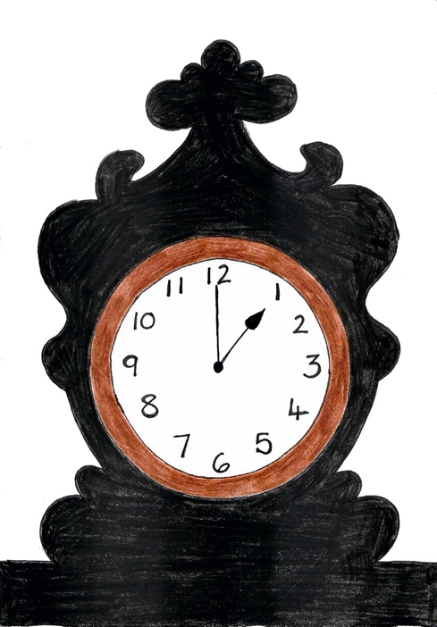
The crying of the baby
The squeaking of the chair
The swishing of the curtain
The creaking of the stair

A stranger called this morning
He didn’t leave his name
Left us only silence
Life will never be the same.

p.408, Read Me

Sound in my house

Listen very carefully and write down the sounds you can hear.
Planning a Poem

- Think of different nouns which could make a sound to be collected:
write them, draw a circle round them and then think of different onomatopoeic words to convey their sound.
e.g.
phone
ping
buzz
blip
ting
bring
plick
knock

- Start looking for potential rhymes with your nouns, e.g. phone & moan, telly & belly and consider swapping hard nouns for easier ones, e.g. swapping ‘porridge’ for oats/bowl. You can underline rhyming pairs in the same colour.

- Choose your favourite onomatopoeic words and begin to develop lots of possible lines,
e.g.

The pinging of the phone

- When you have lots of lines, try arranging them following the pattern of the original poem (ABCB). You only need two rhyming lines per stanza so you can place your trickier words (microwave, Alexa, tablet, etc.) in the non-rhyming positions.

- You could try extending some of the lines, so the sound image takes up two lines,
e.g.

The pinging of the phone
As the messages begin

- Read your lines aloud to listen for the rhythm. You may need to rearrange words or swap them to keep to the rhythm of the original poem.

The Sound-Collector – New Version

Carefully write your poem here. You could start and end it in the same way as the original.

d

