What to do today
IMPORTANT Parent or Carer – Read this page with your child and check that you are happy with what they have to do and any weblinks or use of internet.

1. Read and listen to a poem
- Read Gran, Can You Rap? Read the poem in your head first and then practise reading it out loud until you read it confidently.
- Watch these two performances of the poem. Which do you prefer? Which lines do you think these performers still need to practise?
https://www.youtube.com/watch?v=UpxTNv_P-kA
https://www.youtube.com/watch?v=s-eHQIffpjU

2. Highlight and annotate the poem
- Remind yourself about the Useful Poetic Terms.
- Highlight and annotate the poem to show any of the features that you can find. Make sure that you show the rhymes in this poem.

3. Write new verses for the poem
- Read Example to see how to make new verses for the poem by just changing some of the words.
- Pick a new character and write a verse about them. You could challenge yourself to write about other different characters too.

Try these Fun-Time Extras
- Practise reading your new version until you are really confident. Perform it to others.
- Try writing verses for each person in your house.

Gran, Can You Rap?
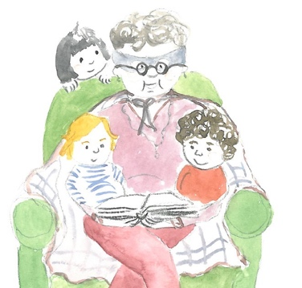
Gran was in her chair she was taking a nap
When I tapped her on the shoulder to see if she could rap.
Gran, can you rap? Can you rap? Can you, Gran?
And she opened one eye and she said to me, man,
I’m the best rapping Gran this world’s ever seen
I’m a tip-top, slip-slap, rap-rap queen.

And she rose from her chair in the corner of the room
And she started to rap with a bim-bam-boom,
And she rolled up her eyes and she rolled round her head
And as she rolled by this is what she said,
I’m the best rapping Gran this world’s ever seen
I’m a nip-nap, yip-yap, rap-rap queen.

Then she rapped past my dad and she rapped past my mother,
She rapped past me and my little baby brother.
She rapped her arms narrow she rapped her arms wide,
She rapped through the door and she rapped outside.
She’s the best rapping Gran this world’s ever seen
She’s a drip-drop, trip-trap, rap-rap queen.

She rapped down the garden she rapped down the street,
The neighbours all cheered and they tapped their feet.
She rapped through the traffic lights as they turned red
As she rapped round the corner this is what she said,
I’m the best rapping Gran this world’s ever seen
I’m a flip-flop, hip-hop, rap-rap queen.

She rapped down the lane she rapped up the hill,
And as she disappeared she was rapping still.
I could hear Gran’s voice saying, Listen, Man,
Listen to the rapping of the rap-rap Gran.
I’m the best rapping Gran this world’s ever seen
I’m a –
tip-top, slip-slap
nip-nap, yip-yap,
hip-hop, trip-trap,
touch yer cap,
take a nap,
happy, happy, happy, happy,
rap_____rap_____ queen.
by Jack Ousbey
p.432, The Works
Useful Poetry Terms

Stanzas - groups of lines – a little like paragraphs
Rhythm - the beat of a poem – can be regular or irregular
Rhyme - using words having the same end sound, can be the whole word or the last syllable (cheese/please)
Alliteration - using words which begin with the same sound
Onomatopoeia - words which make the sound they represent
Repetition – repeating words or phrases for effect in a refrain
Simile - describing something, using 'as' or 'like'
Metaphor - describing something as being something else
Narrative – telling a story
Choral – designed to be performed by more than one voice

Example

Queen, Can You Rap?

The Queen was on her throne with a corgi on her lap

When I tapped her on the shoulder to see if she could rap.

Queen, can you rap? Can you rap? Can you, Queen?

And she lifted her crown and she said to me, man,

I’m the best rapping Queen this world’s ever seen

I’m a tip-top, slip-slap, rap-rap dream.

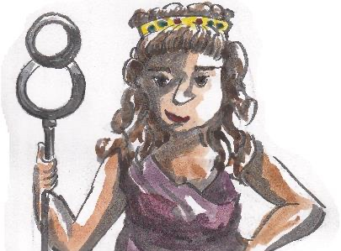

New Version

Write versions of the poem for new characters, by changing some of the words from the original.

