What to do today
IMPORTANT Parent or Carer – Read this page with your child and check that you are happy with what they have to do and any weblinks or use of internet.

1. Read and listen to two poems
- Read The Language of Cat and Russian Doll. Read each poem twice – once in your head and once out loud.
- How are these poems similar? How are they different? Do you prefer one? Why?
- Listen to Rachel Rooney (the poet) read the poems. Did they sound as you expected? Did you notice anything new when you heard them? https://vimeo.com/162519257
https://vimeo.com/162519272

2. Annotate the poems
- Read Useful Poetry Terms.
- Annotate the poems to show which of these features you find.

3. Write a paragraph about one of the poems
- Read Example and Guide.
- Plan a paragraph about some of the features that you found in either of the poems. Now write this beautifully.

Well done. Show your paragraph and the poem to a grown-up. Show them how your paragraph is like the Example one.

Try these Fun-Time Extras
- Explore some more of Rachel Rooney’s poems on her website. Which do you like most? Why?
https://www.rachelrooneypoet.com/about4
- Try writing a new poem, ‘Language of Dog’ (You could write about the language of any animal.)

The language of cat
Rachel Rooney

Teach me the language of Cat;
the slow-motion blink, that crystal stare,
a tight-lipped purr and a wide-mouthed hiss.
Let me walk with a saunter, nose in the air.
Teach my ears the way to ignore
names that I’m called. May they only twitch
to the distant shake of a boxful of biscuits,
the clink of a fork on a china dish.
Teach me that vanishing trick
where dents in cushions appear, and I’m missed.
Show me the high-wire trip along fences
To hideaway places, that no-one but me know exist.
Don’t teach me Dog.
All eager to please; that slobbers, yaps and begs for a pat,
that sits when told by its owner, that’s led on a lead.
No, not that. Teach me the language of Cat.

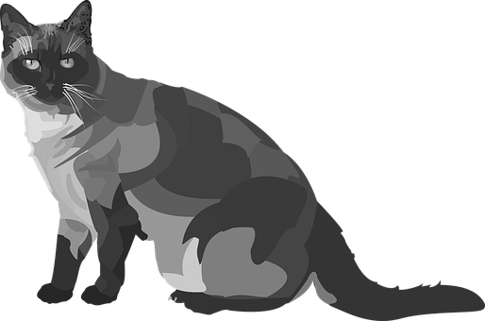

p.10, The Language of Cat and other poems

Russian doll
Rachel Rooney

All you see is outside me: my painted smile,
the rosy-posy shell, the fluttery eyes.
A butter-won’t-melt-in-my-mouth-type me.
But inside there’s another me, bored till playtime.
The wasting paper, daytime dreamer.
A can’t- be-bothered-sort-of me.
And inside there’s another me, full of cheek.
The quick, slick joker with a poking tongue.
A class-clown-funny-one-of me
And inside there’s another me who’s smaller, scared.
The scurrying, worrying, yes miss whisperer.
A wouldn’t-say-boo-to-a-goosey me
And inside there’s another me, all cross and bothered.
The scowling hot-head, stamping feet.
A didn’t-do-it-blameless me
And inside there’s another me, forever jealous
who never gets enough, compared.
A grass-is-always-greener me
And deepest down, kept secretly
a tiny, solid skittle doll.
The girl that hides inside of me.
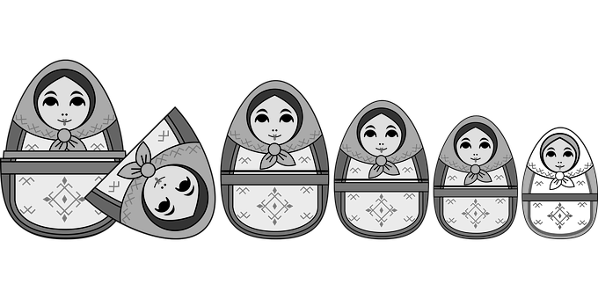
p.22, The Language of Cat and other poems

Useful Poetry Terms

Stanzas - groups of lines – a little like paragraphs
Rhythm - the beat of a poem – can be regular or irregular
Rhyme - using words having the same end sound, can be the whole word or the last syllable (cheese/please)
Alliteration - using words which begin with the same sound
Onomatopoeia - words which make the sound they represent
Repetition – repeating words or phrases for effect in a refrain
Simile - describing something, using 'as' or 'like'
Metaphor - describing something as being something else
Narrative – telling a story
Choral – designed to be performed by more than one voice

Example and Guide

In the poem, ‘The language of cat’ by Rachel Rooney, onomatopoeia is used to show the sound that the cat makes. A good example is,
‘a tight-lipped purr and a wide-mouthed hiss’. I think the poet chose these words because when you say them you make the actual sounds that a cat makes so the listeners can imagine the cat. This makes it good for performance as you can say ‘hiss’ in an aggressive way and ‘purr’ softly like a cat would.

Say which poem you are writing about.
Explain which technique you are describing.
Give a good example inside quotation marks.
Explain why you think the poet chose these words.
Explain why this makes this poem good for performance.
I am writing about…
In the poem…
She uses onomatopoeia/alliteration to…
For example,…
A good example of this is…
I think she chose these words because…
I think these words are used to…
This makes the poem good to perform because…

Poetry Writing

Write a paragraph about one of the features that you found. Use Model/Example to help you plan your paragraph.

