What to do today
IMPORTANT Parent or Carer – Read this page with your child and check that you are happy with what they have to do and any weblinks or use of internet.

1. Read an explanation
- Read Green Vale School Football Team.
- How many reasons for the team’s success are given? Which of these reasons do you think is most important? Why?

2. Remind yourself about adverbials and conjunctions
- Use the PowerPoint about Adverbials and Conjunctions or, if that isn’t possible, remind yourself using the Revision Card.
- Read Green Vale School Football Team again and highlight at least six conjunctions and underline at least six adverbials.
- Check with the Answers below.

3. Write an explanation
- Think about a person or team that you know that has been successful. You might choose a sports-team, a musician/artist or a contestant in a competition.
- Make notes on Explanation Planner about their success and the reasons that they have been successful.
- Use your notes to write an explanation. Check with the Explanation Features list as you do.

Well done! Now show your explanation to a grown-up. Can they understand the reasons that you have given? Can you show them some of the Explanation Features that you have used?

Try this Fun-Time Extra
- Draw a picture of you in ten years’ time. Imagine you have been really successful! Write what you have achieved and explain the reasons for your success.

Green Vale School Football Team

For the last five years, this village school football team has come top of the Small Schools' League. This year they entered and won the County Cup: a competition open to all schools in the area. How is it that a small school can produce such winning results, time after time?
Size  A surprising fact about the school is its size. Green Vale is a small school, comprising of fifty pupils. Whereas a typical school may have 30 children in Year 6 to choose from, Green Vale must select its team from across KS2 in order to have enough players. It is the small size of the school, however, which gives the team an edge over other teams. With such small class sizes, pupils know each other very well and the team often has siblings playing together. Therefore, the team's communication is very strong. Every player on the pitch is quick to call for passes and the goalkeeper keeps the team informed of close marking. | 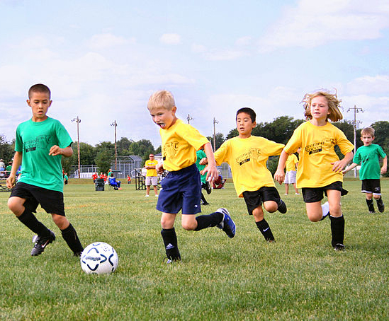

Location
On initial inspection, Green Vale's football pitch is unsuitable for practice: it is on a slope, uneven and on occasion, has livestock grazing. It is because of the unfavourable conditions that Green Vale players have developed renowned skills. The unpredictability of the ball movement results in quick reaction times for both attackers and defenders. Training on a slope results in greater fitness and avoiding a passing sheep presents players with practice in defensive dribbling and scanning the changing surroundings.

Extra-curricular Activity
One of the lesser known features of the school is its dance programme; all pupils attend ballet, tap and ballroom lessons from the age of five. In addition to PE lessons, clubs are run at lunchtime for those who wish to learn bhangra, Irish or street dance. Pupils often take part in festivals and performances. Dance develops balance, fitness and fast footwork. It is because of this that Green Vale players have great ball control. Since players easily change direction and use all parts of the foot, trips and falls are rare. Because players are used to leaps, springs and turns and demonstrate agility and poise on the pitch, it is a combination which proves devastating to opponents.

Whatever the explanation for Green Vale's football success, local coaches and teams stand to benefit from the school's next project: a coach academy. It might be that the team will develop its own worthy competition.
Team Statistics:
- 12 wins
- 3 draws
- 1 loss
- 52 goals scored
- 7 goals conceded
Recommendations for other schools:
- Build strong relationships between team members
- Use the limitations of your home-pitch to your advantage.
- Explore whether other sports or dance could aid your football performance.

Revision Card: Adverbials and Conjunctions

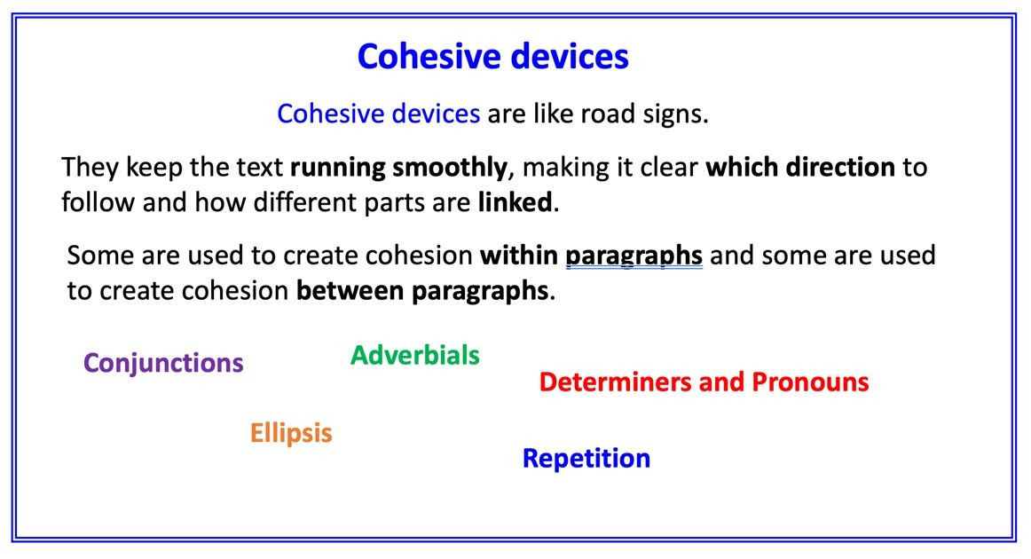
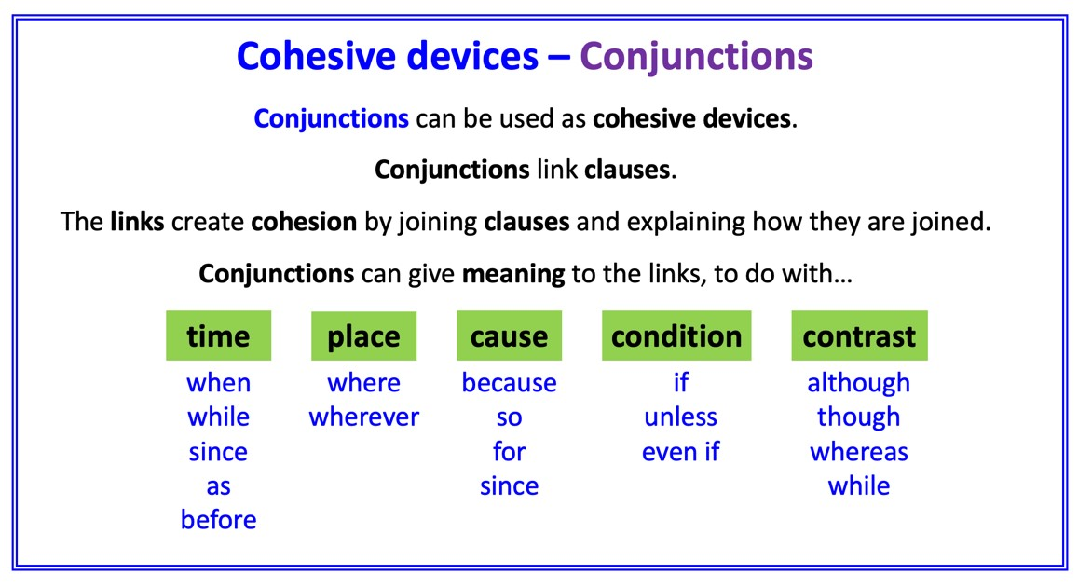
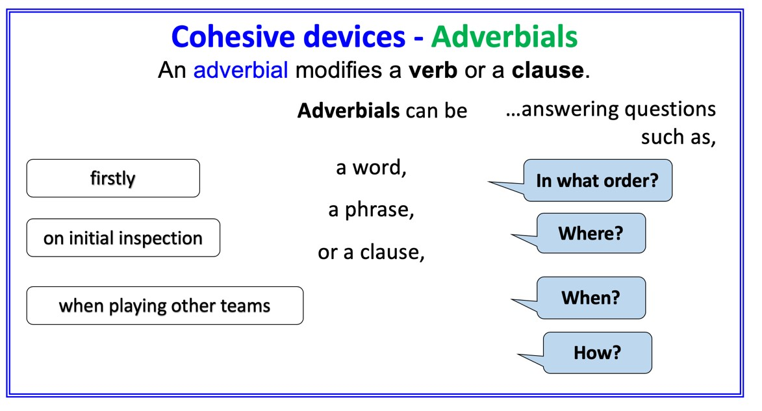

Planner

Whose success are you explaining?

What have they achieved?
What reasons can you think of for their success?

Which of these reasons is most important?

Explanation Features

Purpose – tells why or how something happens

Range – Non-fiction book or article, encyclopaedia entry, write-up of a science experiment, technical manual.

- Title telling what needs to be explained
- Introduction (often making a link to the reader)
- Clear layout, e.g. sections or paragraphs
- Bullet points or sub-headings
- Diagrams and illustrations
- Technical vocabulary (often with definitions)
- Present-tense verbs
- Causal language (e.g. because; ‘if…then…’; the reason that; when; so; this results in; this causes; therefore)
- Passive verbs
- Formal connectives (e.g. however, therefore, consequently)
- Usually formal register
- Closing sentence to round off the explanation

Explanation

Write your explanation about success here. Try to include some of the Explanation Features.

Green Vale School Football Team – Answers – conjunctions and adverbials

Adverbials are underlined. Conjunctions are highlighted

For the last five years, this village school football team has come top of the Small Schools' League. This year they entered and won the County Cup: a competition open to all schools in the area. How is it that a small school can produce such winning results, time after time?
Size
A surprising fact about the school is its size. Green Vale is a small school, comprising of fifty pupils. Whereas a typical school may have 30 children in Year 6 to choose from, Green Vale must select its team from across KS2 in order to have enough players. It is the small size of the school, however, which gives the team an edge over other teams. With such small class sizes, pupils know each other very well and the team often has siblings playing together. Therefore, the team's communication is very strong. Every player on the pitch is quick to call for passes and the goalkeeper keeps the team informed of close marking.

Location
On initial inspection, Green Vale's football pitch is unsuitable for practice: it is on a slope, uneven and on occasion, has livestock grazing. It is because of the unfavourable conditions that Green Vale players have developed renowned skills. The unpredictability of the ball movement results in quick reaction times for both attackers and defenders. Training on a slope results in greater fitness and avoiding a passing sheep presents players with practice in defensive dribbling and scanning the changing surroundings.

Extra-curricular Activity
One of the lesser known features of the school is its dance programme; all pupils attend ballet, tap and ballroom lessons from the age of five. In addition to PE lessons, clubs are run at lunchtime for those who wish to learn bhangra, Irish or street dance. Pupils often take part in festivals and performances. Dance develops balance, fitness and fast footwork. It is because of this that Green Vale players have great ball control. Since players easily change direction and use all parts of the foot, trips and falls are rare. Because players are used to leaps, springs and turns and demonstrate agility and poise on the pitch, it is a combination which proves devastating to opponents.

Whatever the explanation for Green Vale's football success, local coaches and teams stand to benefit from the school's next project: a coach academy. It might be that the team will develop its own worthy competition.

My Successful Future

