What to do today
IMPORTANT Parent or Carer – Read this page with your child and check that you are happy with what they have to do and any weblinks or use of internet.

1. Read some explanations
- Read Judges explain their voting – Kimberley Walsh.
- Watch the video of the dance. How much of what the judges said can you notice?
- Read Judges explain their voting – Johnny Ball.
- Which judge is most positive? Which is most negative? Watch the video of the dance. Which of the judges do you most agree with?

2. Highlight and annotate the text
- Take each text in turn.
- Highlight and annotate the two texts to show any technical vocabulary about dance, any very positive phrases and any very negative phrases.
- Highlight anything else that you notice in the way that the judges explain their voting.
- Compare your highlights with the Judging Sheets below.

3. Give your own explanation
- Choose whether to think about the Stacey Dooley or the Brian Conley dance. Watch the dance and give it a score.
- Make notes of what you would say to explain your voting. Try to think of more than one reason and try to include technical vocabulary and some of the phrases that you found in the text.

Try the Fun-Time Extra
- Practise using your plan to give a spoken explanation. Can you make yourself sound like a professional TV judge? Record your explanation and share it with somebody else.

Judges explain their voting: Kimberley Walsh
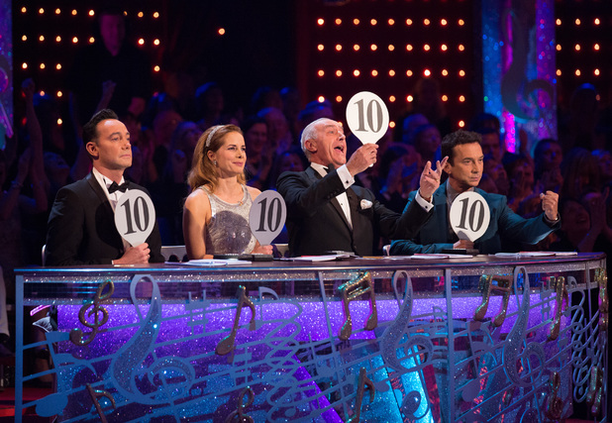
Len: I'll tell you what I thought. I thought you did a great job because the jive isn't easy—the steps have got to be clean, got to be precise and yet you've still got to show the fun, and exuberance of the dance. That you pulled off great footwork—spot on. There were one or two dodgy moments. I was a little bit anxious when you went flying through the legs but you got up from that nicely. In the end, the spins were a little bit off at one stage but overall, well done. Nice job.

Craig: I could not agree more. I thought that was absolutely brilliant. Fast efficient footwork, I thought. Synchronicity was absolutely excellent. I loved the double turn at the end into the end pose—great technique. As Len said, going through the legs was very clumsy and for that reason you'll lose points. But you did a cracking job.

https://www.youtube.com/watch?v=AlGHLcJenx0

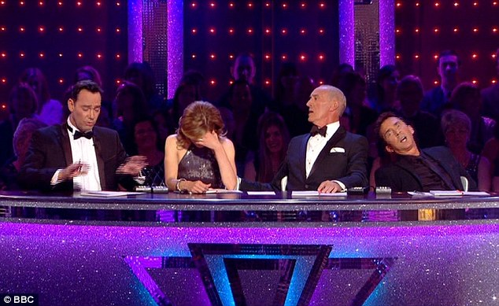
Judges explain their voting: Johnny Ball

Craig: I've never really been a big fan of miming, darling. Your mouth was moving throughout and was very distracting. Your technique needs work because the jerks and spasms all the way through were worrying—a little more fluidity would be good.

Darcy: Great energy. You surprised me—it was beautiful. Sadly, you have been unlucky with your partners changing. That doesn't make it easy. Your weight is always on your heels. This means your balance is wrong because in Latin you must be more on the balls of your feet, so try and remember this for your next dance.

Len: Let me tell you this: first of all, you had good timing; there was plenty of content; you got out and performed it. A lot of people of a similar age would like to be able to get out and move like that. Ok, so your posture could be a bit better, your footwork could be cleaner but your enthusiasm was great.

https://www.youtube.com/watch?v=vElnk0ZnX0I

Judging Sheet – Stacey Dooley

Technical Vocabulary for Dance  balance footwork steps  choreography overextend technique  crisp passion timing  entertaining personality transitions  exciting posture  fluidity rhythm | Persona:
 | nice & supportive
 | grumpy & sharp-tongued
 | flamboyant & enthusiastic
 | tough but fair
Link: https://www.youtube.com/watch?v=FVHw3M1hOaU | Score/10
Plan your explanation below. Remember explanation features.

Judging Sheet – Brian Conley

Technical Vocabulary for Dance  balance footwork steps  choreography overextend technique  crisp passion timing  entertaining personality transitions  exciting posture  fluidity rhythm | Persona:
 | nice & supportive
 | grumpy & sharp-tongued
 | flamboyant & enthusiastic
 | tough but fair
Link: https://www.youtube.com/watch?v=7TXEU7God94 | Score/10
Plan your explanation below. Remember explanation features.

