What to do today
IMPORTANT Parent or Carer – Read this page with your child and check that you are happy with what they have to do and any weblinks or use of internet.

1. Look carefully at illustrations
- Look at Arthur Robbins’ Illustrations. They’re drawn to accompany a poem. What could the story be?
- Choose one of the pictures and think about each of the Picture Prompts. Write down your answers as sentences.

2. Read and listen to a poem
- Listen to Macavity the Mystery Cat read by the poet, TS Eliot.
https://www.youtube.com/watch?v=Mz29e3lv3Js
- Follow the words of the poem as you do.
- Choose part of the poem and practise reading it aloud yourself.
Read Top Tips for Reading a Poem Aloud to help you.

3. Research tricky vocabulary
- Research meanings to the words on Challenging Vocabulary.
- You could use a book dictionary or this online version:
https://kids.wordsmyth.net

Well done! Now show a grown-up the most unusual words that you have found out about.

Try this Fun-Time Extra

- Practise reading part of the poem until you are really fluent. Record your reading and share it with somebody else.
- Choose quotations from the poem to match Arthur Robbin’s Illustrations. Cut out the illustrations and copy your chosen quotation next it to it.

Arthur Robbins’ Illustrations
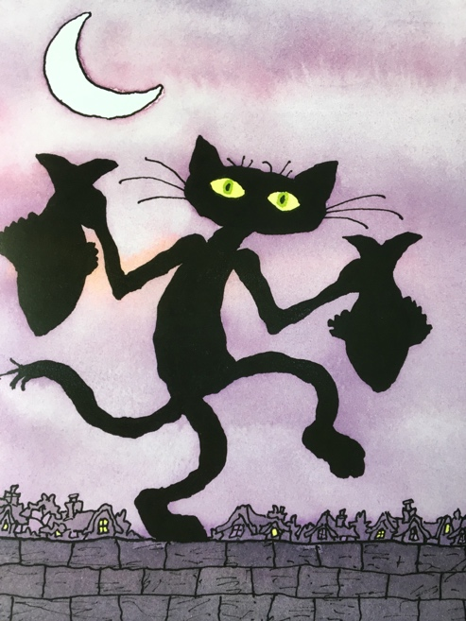 | 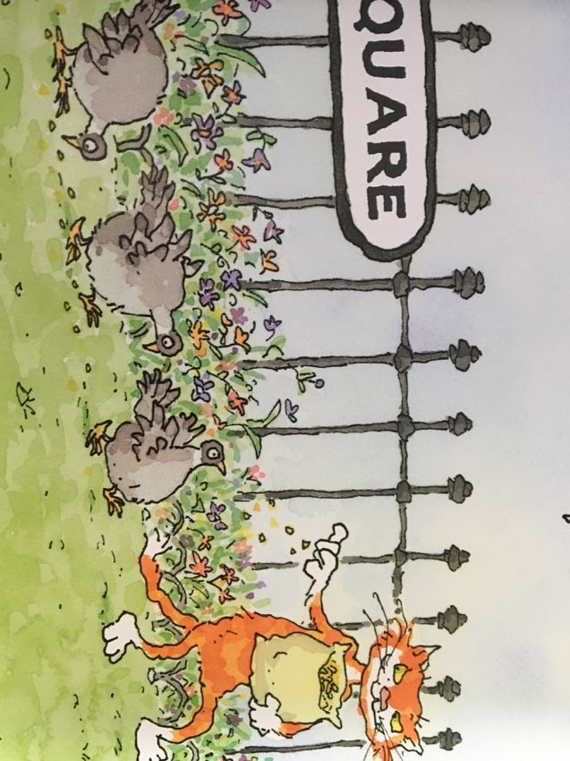 | 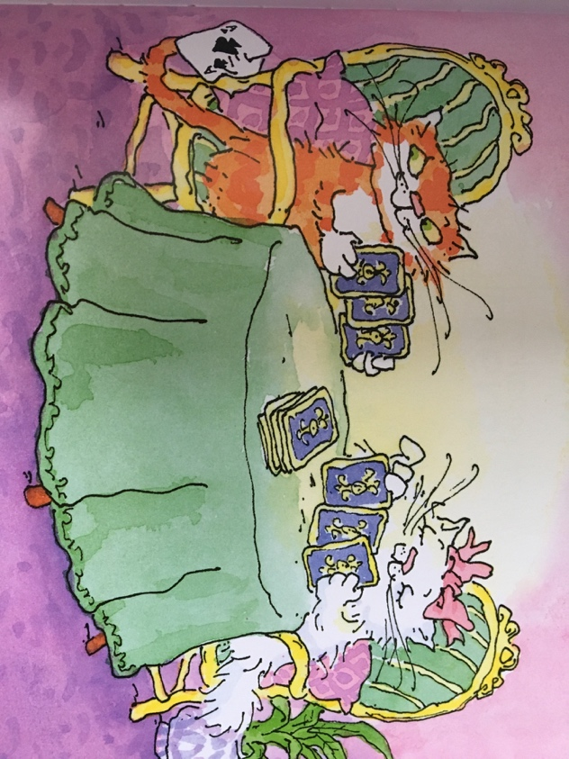
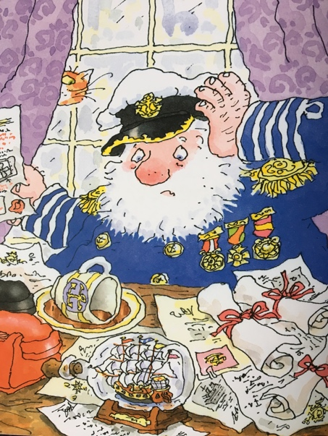 | 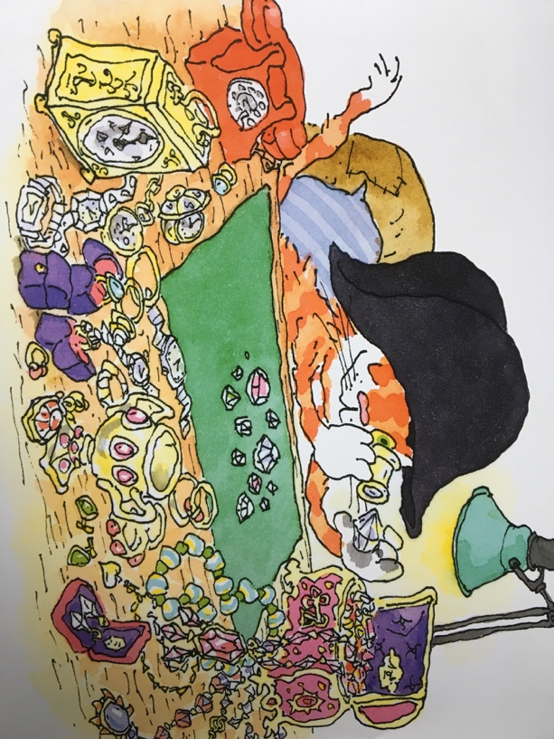

Picture Prompts

Who is in the picture?
What can you tell about who they are?
How do you think they are moving?
How do you think they would sound if they spoke?
What might they say to you if they saw you looking at them?
What can you tell about their character?
What do they seem to be doing?
What else might actually be happening?
What does the background tell you?
What do you think has happened just before this picture?
What might happen next?

Macavity – The Mystery Cat

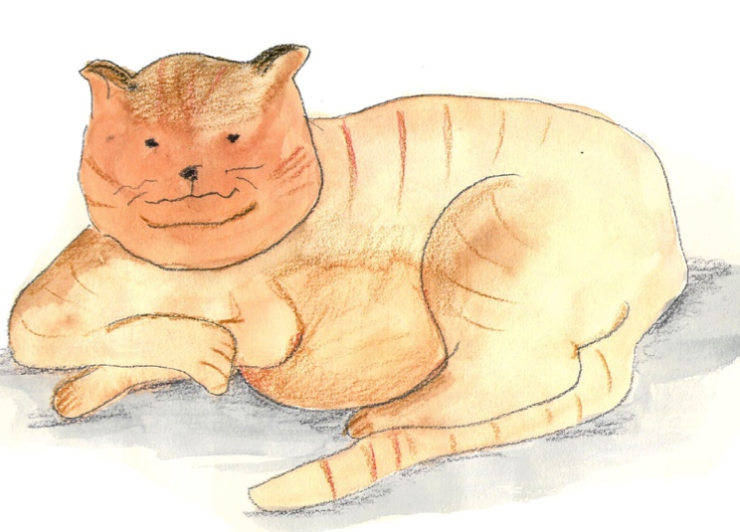
By T.S. Eliot

Macavity's a Mystery Cat: he's called the Hidden Paw—
For he's the master criminal who can defy the Law.
He's the bafflement of Scotland Yard, the Flying Squad's despair:
For when they reach the scene of crime—Macavity's not there!
Macavity, Macavity, there's no one like Macavity,
He's broken every human law, he breaks the law of gravity.
His powers of levitation would make a fakir stare,
And when you reach the scene of crime—Macavity's not there!
You may seek him in the basement, you may look up in the air—
But I tell you once and once again, Macavity's not there!
Macavity's a ginger cat, he's very tall and thin;
You would know him if you saw him, for his eyes are sunken in.
His brow is deeply lined with thought, his head is highly domed;
His coat is dusty from neglect, his whiskers are uncombed.
He sways his head from side to side, with movements like a snake;
And when you think he's half asleep, he's always wide awake.
Macavity, Macavity, there's no one like Macavity,
For he's a fiend in feline shape, a monster of depravity.
You may meet him in a by-street, you may see him in the square—
But when a crime's discovered, then Macavity's not there!

He's outwardly respectable. (They say he cheats at cards.)
And his footprints are not found in any file of Scotland Yard's
And when the larder's looted, or the jewel-case is rifled,
Or when the milk is missing, or another Peke's been stifled,
Or the greenhouse glass is broken, and the trellis past repair
Ay, there's the wonder of the thing! Macavity's not there!
And when the Foreign Office find a Treaty's gone astray,
Or the Admiralty lose some plans and drawings by the way,
There may be a scrap of paper in the hall or on the stair—
But it's useless to investigate—Macavity's not there!
And when the loss has been disclosed, the Secret Service say:
It must have been Macavity!'—but he's a mile away.
You'll be sure to find him resting, or a-licking of his thumb;
Or engaged in doing complicated long division sums.
Macavity, Macavity, there's no one like Macavity,
There never was a Cat of such deceitfulness and suavity.
He always has an alibi, and one or two to spare:
At whatever time the deed took place—Macavity wasn’t there!
And they say that all the Cats whose wicked deeds are widely known
(I might mention Mungojerrie, I might mention Griddlebone)
Are nothing more than agents for the Cat who all the time
Just controls their operations: the Napoleon of Crime!

Top tips for reading a poem aloud

- Work on the tricky words. Find out what they mean and how they are said. Practise saying them.
- Look for the full stops. Make sentences flow to the full stop, even when there’s a new line.
- Slow down. Speak slowly when you’re reading a poem, so that others can hear the words.
- Project your voice. Imagine someone on the other side of the room and speak to them.
- Practise. Read and read and read your poem, so that you get better each time.

Challenging Vocabulary

Write a short definition or explanation for each word

- Scotland Yard
- levitation
- fakir
- brow
- feline
- depravity
- Peke
- trellis
- Admiralty
- disclosed
- deceitfulness
- suavity
- alibi
- Napoleon

