What to do today
IMPORTANT Parent or Carer – Read this page with your child and check that you are happy with what they have to do and any weblinks or use of internet.

1. Read non-fiction information
- Read the report on Sea Myths. Which of these creatures had you heard of before? What is the most important piece of information about each? Why do you think that people like to tell stories of sea creatures like these?

2. Remind yourself about word classes
- Use the PowerPoint on word classes or, if this is not possible, remind yourself using the Revision Card 1 and 2.
- Find examples of each class of word in Sea Myths and write them on the Classification Table.

Well done! Now show a grown-up the words that you have collected. You can check your answers at the end of the pack.

3. Research one of the sea-creatures
- Choose one of the sea-creatures from Sea Myths. Research some more information about it and make a poster about all that you discover. Keep this safe – you will need it tomorrow.

Try the Fun-Time Extra
- Can you make up a story about one of these sea-creatures? You could write it as a comic-strip, a script or as a story. Share your finished story with other people.

Sea Myths

The Kraken

The kraken is a legendary monster. Scandinavian folktales told stories of this giant, terrifying creature who lived in the sea. Some stories told of the kraken pulling ships apart with its strong tentacles. Other myths were that it often caused dangerous whirlpools in the water which sunk ships fast. It is thought that the myths arose from sightings of giant squid and these terrified and inspired tall stories.

Sirens

In Greek Mythology, the sirens were dangerous creatures, who lured unlucky sailors with their enchanting music and beautiful songs. The ships sailed into the rocks that surrounded the island and capsized. Sirens were half human and half bird. Originally, they could be men or women, but later stories described all sirens as women.

Merfolk

In folktales, a mermaid or merman is an aquatic creature with the upper body of a human and the lower body of a fish. They appeared first in stories in ancient Assyria but soon were told around the world. Some tales show merpeople as very kind and helpful towards sailors, while other stories link them to storms, floods and shipwrecks. Many people explain that belief in merpeople is because of manatees (or sea cows).

Selkies

Selkies are found in folktales from the Northern Isles of Scotland. They are able to change from seal to human form by shedding their skins. In some stories they come to land and live as humans for many years before returning to the sea.
Revision Card 1 – Word Classes

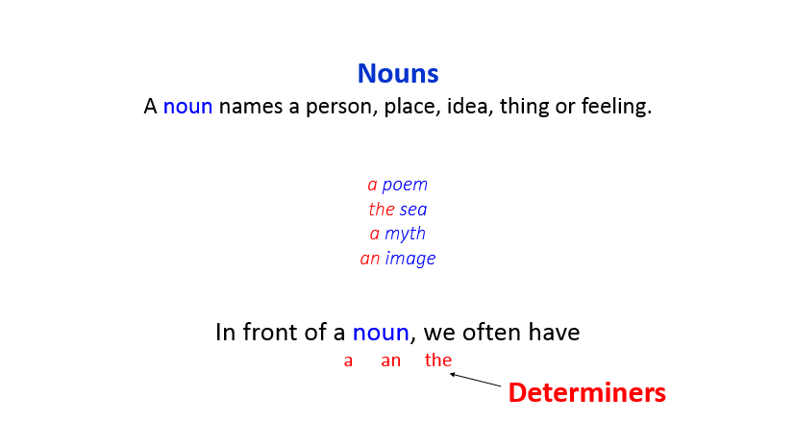 | 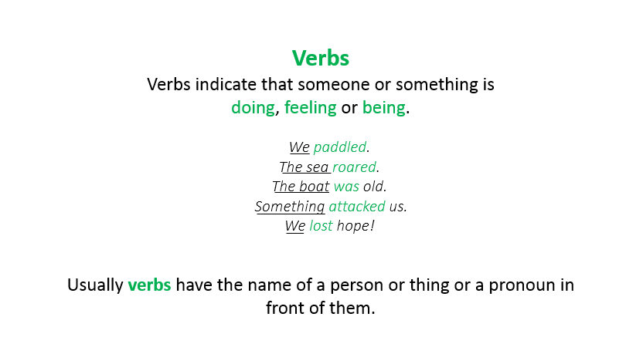
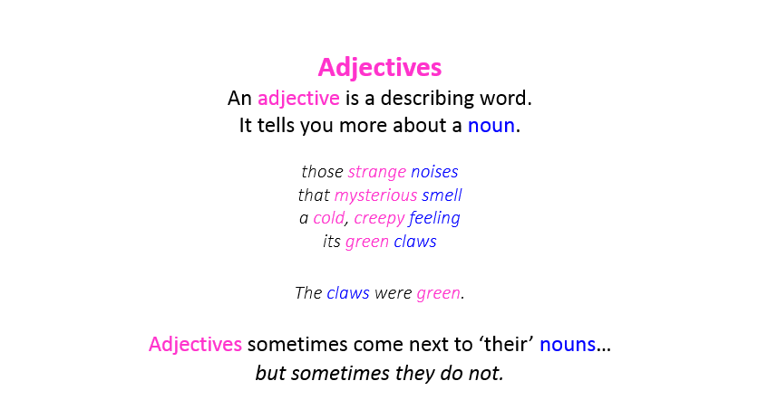 | 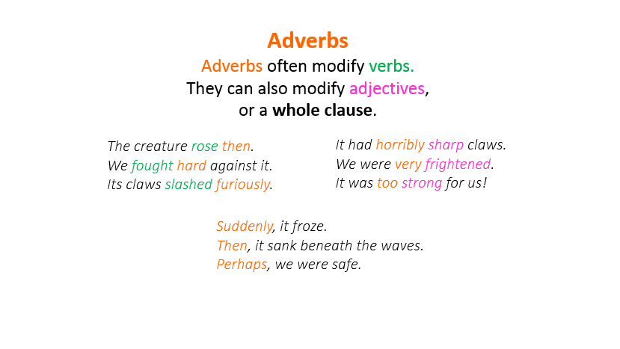

Revision Card 2 – Word Classes

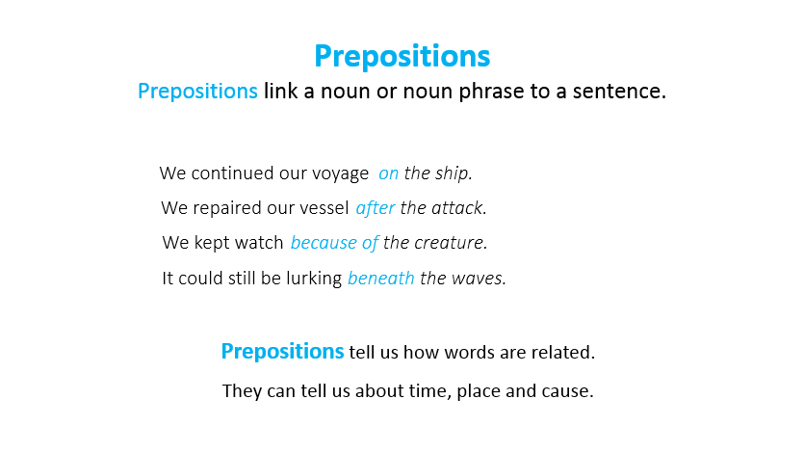 | 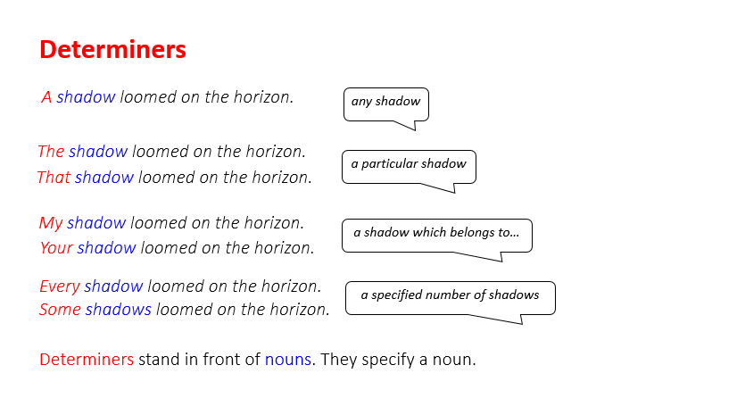
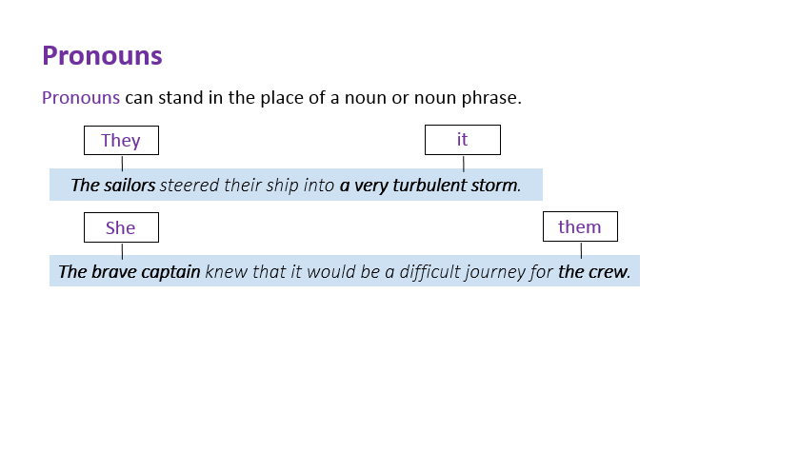 | 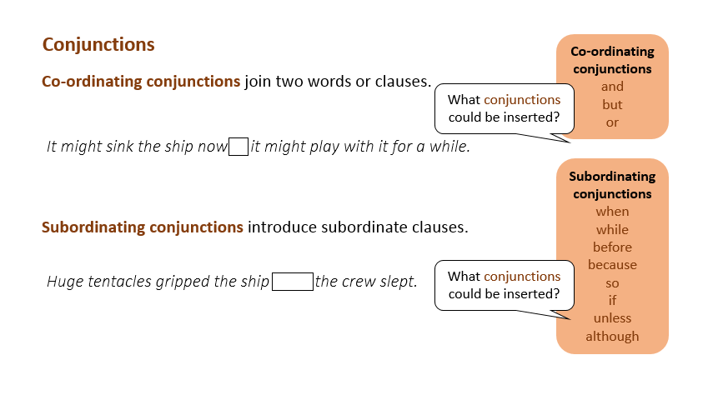

Classification Table

Nouns | Verbs
Adjectives | Adverbs
Prepositions | Determiners
Pronouns  including relative pronouns | Conjunctions

Sea Myths - Word Classes Colour-Coded

Red = determiners Blue = nouns Pink = adjectives Green = verbs
Turquoise = prepositions Orange = adverbs. Purple = pronouns Brown = conjunctions

The Kraken

The kraken is a legendary monster. Scandinavian folktales told stories of this giant, terrifying creature who lived in the sea. Some stories told of the kraken pulling ships apart with its strong tentacles. Other myths were that it often caused dangerous whirlpools in the water which sunk ships fast. It is thought that the myths arose from sightings of giant squid and these terrified and inspired tall stories.

Sirens

In Greek Mythology, the sirens were dangerous creatures, who lured unlucky sailors with their enchanting music and beautiful songs. The ships sailed into the rocks that surrounded the island and capsized. Sirens were half human and half bird. Originally, they could be men or women, but later stories described all sirens as women.

Merfolk

In folktales, a mermaid or merman is an aquatic creature with the upper body of a human and the lower body of a fish. They appeared first in stories in ancient Assyria but soon were told around the world. Some tales show merpeople as very kind and helpful towards sailors, while other stories link them to storms, floods and shipwrecks. Many people explain that belief in merpeople is because of manatees (or sea cows).

Selkies

Selkies are found in folktales from the Northern Isles of Scotland. They are able to change from seal to human form by shedding their skins. In some stories they come to land and live as humans for many years before returning to the sea.

