What to do today
IMPORTANT Parent or Carer – Read this page with your child and check that you are happy with what they have to do and any weblinks or use of internet.

1. Read the start of a story
- Read Opening. This is the start of a story. What do you think might happen in the rest of the book? Why do you think that?

2. Choose some memorable phrases
- Read the six phrases that have been chosen on Memorable Phrases.
- Use lines to match the reasons to the phrases.
- Read Further Extract. Choose 3-5 memorable phrases from here and write reasons for why they are memorable on My choice of phrases.

Well done! Now show a grown-up the phrases that you chose and explain why you thought that they were memorable.

3. Make an illustration
- Look at the illustrations from the start of the story.
- Make an illustration that will fit the Further Extract part of the story.
- Write your memorable phrases around your illustration.

Try this Fun-Time Extra

- Imagine a city that is the exact opposite of the one described in this story. What would it be like? What would the people be like? Write about it and make an illustration of it.

Opening

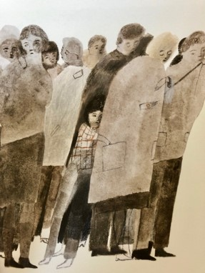

When I was young, I lived in a city that was mean and hard and ugly. Its streets were dry as dust, cracked by heat and cold,
and never blessed with rain.

A gritty, yellow wind blew constantly, scratching around the building like a hungry dog.

Nothing grew. Everything was broken. No one ever smiled.
The people had grown as mean and hard and ugly as their city, and I was mean and hard and ugly too.

I lived by stealing from those who had almost as little as I did.
My heart was as shrivelled as the dead trees in the park.

from The Promise by Nicola Davies
Memorable phrases

The reasons are muddled. Draw lines to match the reason to the phrase.

Memorable phrase |  | Reason it’s memorable
When I was young I lived in a city that was mean and hard and ugly. |  | This is an unusual adjective to have chosen. It makes the phrase vivid and memorable
A gritty, yellow wind blew constantly |  | Simile. The character’s inner condition is as desolate as the setting.
Scratching round the buildings like a hungry dog. |  | Three dramatic short sentences. Nothing, everything and no-one = hyperbole/possible exaggeration.
Nothing grew. Everything was broken. No one ever smiled. |  | Repetition giving emphasis and echoing: mean, hard, ugly.
The people had grown as mean and hard and ugly as their city, and I was mean and hard and ugly too. |  | A simile. The dog sounds wild and uncared for which fits the description of the city.
My heart was as shrivelled as the dead trees in the park. |  | The extra ‘and’ emphasises all three words in this list.

Further extract

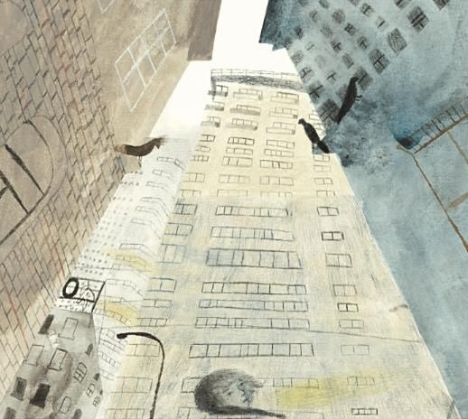

And then, one night,
I met an old lady down a dark street.
She was frail and alone, an easy victim.
Her bag was fat and full,
but when I tried to snatch it from her,
she held on with the strength of heroes.

To and fro we pulled that bag until at last she said,
“If you promise to plant them, I’ll let go.”

What did she mean? I didn’t know or care,
I just wanted the bag, so I said,
“All right, I promise.”
She loosened her grip at once and smiled at me.

I ran off without a backward look,
thinking of the food and money in her bag.

from The Promise by Nicola Davies
My choice of phrases

Choose 3-5 phrases from Further Extract. Explain why each phrase is memorable.

Memorable phrase |  | Reason it’s memorable

Illustrations

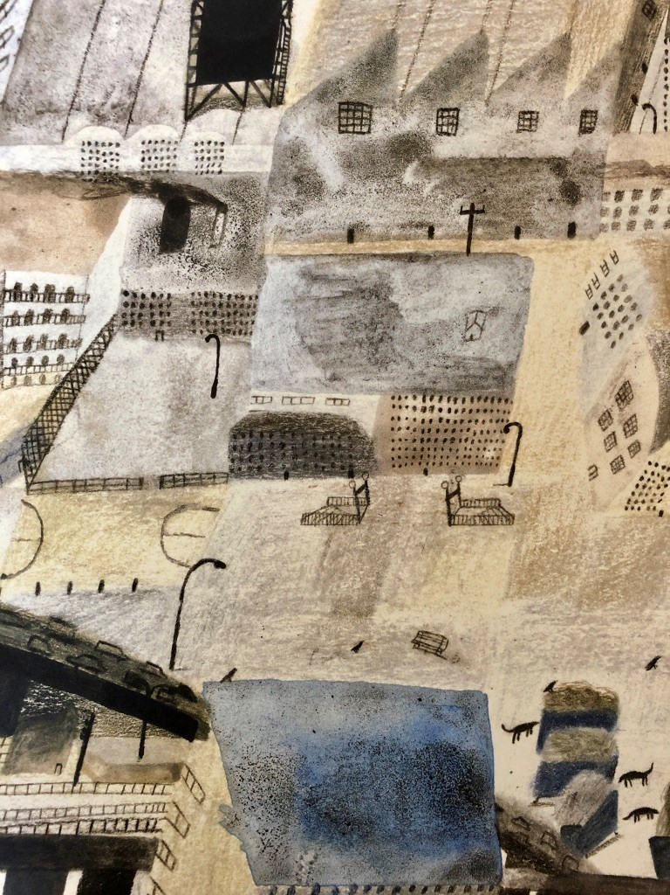 | 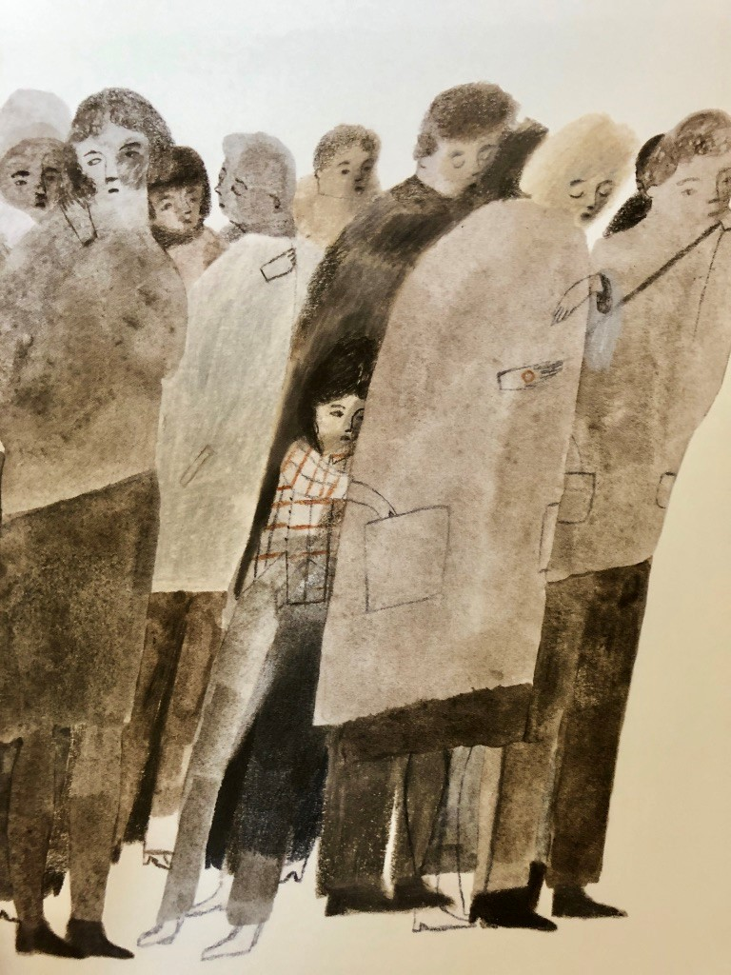

from The Promise, illustrated by Laura Carlin
Memorable phrases - ANSWERS

These reasons match the phrases.

Memorable phrase |  | Reason it’s memorable
When I was young I lived in a city that was mean and hard and ugly. |  | The extra ‘and’ emphasises all three words in this list.
A gritty, yellow wind blew constantly |  | This is an unusual adjective to have chosen. It makes the phrase vivid and memorable
Scratching round the buildings like a hungry dog. |  | A simile. The dog sounds wild and uncared for which fits the description of the city.
Nothing grew. Everything was broken. No one ever smiled. |  | Three dramatic short sentences. Nothing, everything and no-one = hyperbole/possible exaggeration
The people had grown as mean and hard and ugly as their city, and I was mean and hard and ugly too. |  | Repetition giving emphasis and echoing: mean, hard, ugly
My heart was as shrivelled as the dead trees in the park. |  | Simile. The character’s inner condition is as desolate as the setting.

