What to do today
IMPORTANT Parent or Carer – Read this page with your child and check that you are happy with what they have to do and any weblinks or use of internet.

1. Read three more stories from Africa
- Read these three stories from Africa:
- Creation and Separation Myth of Man and the Elephant
- How the Monkeys Saved the Fish
- The Poor Man without work
- How are these stories similar to yesterday’s stories? How are they different? Which two stories would you say are most alike? Why? Which two are most different? Why?

2. Spot story-telling techniques
- Watch The ‘Yes, Sir’ Chief again (1:03 to 5:45)
https://www.youtube.com/watch?v=0L-TpcdwI9Q
- Make a list of all the things that the story-teller does to make the story interesting.

3. Practise telling a story
- Pick your favourite story from today or yesterday. There are 8 to choose from – yesterday’s stories are at the end of this document.
- First make a StoryBoard for your story. Use words and pictures in the boxes to show what happens.
- Now practise telling your story again and again. What techniques can you use to make it interesting?

Try these Fun-Time Extras
- Share your story-telling with somebody else. You could make a recording and send it to them.
- Teach your story to somebody else. Show them your storyboard and teach them how to use it to tell the story. Show them how to keep the story interesting.
African stories from http://www.afriprov.org/

Creation and Separation Myth of Man and the Elephant

God created man and an elephant. These he put in a beautiful garden, and he walked with them every day. There was pure drinking water in a flowing river. But the elephant started muddying the waters. He would listen to neither God nor man who told him not to. In the end, man killed the elephant. God, though, was upset at this act and drove man out of the garden. Hence the Borana now live in a ceaseless search for water in drought-stricken lands, semi-nomads in a semi-desert.
(Borana-Oromo, Ethiopia/ Kenya Myth)

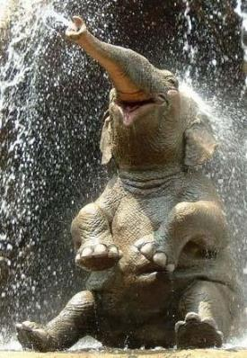

How the Monkeys Saved the Fish

The rainy season that year had been the strongest ever and the river had broken its banks. There were floods everywhere and the animals were all running up into the hills. The floods came so fast that many drowned except the lucky monkeys who used their proverbial agility to climb up into the treetops. They looked down on the surface of the water where the fish were swimming and gracefully jumping out of the water as if they were the only ones enjoying the devastating flood.

One of the monkeys saw the fish and shouted to his companion: "Look down, my friend, look at those poor creatures. They are going to drown. Do you see how they struggle in the water?" "Yes," said the other monkey. "What a pity! Probably they were late in escaping to the hills because they seem to have no legs. How can we save them?" "I think we must do something. Let's go close to the edge of the flood where the water is not deep enough to cover us, and we can help them to get out."

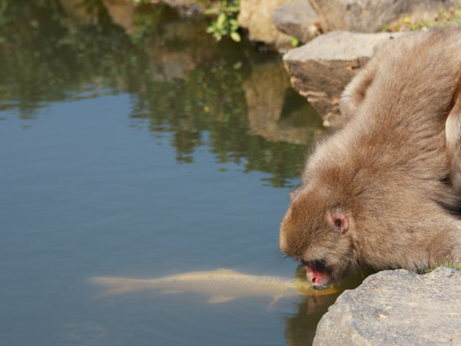 | So the monkeys did just that. They started catching the fish, but not without difficulty. One by one, they brought them out of the water and put them carefully on the dry land. After a short time there was a pile of fish lying on the grass motionless. One of the monkeys said, "Do you see? They were tired, but now they are just sleeping and resting. Had it
not been for us, my friend, all these poor people without legs would have drowned."
The other monkey said: "They were trying to escape from us because they could not understand our good intentions. But when they wake up they will be very grateful because we have brought them salvation."
(Traditional Tanzanian Folktale)

The Poor Man Without Work

Once upon a time there was a poor man who did not have a job or a place to stay. Finally, he went with his dog to the palace of the Sukuma chief. The chief warmly received the man with his dog. The poor man was accepted as part of the royal family. The chief fed both him and his dog. Later on enemies came to kill the chief. The dog barked, the alarm was sounded, the chief escaped, and his life was saved.

(Traditional Sukuma, Tanzania Story)

Storyboard

1. | 2. | 3.
4. | 5. | 6.

Yesterday’s Stories

The Lion's Share  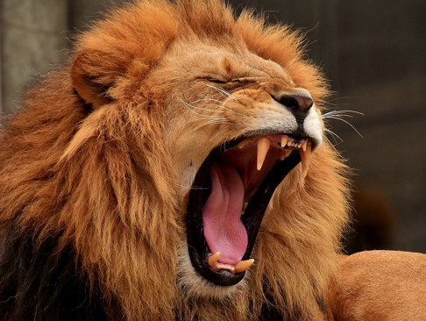  One day the lion, the wolf and the fox went out hunting together. They caught a wild ass, a gazelle and a hare. The lion spoke to the wolf, "Mr Wolf, you may divide the spoils for us today."  The wolf said, "I would have thought it best, Sire, that you should have the ass and my friend the fox should take the hare; as for me, I shall be content to take only the gazelle."  On hearing this, the lion was furious. He raised his mighty paw and struck the wolf on the head. The wolf's skull was cracked, so he died.  Whereupon the lion spoke to the fox, "Now you may try and divide our meal better.”  The fox spoke solemnly, "The ass will be your dinner, Sire, the gazelle will be your Majesty's supper and the hare will be your breakfast for tomorrow morning."  Surprised, the lion asked him, "When did you learn so much wisdom?"  Said the fox, "When I heard the wolf's skull cracking." | Two Roads Overcame the Hyena  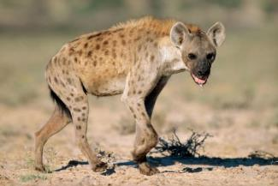  A very hungry hyena went out on the Tanzanian plains to hunt for food. He came to a branch in the bush road where the two paths veered off in different directions. He saw two goats caught in the thickets at the far end of the two different paths. With his mouth watering in anticipation, he decided that his left leg would follow the left path and his right leg the right path. As the two paths continued to veer in different directions he tried to follow them both at once. Finally, he split in two.  As the well-known African proverb says: Two roads overcame the hyena.  (Story and proverb found in many African languages).

Yesterday’s Stories

The Two Cold Porcupines  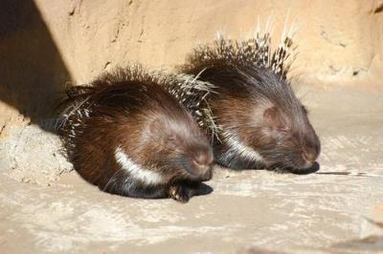  One cold night two porcupines found themselves alone out on the plains. There was no shelter or place to keep warm. They only had their body heat. But they were scared that if they stood too close together during the night one could prick and even kill the other by mistake. After experimenting they found the right distance to stand next to each other. They were close enough together that their bodies gave heat to each other, but far enough apart that they would not prick each other during the night.  (Folktale told by Bernard Joinet, M.Afr.) | The Community of Rats  Once upon a time there was a community of rats in a certain African village. In one particular house a big, mean cat terrorized the rats. They decided to work together and build a small but strong hole that they could easily enter, but which the bigger cat couldn't. After finishing and testing the hole the rats were very pleased by their teamwork and cooperation. But then at a community meeting one rat said, "The cat himself can't go into the hole but he can still catch us as we enter and leave the hole. Who is going to tie a bell around the cat's neck to warn us when he is approaching?"  Everyone was silent. All were afraid. While they succeeded in building the hole together, no one was ready to sacrifice himself or herself to tie the bell.  (Folktale told by different storytellers in Eastern Africa)

