What to do today
IMPORTANT Parent or Carer – Read this page with your child and check that you are happy with what they have to do and any weblinks or use of internet.

1. Listen to a story
- Watch this this video from 1:03 to 5:45
https://www.youtube.com/watch?v=0L-TpcdwI9Q
- What do you like about the story? Which was your favourite part? What lessons could someone learn from it?

2. Read more stories from Africa
- Read these four stories from Africa:
- The Lion’s Share
- Two Roads Overcame the Hyena
- The Two Cold Porcupines
- The Community of Rats
- Think about Story Questions and write your answers as complete sentences.

3. Write a single sentence summary for each story
- Read each story again. Write a Single Sentence Summary for each story. Try to sum up the whole story in just one sentence.

Try these Fun-Time Extras

- Can you act out one of the stories? You could write a script and give roles to people in your house or you could act it out with toys.
- Can you research and find out more about lions, hyenas, porcupines or rats?
- Can you make up another story with lions, hyenas, porcupines or rats?

African stories from http://www.afriprov.org/

The Lion's Share

One day the lion, the wolf and the fox went out hunting together. They caught a wild ass, a gazelle and a hare. The lion spoke to the wolf, "Mr Wolf, you may divide the spoils for us today."
The wolf said, "I would have thought it best, Sire, that you should have the ass and my friend the fox should take the hare; as for me, I shall be content to take only the gazelle."
On hearing this, the lion was furious. He raised his mighty paw and struck the wolf on the head. The wolf's skull was cracked, so he died.
Whereupon the lion spoke to the fox, "Now you may try and divide our meal better.”
The fox spoke solemnly, "The ass will be your dinner, Sire, the gazelle will be your Majesty's supper and the hare will be your breakfast for tomorrow morning."
Surprised, the lion asked him, "When did you learn so much wisdom?"
Said the fox, "When I heard the wolf's skull cracking."
(Nubian, Sudan Fable)

Two Roads Overcame the Hyena

A very hungry hyena went out on the Tanzanian plains to hunt for food. He came to a branch in the bush road where the two paths veered off in different directions. He saw two goats caught in the thickets at the far end of the two different paths. With his mouth watering in anticipation, he decided that his left leg would follow the left path and his right leg the right path. As the two paths continued to veer in different directions he tried to follow them both at once. Finally, he split in two.
As the well-known African proverb says: Two roads overcame the hyena.
(Story and proverb found in many African languages).

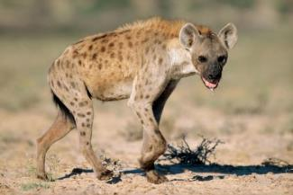

The Two Cold Porcupines

One cold night two porcupines found themselves alone out on the plains. There was no shelter or place to keep warm. They only had their body heat. But they were scared that if they stood too close together during the night one could prick and even kill the other by mistake. After experimenting they found the right distance to stand next to each other. They were close enough together that their bodies gave heat to each other, but far enough apart that they would not prick each other during the night.
(Folktale told by Bernard Joinet, M.Afr.)

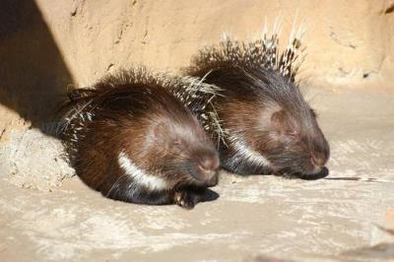

The Community of Rats

Once upon a time there was a community of rats in a certain African village. In one particular house a big, mean cat terrorized the rats. They decided to work together and build a small but strong hole that they could easily enter, but which the bigger cat couldn't. After finishing and testing the hole the rats were very pleased by their teamwork and cooperation. But then at a community meeting one rat said, "The cat himself can't go into the hole but he can still catch us as we enter and leave the hole. Who is going to tie a bell around the cat's neck to warn us when he is approaching?"
Everyone was silent. All were afraid. While they succeeded in building the hole together, no one was ready to sacrifice himself or herself to tie the bell.
(Folktale told by different storytellers in Eastern Africa)

Story Questions

Give your opinion and explain your answer to each of these questions.

- Which is your favourite of these four stories? Explain why.

- Which character in these stories is the cleverest? Explain why you think that.

- Which of these stories is the funniest? What makes it funny?

- Which two of these stories are most different? Explain your answer.

- Which story might be most important for other people to hear? Why do you think that?

Single Sentence Summaries

The ‘Yes, Sir’ Chief | A king learns that removing the problem of frogs causes him even more problems with mosquitoes.

