What to do today
IMPORTANT Parent or Carer – Read this page with your child and check that you are happy with what they have to do and any weblinks or use of internet.

1. Read the poem
- Re-read Hero Dad.
- What do you notice when you read it again? What patterns can you spot? Which is your favourite phrase?

2. Practise finding and changing determiners
- Use the Revision Card to remind yourself about determiners.
- Look at the list of determiners on the Determiner Card.
- Find and highlight the determiners in the poem, ‘Hero Dad’. There are 18 in all – can you find them all?
- Try changing the determiners. Use Determiners List. Can you notice how the meaning changes?

3. Write your own poem
- Use Poem Frame to write your own poem about someone in your family or a friend of yours. Explain why they are a hero to you.
- Carefully write your poem out in your best handwriting.
- Share your poem with the person that you wrote about.

Try this Fun-Time Extra

- Think of ways that you could be like a hero to someone else. Make a list of ideas of small things, that are kind and that would help them. Try putting some of these into action today.

Hero Dad

He’s never scaled the foothills
of the Himalayas or climbed Mount Everest.

Never parachuted from a plane
or circumnavigated the planet.

Never swam the breadth of any river
or explored the North Pole.

But to his daughter
rapping him up from his deep dreaming
to rid her bedroom ceiling
of that spider creeping by in furtive spurts
sending jiggles down her nerves –

He is a hero all right – a sleepy-eyed knight
mounting that high horse of a stool
a paper napkin his only armour –
See how he catches the eight-legger
and sets it free to weave a safer harbour.

Grace Nichols

p.32 Cosmic Disco

Revision Card – Determiners
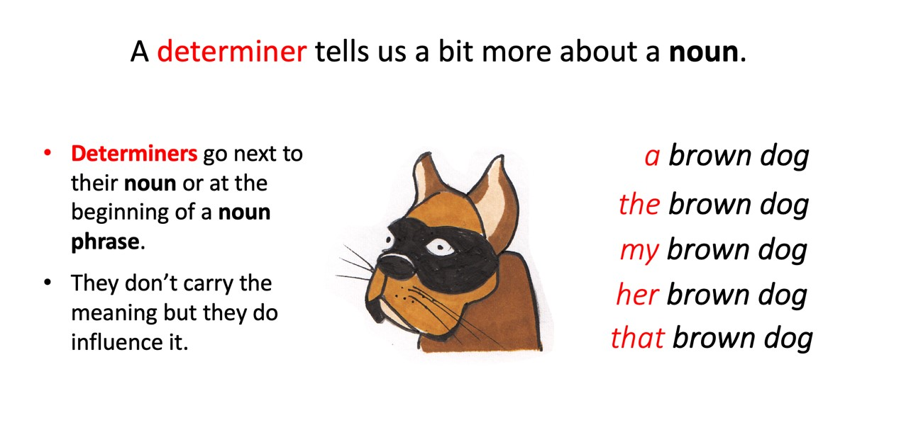
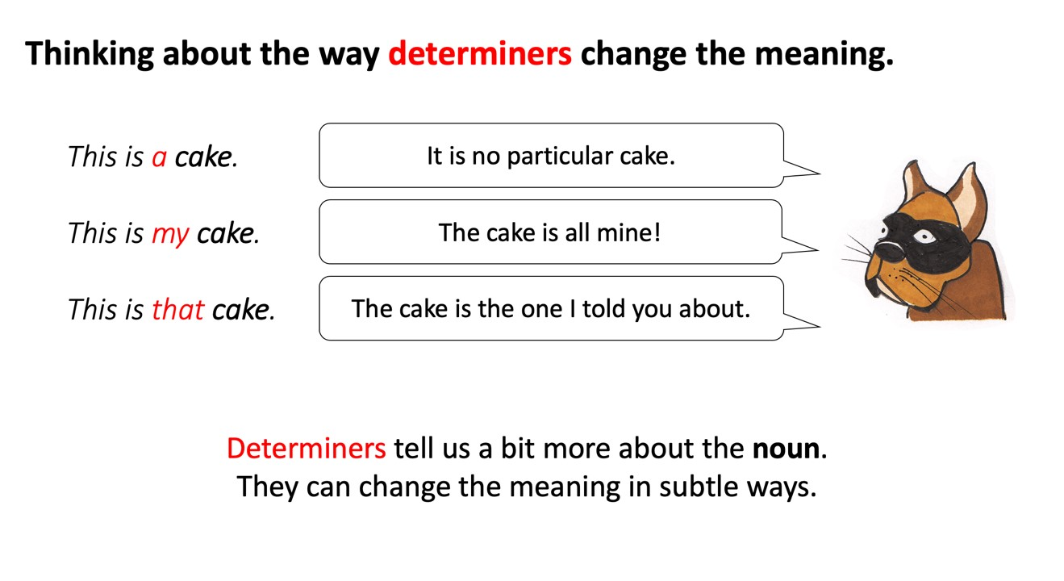
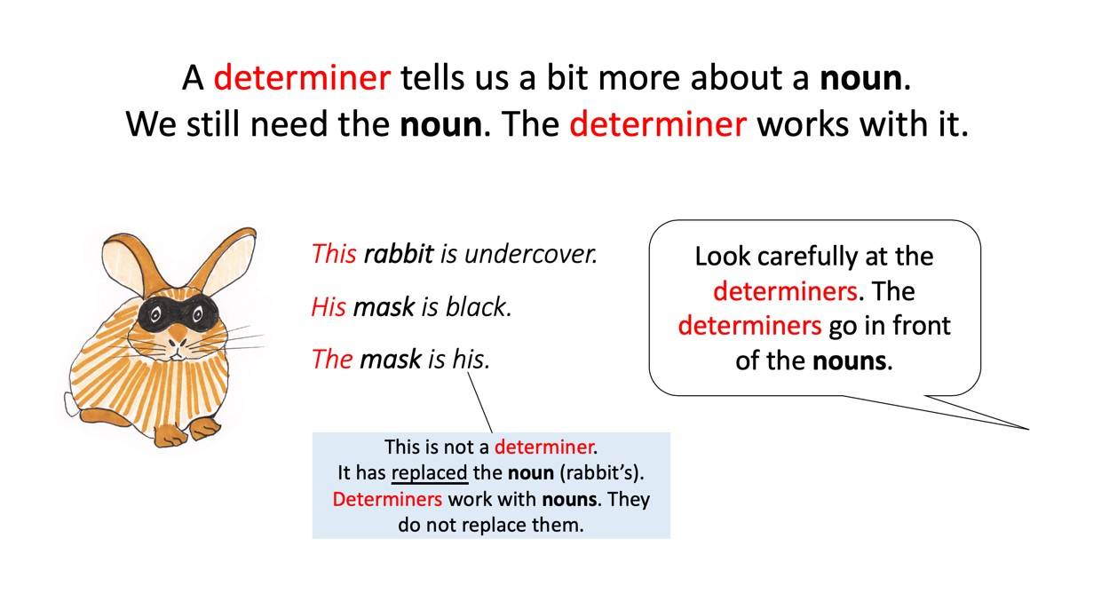

Determiners List

Determiners give different types of information about their noun.
Articles | Possessives | Quantifier/  Numbers | Demonstratives
a  an  the | my  your  his  her  its  our  their | some  any  no  every  one  two | this  that  these  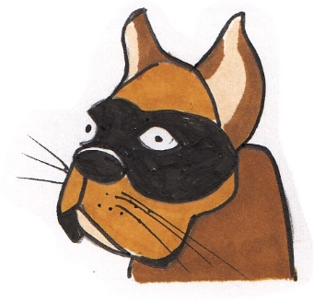  those
a brave dog her heroic rescue that terrifying spider

Poem Frame

Hero ________

He’s/she’s never_____________________________
Never_____________________________________
Never_____________________________________
Or________________________________________

He/she does ________________________________
Or_________________________________________
Or_________________________________________
Or even_____________________________________
But to his/her _____________
He/she is a hero all right
Because whenever ___________________________
He/she is there.

Hero Poem

Write your poem here.

Highlighting Determiners - answers

Hero Dad

He’s never scaled the foothills
of the Himalayas or climbed Mount Everest.

Never parachuted from a plane
or circumnavigated the planet.

Never swam the breadth of any river
or explored the North Pole.

But to his daughter
rapping him up from his deep dreaming
to rid her bedroom ceiling
of that spider creeping by in furtive spurts
sending jiggles down her nerves –

He is a hero all right – a sleepy-eyed knight
mounting that high horse of a stool
a paper napkin his only armour –
See how he catches the eight-legger
and sets it free to weave a safer harbour.

Grace Nichols

