What to do today
IMPORTANT Parent or Carer – Read this page with your child and check that you are happy with what they have to do and any weblinks or use of internet.

1. Read a poem
- Read Hero Dad. Read it twice: once in your head, once out loud.
- What is the poem about? What things has the Dad not done? What does he do that makes him a hero to his daughter?

2. Remind yourself about determiners
- Use the PowerPoint on Determiners or, if this is not possible, remind yourself using the Revision Card.
- Complete Determiners: Identify and Choose.

3. Write about an imaginary adventure
- Read the Writing Brief.
- Write about an imaginary adventure with your family and friends. Underline the determiners that you have used in your writing. The Determiners List might help you spot them.

Well done. Share your writing with a grown-up. Show them the determiners that you have used. You can check your answers to Determiners: Identify and Choose at the end of this pack.

Try these Fun-Time Extras

- Find out more about Grace Nichols poetry on this website:
https://childrens.poetryarchive.org/explore/?key=Grace+Nichols
- Practise reading the poem. Use Tips for Reading Aloud to help you. Share your reading with someone else.

Hero Dad

He’s never scaled the foothills
of the Himalayas or climbed Mount Everest.

Never parachuted from a plane
or circumnavigated the planet.

Never swam the breadth of any river
or explored the North Pole.

But to his daughter
rapping him up from his deep dreaming
to rid her bedroom ceiling
of that spider creeping by in furtive spurts
sending jiggles down her nerves –

He is a hero all right – a sleepy-eyed knight
mounting that high horse of a stool
a paper napkin his only armour –
See how he catches the eight-legger
and sets it free to weave a safer harbour.

Grace Nichols

Revision Card - Determiners

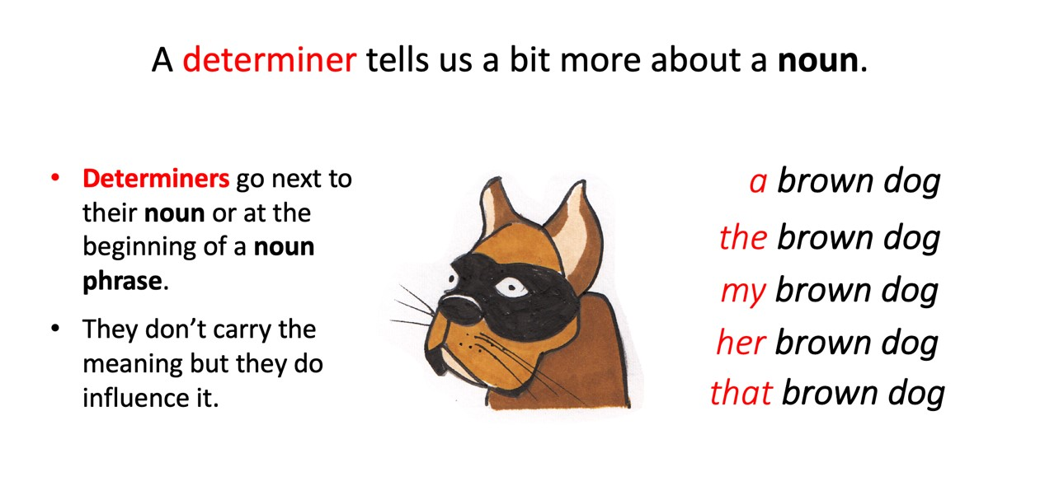
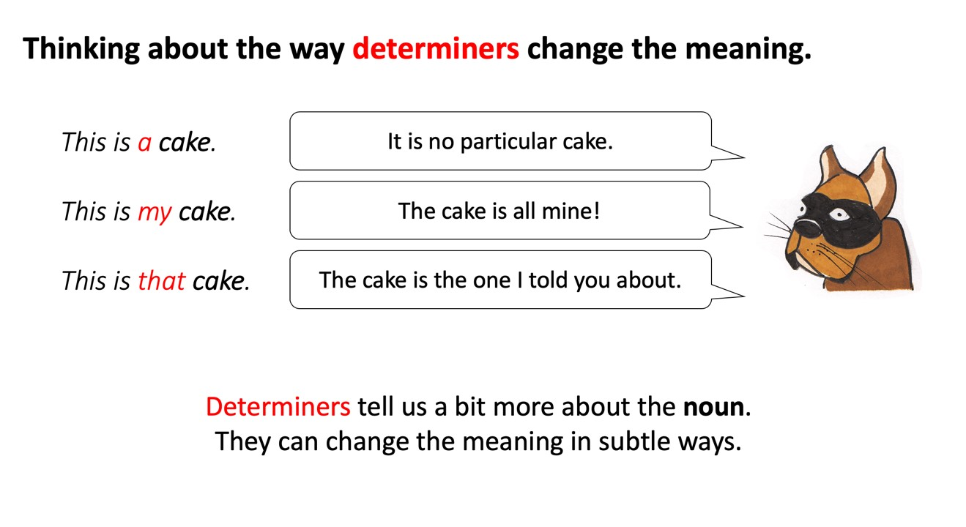
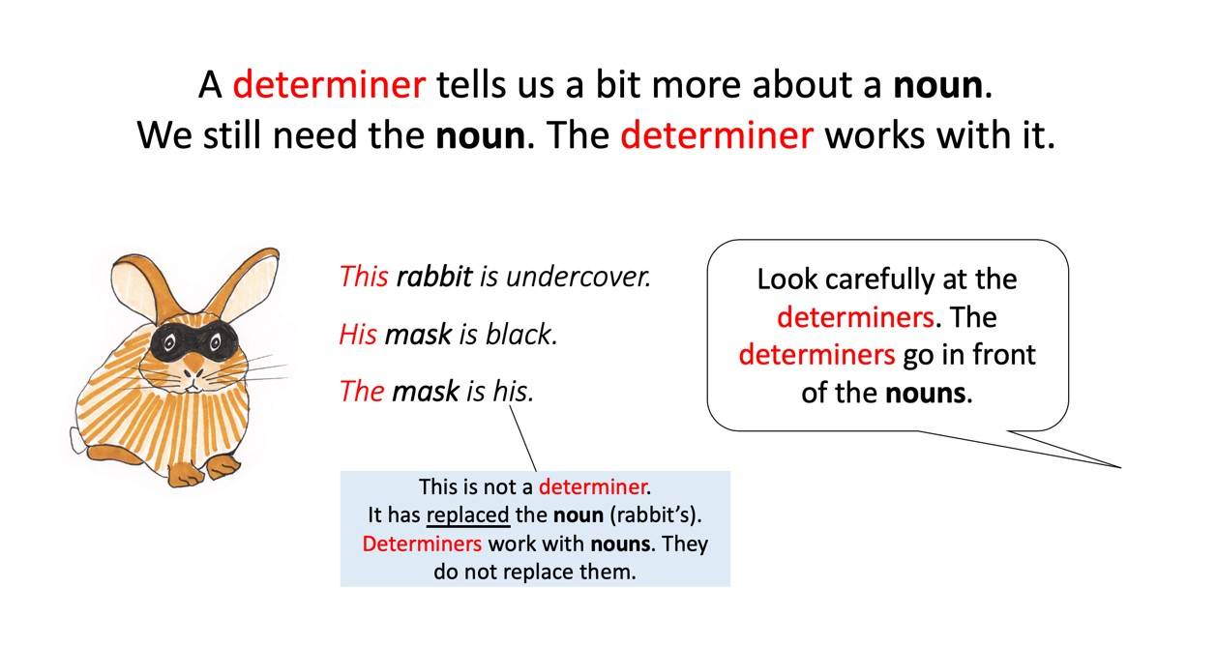

Determiners: Identify, Choose, Use
Now write a short paragraph containing exactly 15 pronouns/determiners.

A Check your understanding – Underline the determiners in each sentence

- My dad has never jumped out of a plane.
- My mum has never walked along a tightrope between two buildings.
- Our family does not climb any mountains on the way home from school.
- The cat does not battle those ferocious dogs from next door.
- My gran does not canoe down any rapid waters.
- The dog does not solve crimes for the grateful police force.
- My sister has never defused an unexploded bomb.
- I think my family is a rather ordinary family.

B Build your skills - Choose the best determiner for each sentence

- I am scared of ________ dark. (a/the)
- I would never touch ________ spider. (a/the).
- ________ dad uses a paper napkin to pick up spiders. (my/some)
- _________ mum checks under the bed before Emma goes to sleep. (the/her)
- My brother and I asked ________ gran to tell us a ghost story. (our/its)
- My cat is afraid of ________ loud noises. (any/that)
- It is ________ amazing feeling, travelling on a plane. (a/an)
- I would love to climb _______ highest mountain in the world. (a/the)

Writing Brief

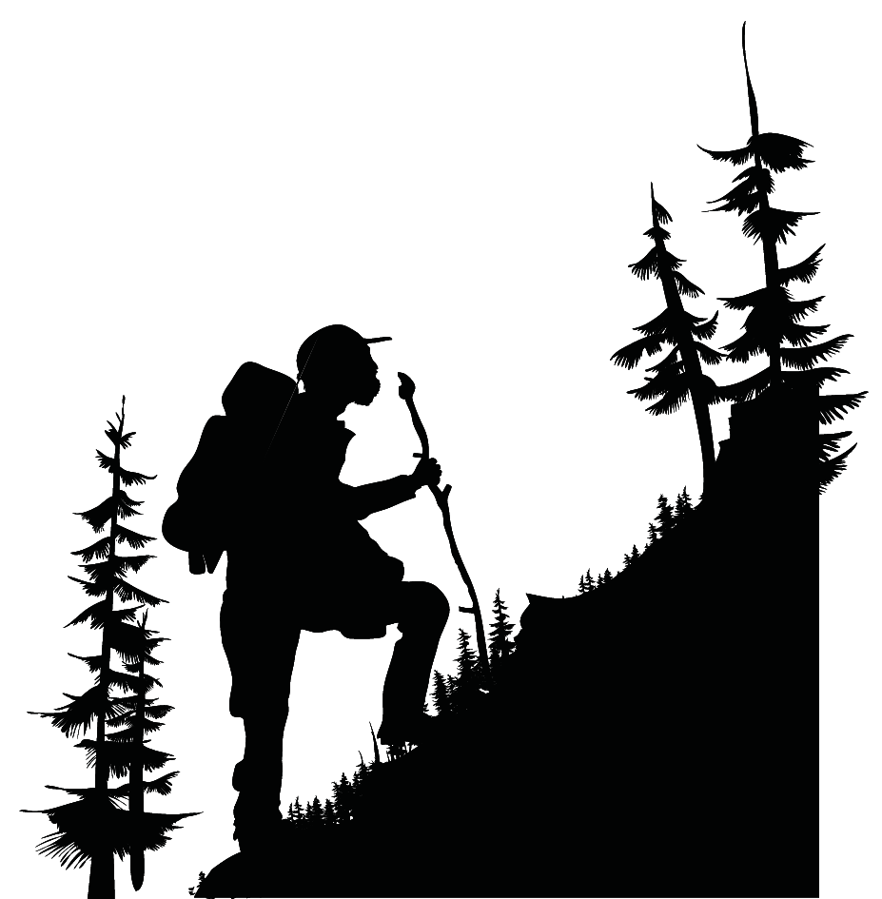

Write about an imaginary adventure with your family or friends
Underline the determiners you have used.

You could describe your mum flying a plane, or your friend exploring a jungle.

- Describe it as if it happened last month and after each few sentences, go back and undermine the determiners you have used.

- Do they influence the meaning in the way you intended?
Determiners List

Determiners give different types of information about their noun.
Articles | Possessives | Quantifier/  Numbers | Demonstratives
a  an  the | my  your  his  her  its  our  their | some  any  no  every  one  two | this  that  these  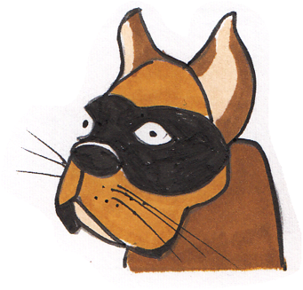  those
a brave dog her heroic rescue that terrifying spider

An amazing adventure

Write your imaginary adventure here. Underline the determiners you have used. Do they influence the meaning in the way you intended?

Determiners: Identify, Choose, Use - Answers
Now write a short paragraph containing exactly 15 pronouns/determiners.

A Check your understanding – Underline the determiners in each sentence

- My dad has never jumped out of a plane.
- My mum has never walked along a tightrope between two buildings.
- Our family does not climb any mountains on the way home from school.
- The cat does not battle those ferocious dogs from next door.
- My gran does not canoe down any rapid waters.
- The dog does not solve crimes for the grateful police force.
- My sister has never defused an unexploded bomb.
- I think my family is a rather ordinary family.

B Build your skills - Choose the best determiner for each sentence

1. I am scared of ________ dark. (a/the)
2. I would never touch ________ spider. (a/the).
3. ________ dad uses a paper napkin to pick up spiders. (my/some)
4. _________ mum checks under the bed before Emma goes to sleep. (the/her)
5. My brother and I asked ________ gran to tell us a ghost story. (our/its)
6. My cat is afraid of ________ loud noises. (any/that)
7. It is ________ amazing feeling, travelling on a plane. (a/an)
8. I would love to climb _______ highest mountain in the world. (a/the)

Reading Aloud Tips

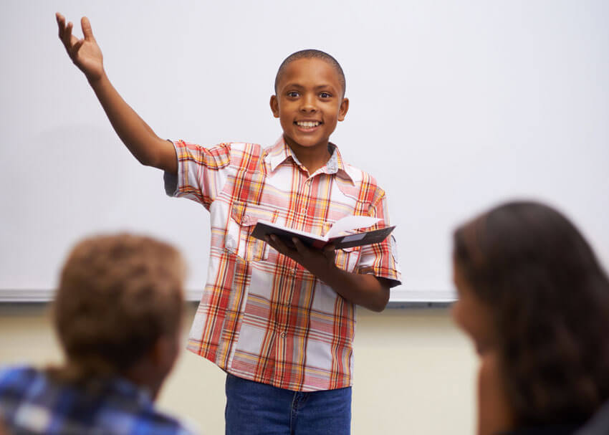

- Speak clearly - appropriate volume, speed & enunciation
- Face the audience and make eye-contact
- Use actions, move your body position, and change the expression of your face
- Use voice for effect - try varying tone and volume
- Learn the poem to allow a more energetic performance
- Try to judge how the performance is being received by watching your audience

