What to do today
IMPORTANT Parent or Carer – Read this page with your child and check that you are happy with what they have to do and any weblinks or use of internet.

1. Read a poem
- Read Spaghetti Spaghetti. Read it twice: once in your head and once out loud.
- What do you like about the poem? What patterns can you notice? Which is your favourite phrase?

2. Learn Poetic Terms
- Read What is an ode? and Poetry Terms.
- Use Check the Terms to check how well you can remember each of these words. You can write notes on the sheet.

3. Read and think about poems
- Read three more poems: Apple Pie, Ode to an Olive and Ode to a Chestnut on the Ground.
- Read and think about each of the Reflection Prompts. Find someone who will listen to your answers and discuss them.
- Annotate the poems to show your favourite phrases in each.

Try this Fun-Time Extra

- Pick your favourite poem from today and practise reading it aloud. Read the Reading Aloud Tips to help you. You could record your reading and share it with somebody else.
- Try to learn part or all of one of these poems off-by-heart.

Spaghetti Spaghetti!

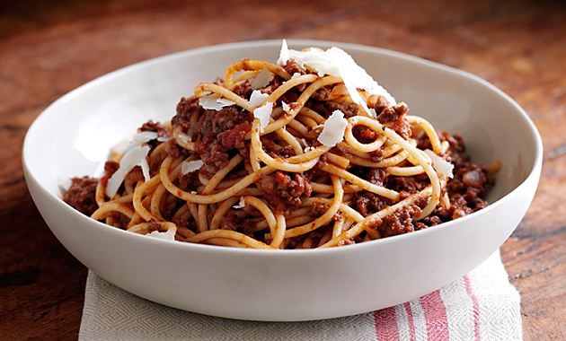

Spaghetti! Spaghetti!
you're wonderful stuff,
I love you spaghetti,
I can't get enough.
You're covered with sauce
and you're sprinkled with cheese,
spaghetti! spaghetti!
oh, give me some please.

Spaghetti! Spaghetti!
piled high in a mound,
you wiggle, you wriggle,
you squiggle around.
There's slurpy spaghetti
all over my plate,
spaghetti! spaghetti!
I think you are great.

Spaghetti! spaghetti!
I love you a lot,
you're slishy, you're sloshy,
delicious and hot,
I gobble you down
oh, I can't get enough,
spaghetti! spaghetti!
you're wonderful stuff.
Jack Prelutsky

What is an ode?

- A form of poem which praises something or someone
- They often speak to their subject
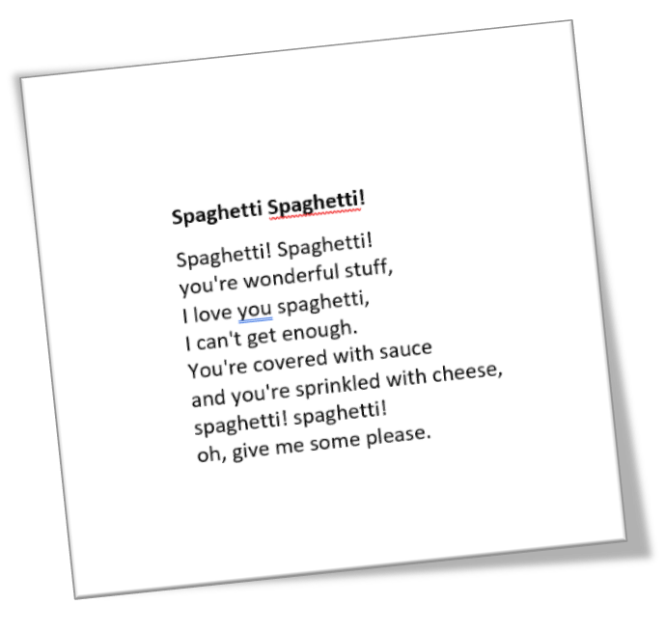
- They use formal, emotional language
- They build strong images
- They use hyperbole (exaggeration)

Poetry Terms

Stanzas - groups of lines – a little like paragraphs
Rhythm - the beat of a poem – can be regular or irregular
Rhyme - using words with the same sound, can be the whole word or the last syllable (cheese/please)
Alliteration - using words starting with the same sound
Simile - describing something, using 'as' or 'like'
Metaphor - describing something as being something else
Onomatopoeia - using words which make the sound they represent
Hyperbole – exaggeration for effect

Check the terms

Stanzas
Rhythm
Rhyme
Alliteration
Simile
Metaphor
Onomatopoeia
Hyperbole
Apple Pie

Oh, apple pie I love you,
I love your crunchy crust;
And if my mum would let me,
I'd eat you till I bust.

John Cunliffe

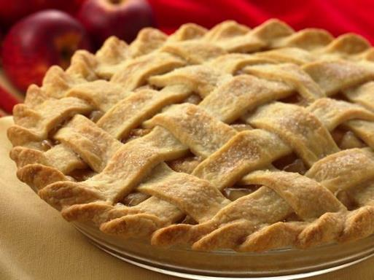

Extract from Soggy Greens
The Puffin Book of Fantastic First Poems

Ode to an Olive
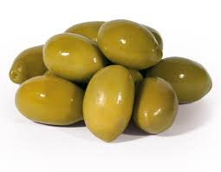

Oh Olive,
You are as precious to me as any gem,
With your beautiful, pure skin as smooth as silk
And as green as the grass in summertime.
I love your taste and the smell of your tender fruit
Which hides beneath your green armour.
Olive, sweet, tasty Olive,
How I love you so and my mealtimes wouldn't be the same
If you weren't in my life.
Oh Olive,
Nothing can compare to you, nothing at all,
You are food of the gods, a king's riches
And, most importantly, you are mine, oh Olive!

Poet Unknown
Retrieved from: https://www.youngwriters.co.uk/types-ode

Ode to a Chestnut on the Ground

From bristly foliage  you fell  complete, polished wood, gleaming mahogany,  as perfect  as a violin newly  born of the treetops,  that falling  offers its sealed-in gifts,  the hidden sweetness  that grew in secret  amid birds and leaves,  a model of form,  kin to wood and flour,  an oval instrument  that holds within it  intact delight, an edible rose.  In the heights you abandoned  the sea-urchin burr  that parted its spines  in the light of the chestnut tree;  through that slit  you glimpsed the world,  birds  bursting with syllables,  starry  dew  below,  the heads of boys  and girls,  grasses stirring restlessly,  smoke rising, rising.  Pablo Neruda | 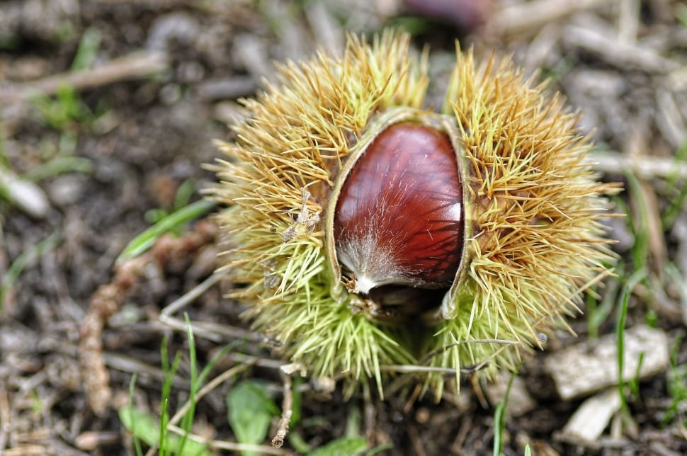
 | 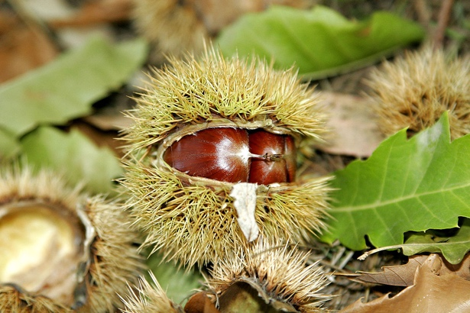
 | 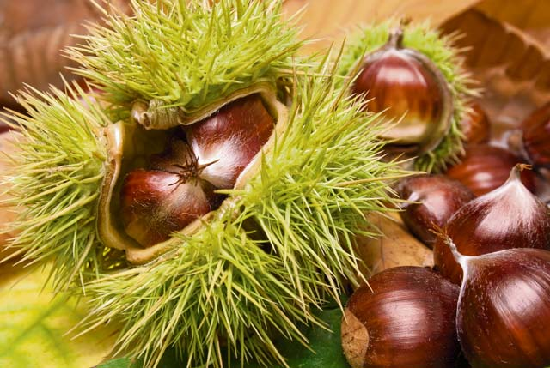
 | 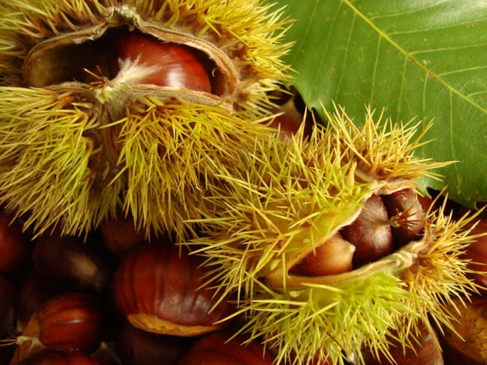
An extract from Ode to a Chestnut
Retrieved from:
http://www.poetrysoup.com/famous/poem/8527/ode_to_a_chestnut_on_the_ground

Reflection Prompts

Who or what are the odes about?
Are they written to the subject? How can you tell?
Which ode is your favourite?
Why you have chosen it?
What poetry features can you find in the odes?
Rhythm, rhyme, repetition, alliteration, simile, metaphor, onomatopoeia, hyperbole - What impact do they have?
Which words and phrases stand out
when you read them? Can you say why?

Annotate the poem so you will remember the words you have chosen.
How can you tell they are odes?

Reading Aloud Tips

- Speak clearly - appropriate volume, speed & enunciation
- Face the audience and make eye-contact
- Use actions, move your body position, and change the expression of your face
- Use voice for effect - try varying tone and volume
- Learn the poem to allow a more energetic performance
- Try to judge how the performance is being received by watching your audience

