What to do today
IMPORTANT Parent or Carer – Read this page with your child and check that you are happy with what they have to do and any weblinks or use of internet.

1. Read a poem
- Read The Cow. Read the poem twice – once in your head and once out loud.
- What patterns do you notice in the poem? Which is your favourite line?

2. Remind yourself abut adverbs
- Use the PowerPoint on Adverbs to remind yourself of adverbs. If this is not possible, use the Revision Card.
- Complete Loving Cows.

Well done! Now show a grown-up your answers to the questions. You can check the answers at the end of the pack.

3. Learn the poem by heart
- Read Top Tips for learning a poem by heart.
- Practise reading The Cow until you know all or some of it off by heart. Recite it to a grownup.

Try these Fun-Time Extras
- Can you perform to the poem to somebody else? You could film it and share it with them.
- Which animal would you choose to write about? Pick your favourite animal. Write some sentences about why you like it and what it does that you appreciate. You could try to turn your sentences into a poem.

The Cow

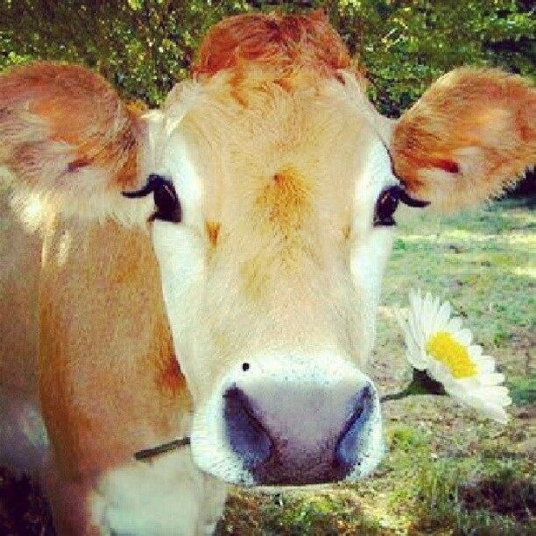

The friendly cow, all red and white,
I love with all my heart:
She gives me cream with all her might,
To eat with apple tart.
She wanders lowing here and there,
And yet she cannot stray,
All in the pleasant open air,
The pleasant light of day;
And blown by all the winds that pass
And wet with all the showers,
She walks among the meadow grass
And eats the meadow flowers.

By Robert Louis Stevenson

Revision Card - Adverbs

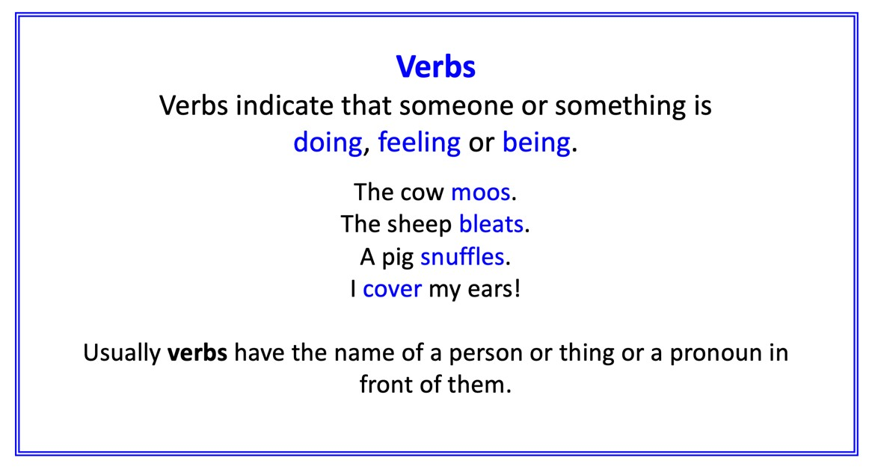 | 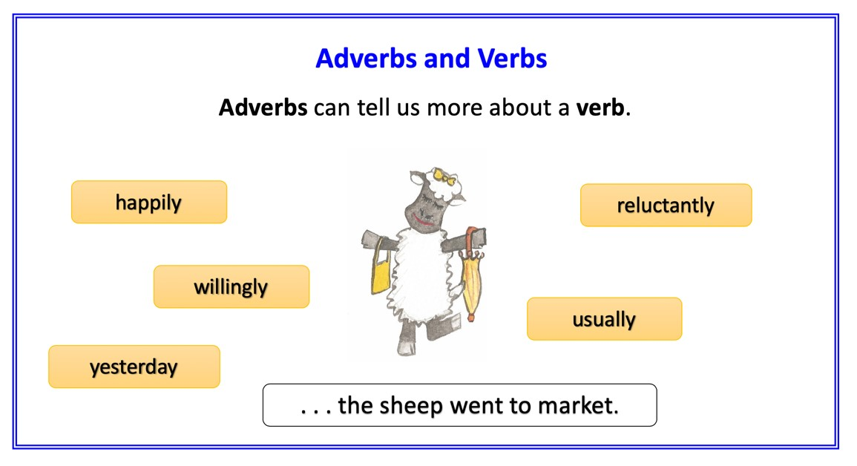
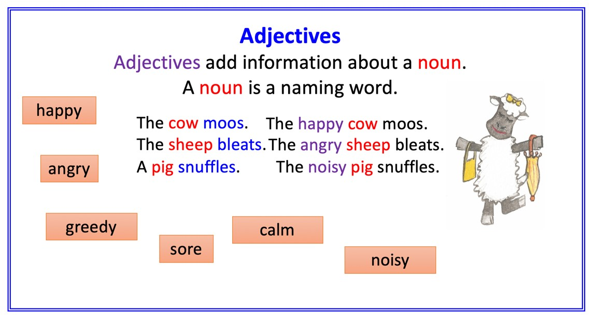 | 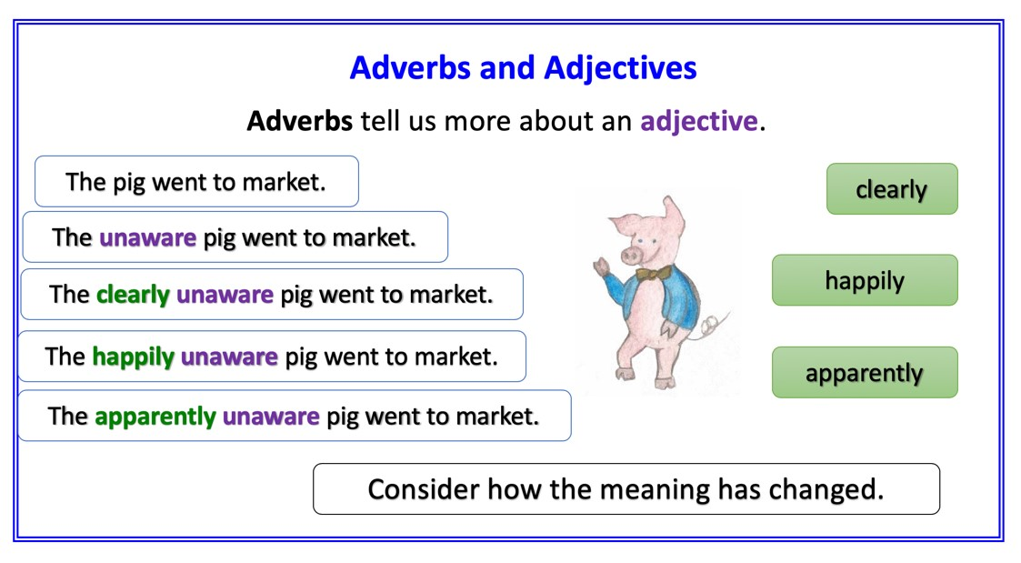

Loving Cows

Identify and underline the adverbs in these sentences.

1. The friendly cow moos gently and persistently.

2. She often gives me milk and cream.

3. The cows usually wander haphazardly all over the field.

4. Cows get battered viciously by the strong east wind.

5. My favourite cow often walks slowly and peacefully though the meadow.

6. How can I move the cows tenderly and kindly out of the field?

Re-write each sentence, adding an adverb. You could use one of the ones in the blue boxes below.

- The farmer ________ feeds his cows hay.
- My cow __________ strays from the herd.
- The sun shines _________ on the cows.
- __________ each cow stands close to its neighbour when it rains.
- We _________ enjoy eating apple pie and cream.
- His favourite cow moos __________ when she sees him.
Does the adverb tell us more about ‘how’, ‘when’ or ‘where’ each action happens? Write ‘how’, ‘when’ or ‘why’ above each adverb you used.
Write two sentences using adverbs in each one.
gently
greedily
warmly
happily
fiercely
contentedly
always
frequently
never
often

Top tips for learning a poem by heart

- Read the poem aloud several times slowly.
- Copy the poem out a couple of times.
- Pick a poem with a pattern, metre and rhyme are much easier to learn by heart than free verse.
- Learn and imagine the “story” in the poem
- Understand the poem by knowing every word’s meaning
- With a card, cover everything but the first line of the poem. Read it. Look away, see the line in the air, and say it. Look back. Repeat until you’ve “got it.”
- Uncover the second line. Learn it as you did the first line, but also add second line to first, until you’ve got the two.
- Then it’s on to three. Always repeat the first line on down, till the whole poem sings.
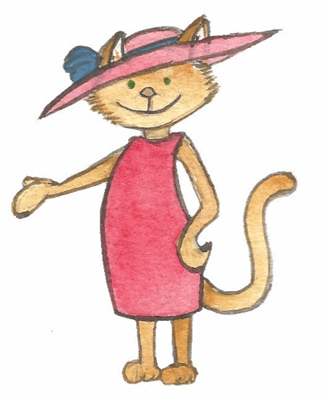
Loving Cows - Answers

Identify and underline the adverbs in these sentences.

1. The friendly cow moos gently and persistently.

2. She often gives me milk and cream.

3. The cows usually wander haphazardly all over the field.

4. Cows get battered viciously by the strong east wind.

5. My favourite cow often walks slowly and peacefully though the meadow.

6. How can I move the cows tenderly and kindly out of the field?

