What to do today
IMPORTANT Parent or Carer – Read this page with your child and check that you are happy with what they have to do and any weblinks or use of internet.

1. Think about characters
- Listen to the reading of King of the Sky again.
https://www.youtube.com/watch?v=Mz5SBh4A9mg&t=2s
- Write what we know about Mr Evans and the Boy on Outlines 1 and 2.
- Write what else you would like to know about them too.

2. Remind yourself about direct speech
- Use the PowerPoint on direct speech. If this is not possible, remind yourself using the Revision Card.
- Look closely at Speech Bubbles 1 and 2. Decide what the boy and Mr Evans could be saying and write it inside the speech bubble.

3. Now for some writing
- Write the speech that you put in Speech Bubbles as sentences. Use speech marks, commas and reporting clauses.
- You could challenge yourself to write a paragraph that describes the scene and which includes direct speech.

Try the Fun-Time Extra

- Watch the reading of the story with a grown-up. Choose some of the questions on Talking Points and ask them about their ideas and opinions about the story. Do they give the same answers as you would?
Outline 1
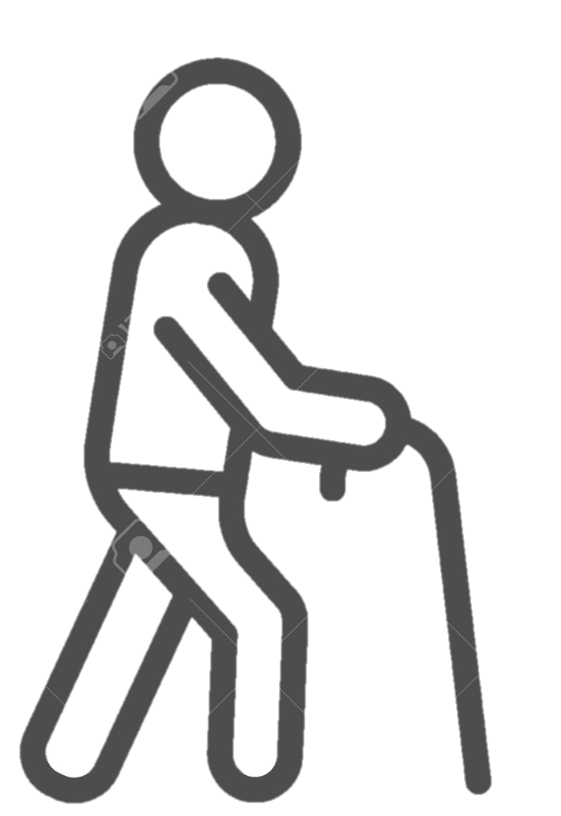

Outline 2

Revision Card – Direct Speech

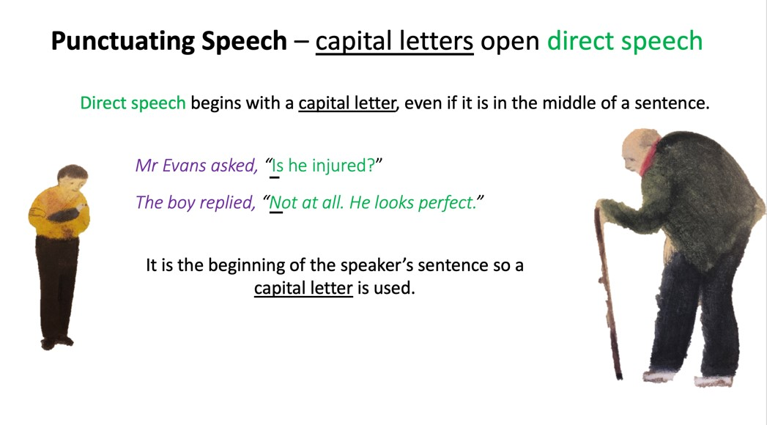 | 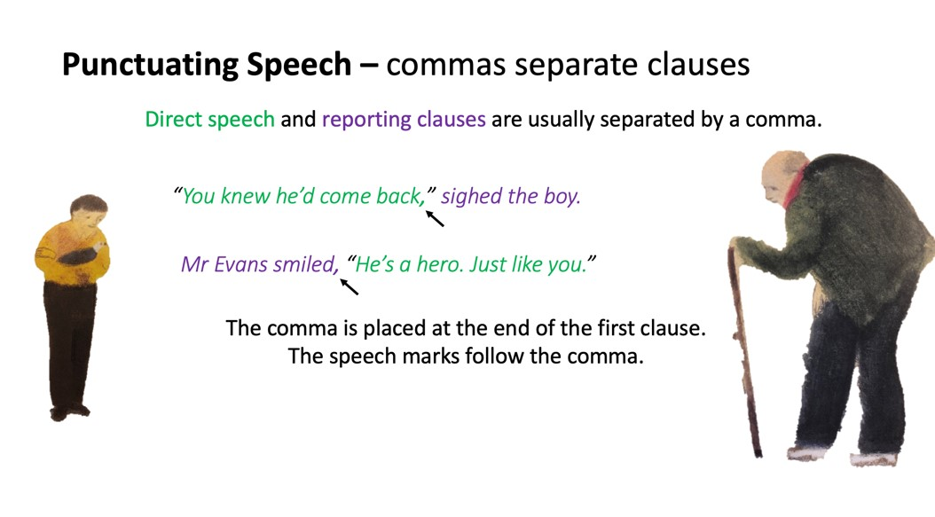
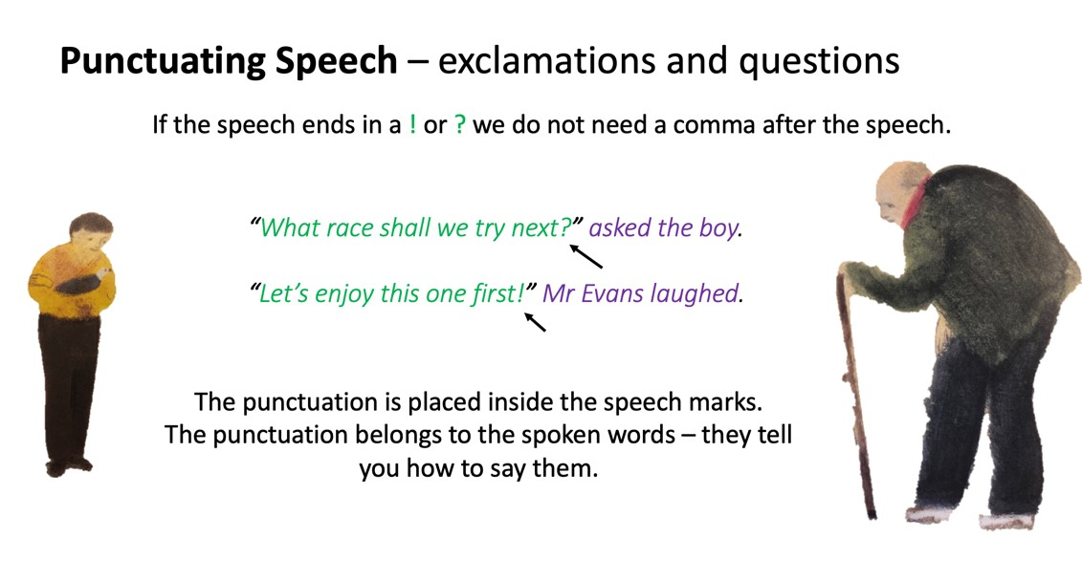 | 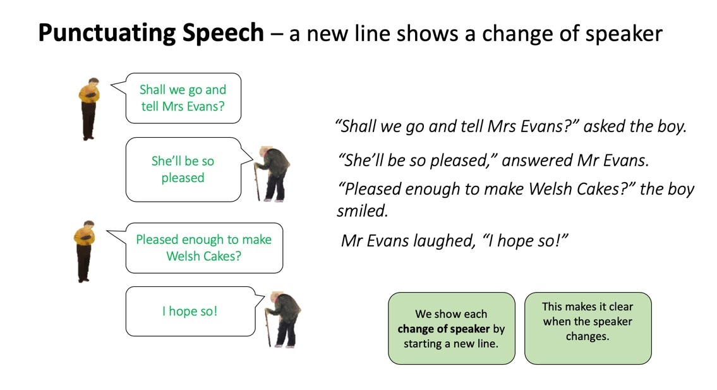

Speech Bubble 1

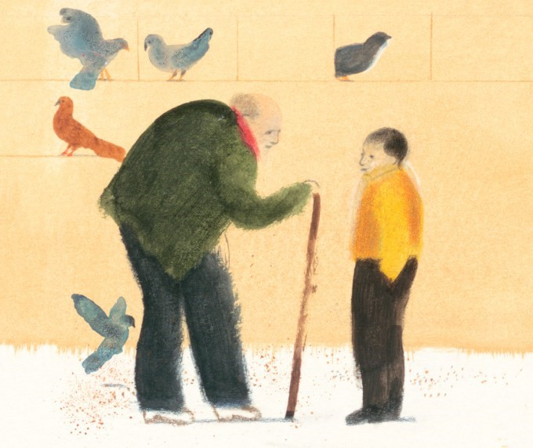

Speech Bubble 2

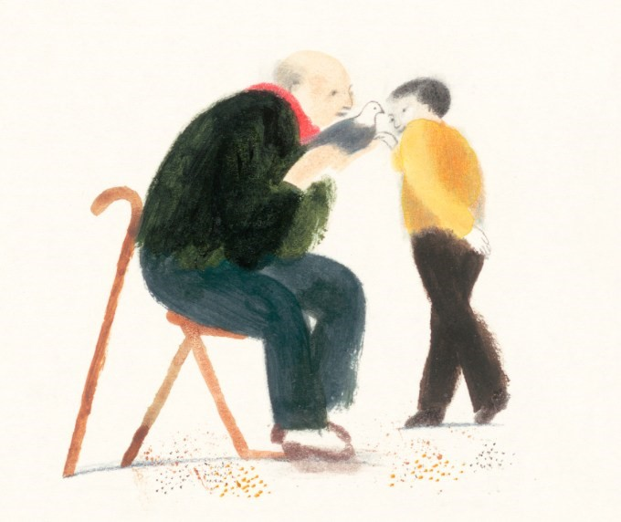

Speech Sentences

Write the speech that you wrote in speech bubbles in full sentences with speech marks, commas and reporting clauses.

Talking Points

How did the story make you feel?
Can you explain why?

What does the story make you think about?

What has happened to you that is most like this story?

Choose one of the main characters.
What happens to them in the story?
How are they different at the end of
the story?
What made them different?

What is your favourite illustration in this story?

Why is it your favourite?

Why do you think that Nicola Davies wrote this story?

What lessons could someone learn from this story?

