What to do today
IMPORTANT Parent or Carer – Read this page with your child and check that you are happy with what they have to do and any weblinks or use of internet.

1. Read a poem
- Read Where Go the Boats. Read the poem twice – once in your head and once out loud.
- What do you like about the poem? What patterns can you spot?
- Use the Poem PowerPoint to listen to the poem being read. Is it how you expected it? What is the same and what is different?

2. Remind yourself about the perfect form
- Use the PowerPoint Slides 8 to 12 on Perfect Form. If this is not possible, remind yourself of Perfect form using the Revision Cards. Complete Which Tense?
- Now turn each of the simple past tense sentences that you found into the perfect form.

Well done! Now show a grown-up your sentences. You can check your answers at the end of the pack.

3. Learn a poem by heart
- Choose your favourite poem from: Where Go the Boats, The Swing (Day 4) and A Good Play (Day 3).
- Practise reading a verse from the poem again and again, until you can say it without looking at the words. Learn all the verses.

Try these Fun-Time Extras
- Listen to the other poems on the Poem PowerPoint. Which is your favourite?
- Ask someone to test you on the poem you have been practising. Get them to read it but to leave out words – fill the words in from your memory.
Where Go the Boats

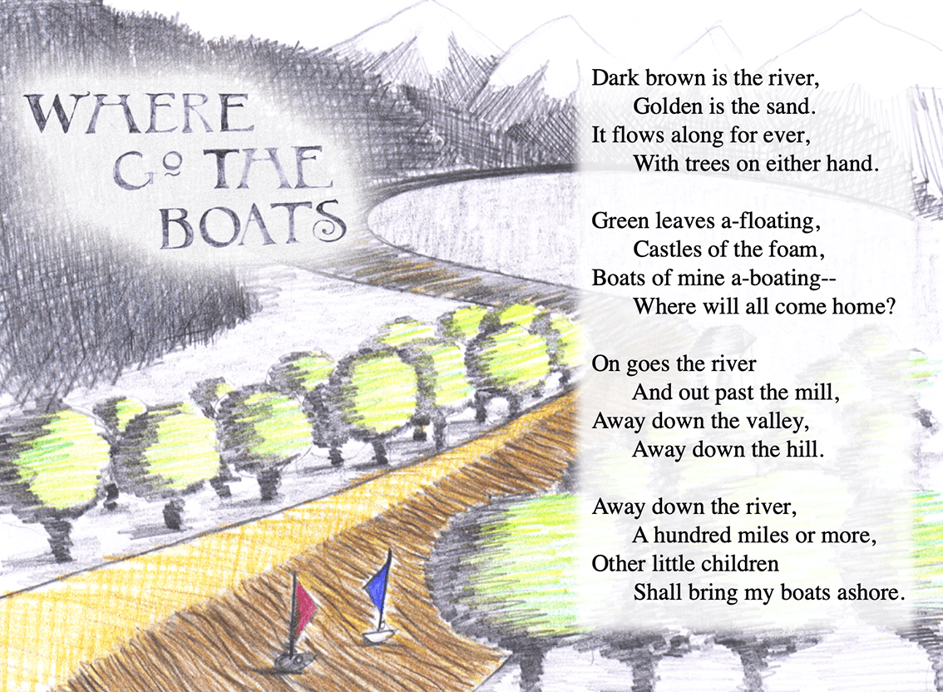

Revision Card – Perfect Form

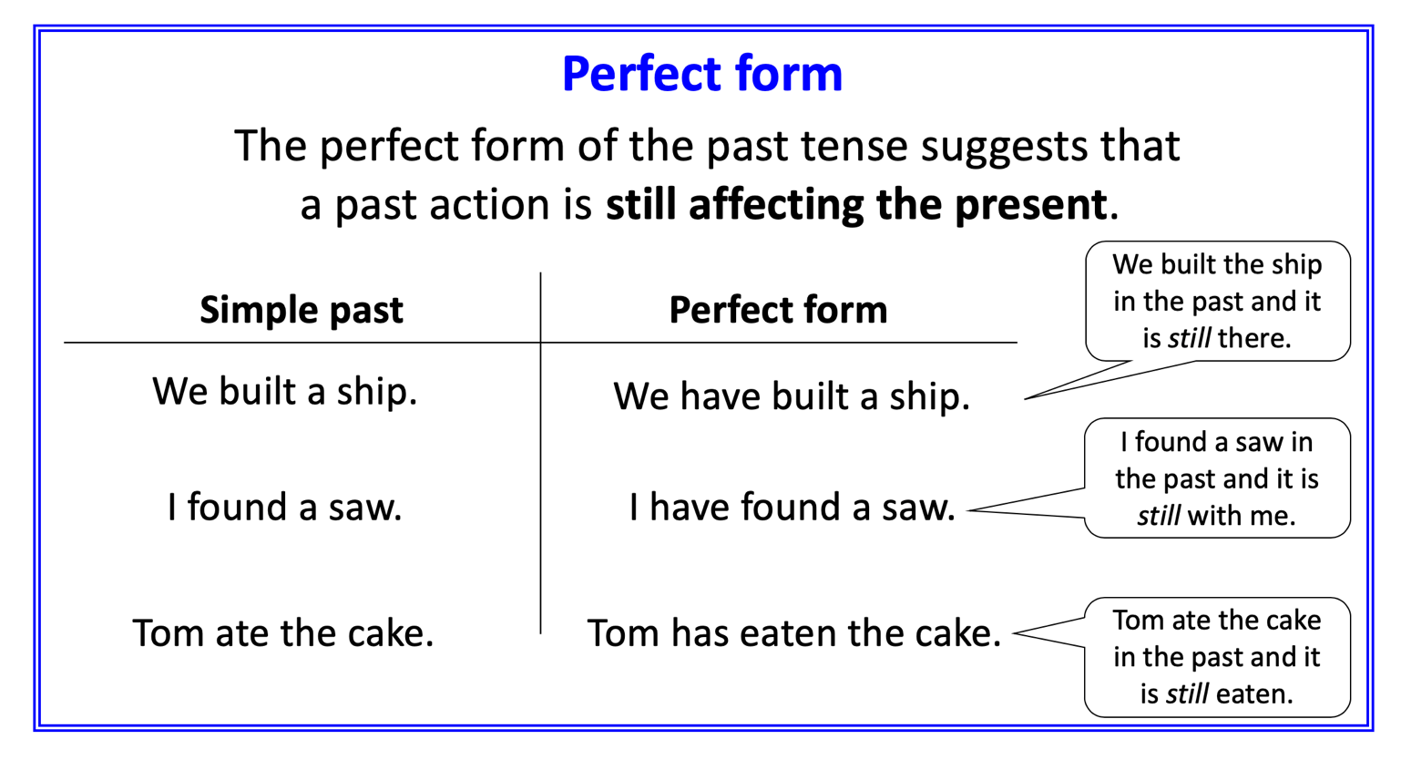
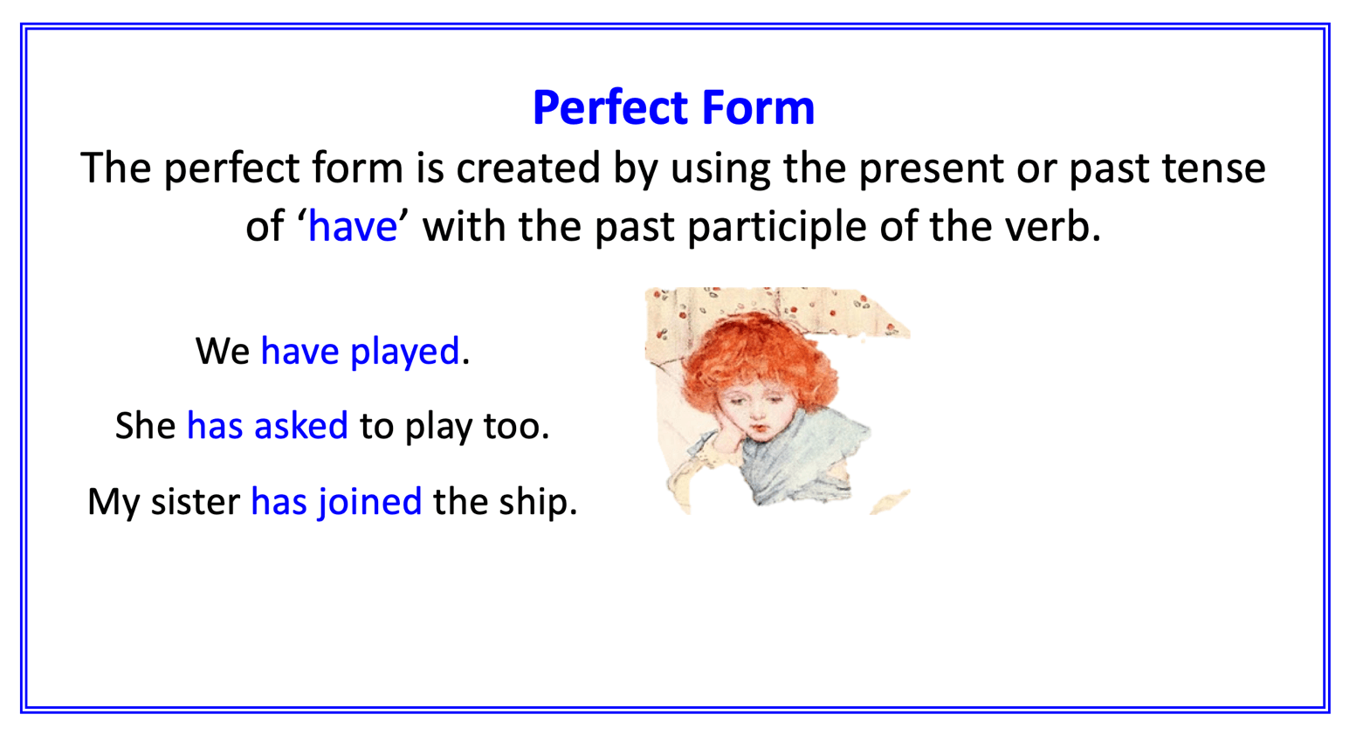

Which Tense?

Read each sentence below and decide whether it is in the simple, progressive or perfect form of the past tense. The first one has been done for you.

 | Simple past | Progressive Past | Perfect form
I stood on the riverbank under the trees. | /
The river was flowing swiftly by.
Happily, I launched my boat into the water.
I had watched the leaves on the current.
The river made castles of foam.
My little ship drifted away towards the old mill.
Clouds were bustling across the sky.
Finally, the boat had reached the distant shore.
A group of children pulled my paper ship from the water and clapped with delight.

Perfect Form Sentences

Now, turn each of the simple past tense sentences that you found into the perfect form.

Which Tense? - ANSWERS

Read each sentence below and decide whether it is in the simple, progressive or perfect form of the past tense. The first one has been done for you.

 | Simple past | Progressive Past | Past perfect
I stood on the riverbank under the trees. | X
The river was flowing swiftly by. |  | X
Happily, I launched my boat into the water. | X
I have watched the leaves on the current. |  |  | X
The river made castles of foam. | X
My little ship drifted away towards the old mill. | X
Clouds were bustling across the sky. |  | X
Finally, the boat has reached the distant shore. |  |  | X
A group of children pulled my paper ship from the water and clapped with delight. | X

Into Past Perfect Form:

I have stood on the riverbank under the trees.
Happily, I have launched my boat into the water.
The river has made castles of foam.
My little ship has drifted away towards the old mill.
A group of children have pulled my paper ship from the water and clapped with delight.

