What to do today
IMPORTANT Parent or Carer – Read this page with your child and check that you are happy with what they have to do and any weblinks or use of internet.

1. Read a poem
- Read The Swing. Read it twice –in your head and out loud.
- What do you like about this poem? What rhyming patterns can you spot?
- Now use the Poem PowerPoint to listen to the poem being read. Does it sound like you expected or is it different? How?

2. Remind yourself about the progressive form
- Use the PowerPoint slides 5, 6 and 7 on the progressive form of the past tense. If this is not possible, remind yourself about progressive form using the Revision Card.
- Complete In the Playground by rewriting the sentences in the progressive past tense.

3. Imagine the best playground ever
- Imagine you have been playing in the very best playground ever. What was in it? What were you playing? Who was playing with you?
- Draw a picture of your playground.
- Write some sentences in the progressive form to say what you were playing and doing.

Well done! Now show a grown-up your drawing and sentences. You can check your answers to In the Playground at the end of this pack.

Try this Fun-Time Extra
- Can you learn one of the verses of The Swing off by heart?
- You could challenge yourself to learn all three verses!

The Swing

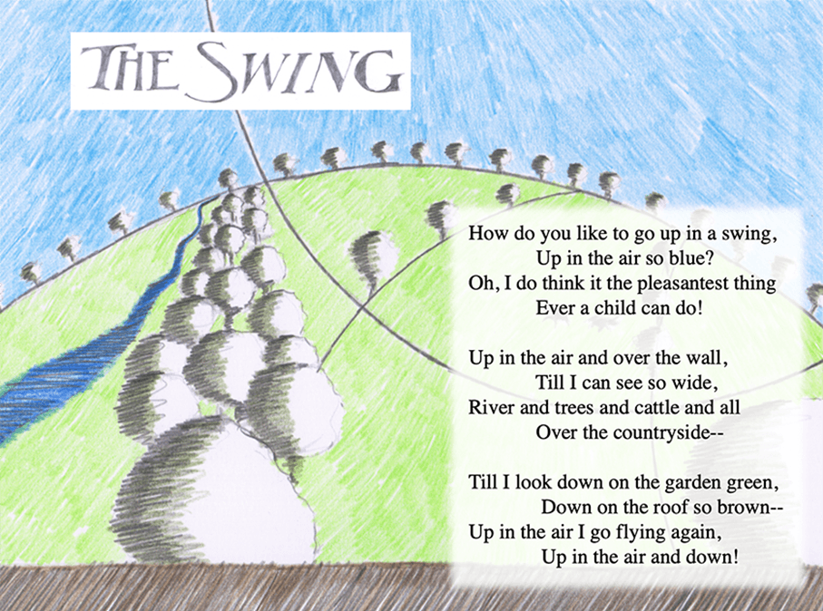

Revision Card – progressive form

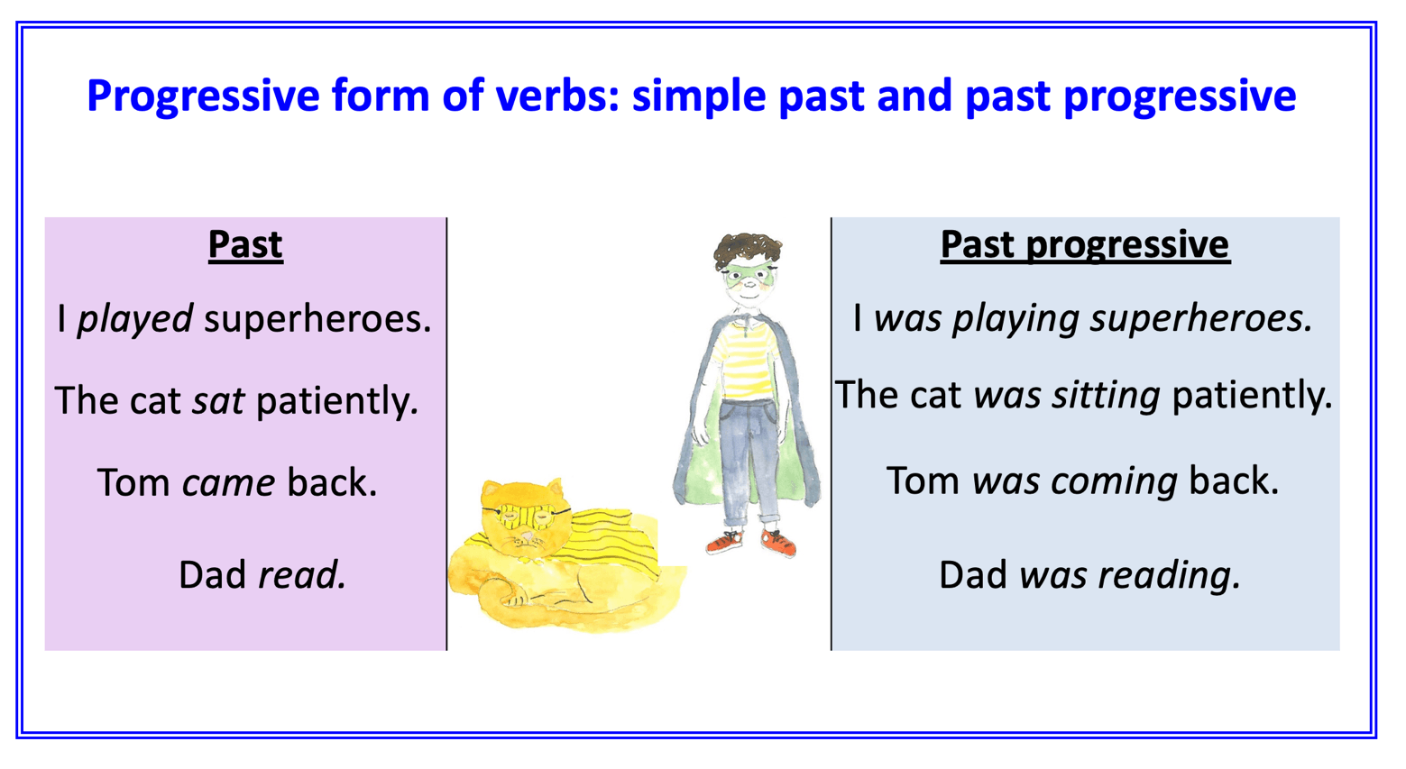
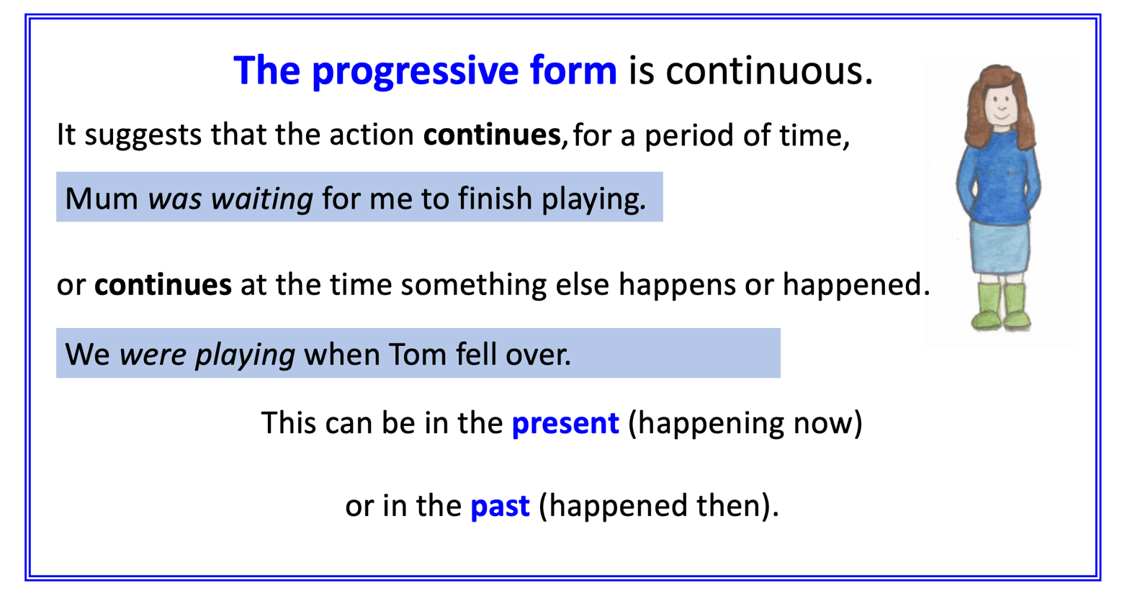

In the Playground
Read each of the sentences below and then rewrite them in the progressive past tense.
The first two have been done for you.
We ran to the playground.
We were running to the playground.
I climbed on the slide.
I was climbing on the slide.
Tom used the swings.
Two girls sat on the roundabout.
Their Dad helped them to go round.
I came down the slide super fast.
Tom swung up to the top of the trees.
The girls went so quickly their hats came off.
The Dad looked amazed!

The best playground ever
Draw you and your friends playing in the best playground ever.

The best playground ever

Write some sentences in the progressive form to say what you and your friends were playing and doing in the best playground ever.

In the Playground - ANSWERS
Read each of the sentences below and then rewrite them in the progressive past tense.
The first two have been done for you.
We ran to the playground.
We were running to the playground.
I climbed on the slide.
I was climbing on the slide.
Tom used the swings.
Tom was using the swings.
Two girls sat on the roundabout.
Two girls were sitting on the roundabout.
Their Dad helped them to go round.
Their Dad was helping them to go round.
I came down the slide super fast.
I was coming down the slide super fast.
Tom swung up to the top of the trees.
Tom was swinging up to the top of the trees.
The girls went so quickly their hats came off.
The girls were going so quickly that their hats were coming off.
The Dad looked amazed!
The Dad was looking amazed.

