What to do today
IMPORTANT Parent or Carer – Read this page with your child and check that you are happy with what they have to do and any weblinks or use of internet.

1. Read a poem
- Read A Good Play. Read the poem twice – once in your head and once out loud.
- What do you like about the poem? What patterns can you find in it?

2. Remind yourself about the past tense
- Use the PowerPoint Slides 1, 2, 3 and 4 on the past tense. If this is not possible, then use the Revision Card to remind yourself.
- Complete Present and Past.
- Choose 3-5 of these verbs and write them into longer sentences in the past tense.

3. Write and draw from your imagination
- Imagine the best time playing indoors that you can think of. Who would be with you? What would you play?
- Write about the time in sentences in the past tense, so that it sounds like it really happened!
- Draw a detailed picture to match your writing.

Well done! Now show a grown-up your writing. Can they see how your picture matches? You can check your answers to Present and Past at the end of this pack.

Try this Fun-Time Extra
- Can you find a way to make an imaginary ship at home? Talk to a grown-up about what you want to do first.
A Good Play
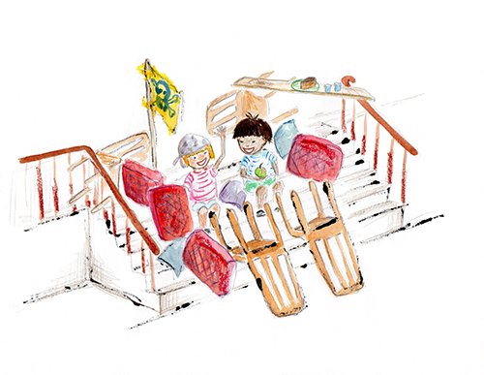
We built a ship upon the stairs,
All made of the back-bedroom chairs,
And filled it full of sofa pillows
To go a-sailing on the billows.

We took a saw and several nails,
And water in the nursery pails;
And Tom said, “Let us also take
An apple and a slice of cake”; –
Which was enough for Tom and me
To go a-sailing on, till tea.

We sailed along for days and days,
And had the very best of plays;
But Tom fell out and hurt his knee,
So there was no one left but me.

Robert Louis Stevenson

Revision Card – Present and Past Tense

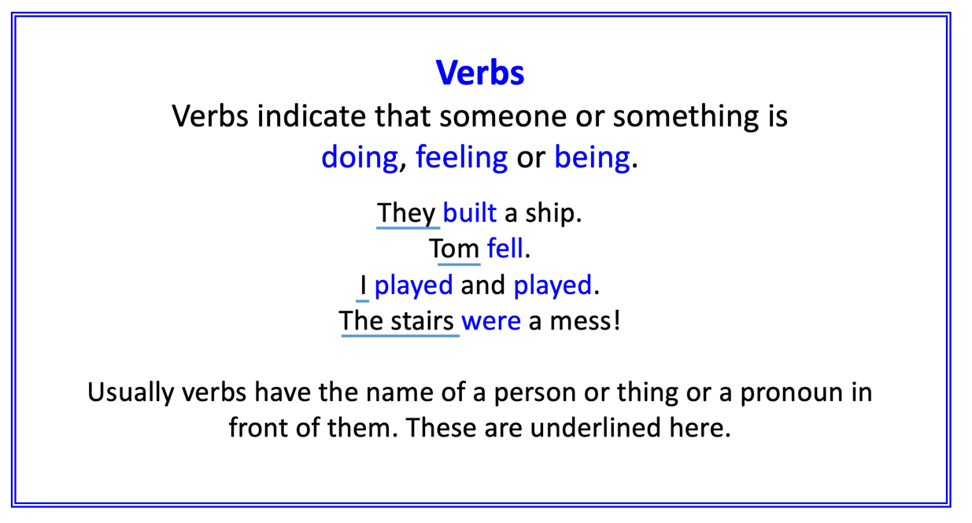
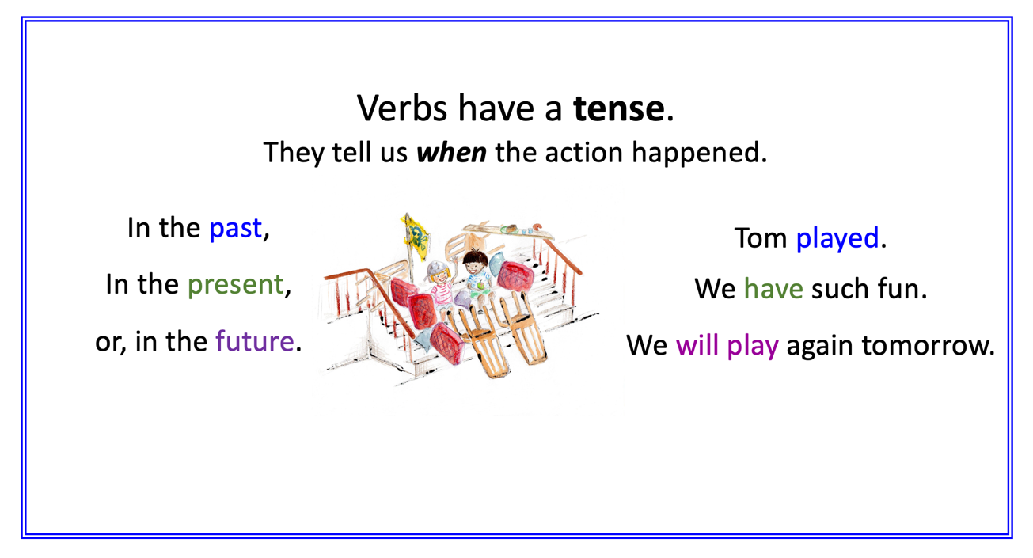
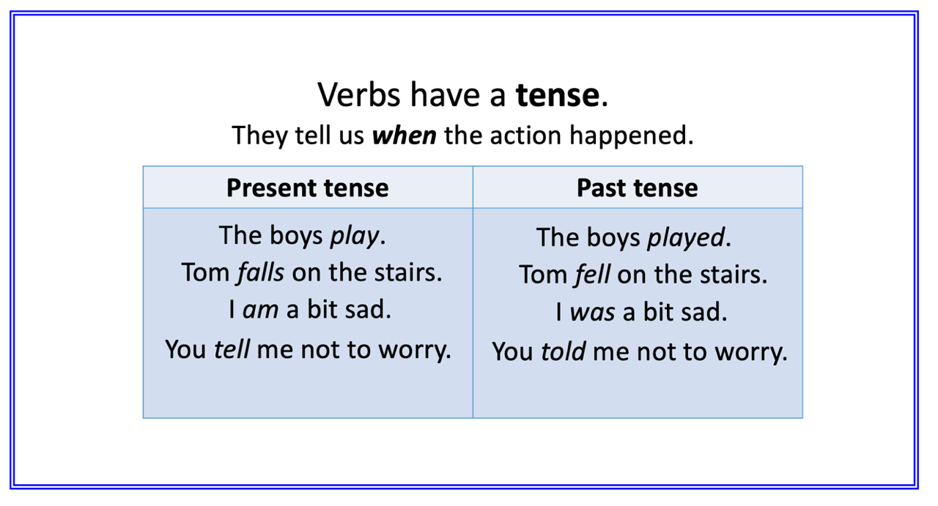

Present and Past

Convert each of the present tense verbs in the first column into the simple past tense. The first one has been done for you.

Simple present tense | Simple past tense
the boys play | the boys played
a ship sails
we climb
they talk
children pick
she pulls
you take
I bring
he sees
they are

My best indoors playing

Write about the best indoors playing that you can imagine. Write in the past tense so that it sounds like it actually happened!
Illustration

Present and Past - Answers

Convert each of the present tense verbs in the first column into the simple past tense. The first one has been done for you.

Simple present tense | Simple past tense
the boys play | the boys played
a ship sails | a ship sailed
we climb | we climbed
they talk | they talked
children pick | children picked
she pulls | she pulled
you take | you took
I bring | i brought
he sees | he saw
they are | they were

